Morning Challenge | 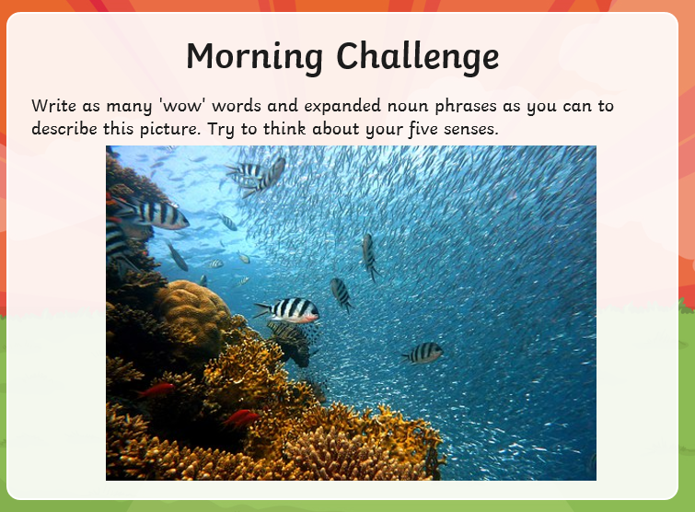
Maths | Morning Year 6, in this lesson, we will solve division equations that involve remainders.  LO: Can I Solve problems involving division with remainders?  Watch the session from Oak academy, linked below:  https://classroom.thenational.academy/lessons/solve-problems-involving-division-with-remainders-part-1-6hjp6t  The worksheet is below, remember to watch the lesson first.  Then take the quiz, to check your understanding.  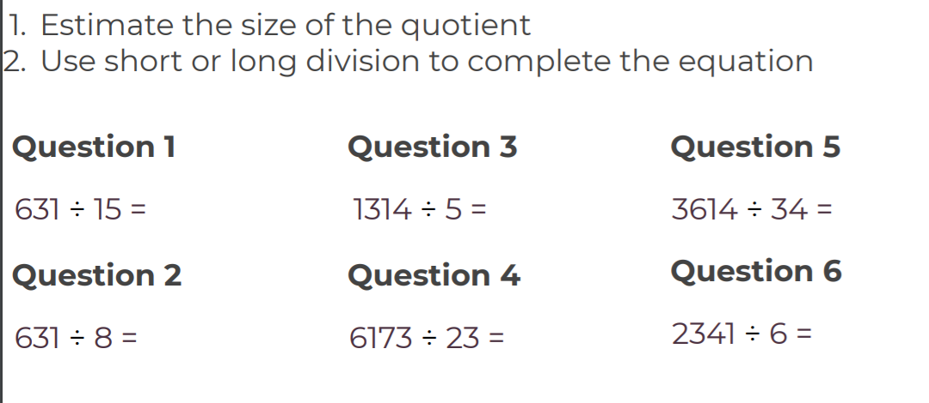
English | Today we continue our book, The Ultimate Guide to Unicorns and Flying Horses by Pie Corbett.  Here is the link:  https://www.talk4writing.com/wp-content/uploads/2021/01/The-Ultimate-Guide-to-Unicorns-Flying-Horses-2.pdf  Please complete page 9, Activity 6: Magpie useful words and openers.  Next, read page 10, Activity 7: Spot the underlying pattern. Finally, Complete page 11: Activity 8: What additional paragraphs to include.  These are the pages below, remember to click on the link for the larger versions.  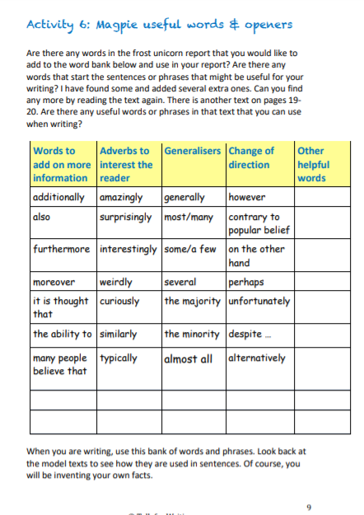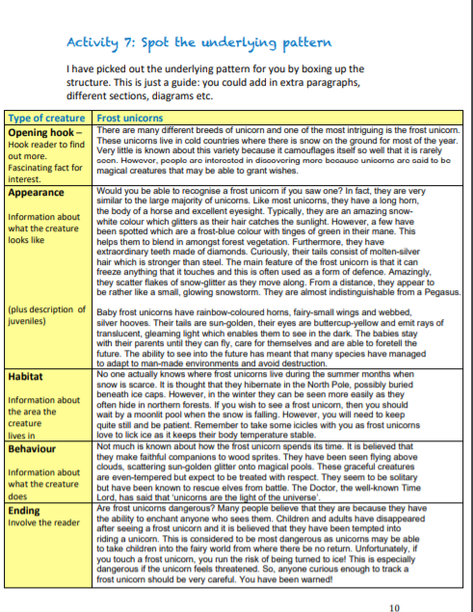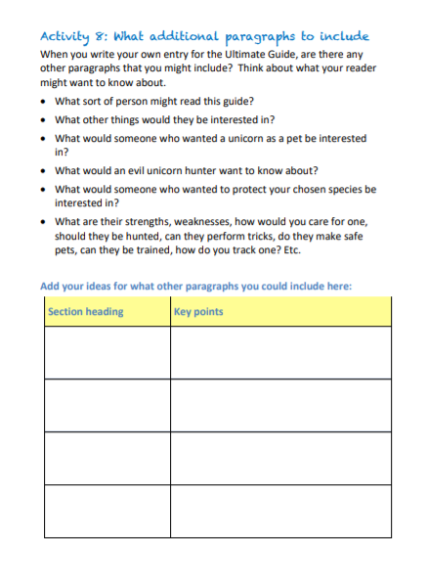
Spelling | In this lesson, we will recap the rules associated with adding the suffix -ous, look at other words with the same suffix and learn a spelling practice strategy. The 10 spelling words set in the previous lesson will be revisited and tested.  LO: Can I score 10/10 on the test?  Here is the link:  https://classroom.thenational.academy/lessons/to-practise-and-apply-knowledge-of-suffixes-ous-including-test-6rv34d
Afternoon lessons:  French | 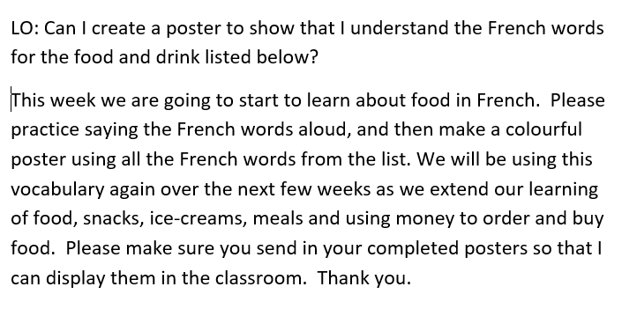  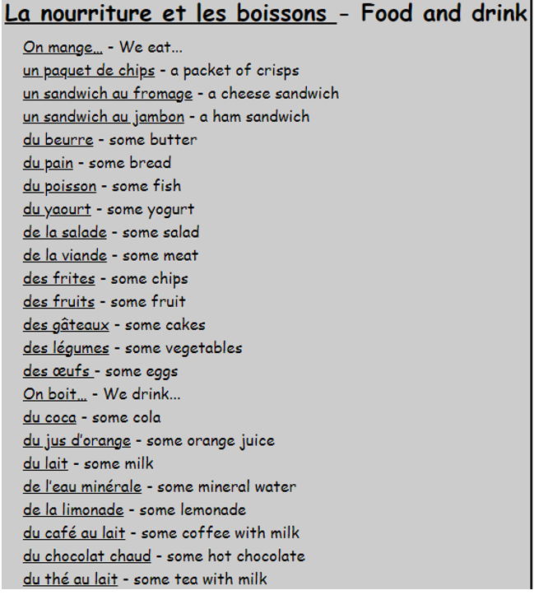
Music | For music Ms Burners has recommended we take a look at the BBC ten pieces site.  Click the link below:  https://www.bbc.co.uk/teach/ten-pieces/ten-pieces-musical-menu/zmypxbk  This week you will be exploring the Musical Menu Themes: Animals, rhythm, dancing and drawing.  You have :’listen’, ‘learn’ then ‘do’ videos to look at.
Thanks Oak, I’ll hear from you via the class email.
Remember Miss Wharton has her laptop on all day during the week, like when we are at school, so you can send your work or a message when you like (I can share these with Mrs Wylie), We love hearing from you.

Please ensure that you email completed work to oak@lyng.norfolk.sch.uk so I can provide feedback on certain pieces to ensure progression.

