Morning  Challenge | 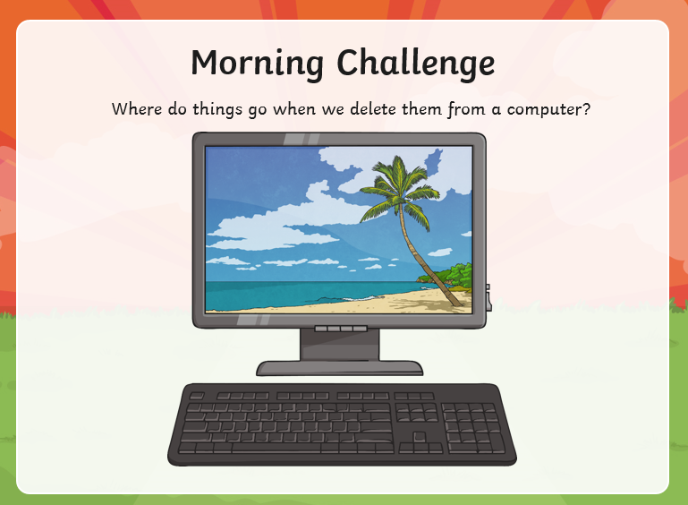
Maths | Morning Year 6, in this lesson, you will learn to interpret the remainder using the context of the problem being solved.  LO: Can I represent remainders in different ways depending on the context of the problem?  Watch the session from Oak academy, linked below:  https://classroom.thenational.academy/lessons/represent-remainders-in-different-ways-depending-on-the-context-of-the-problem-part-2-ccu32d  The worksheets are below, remember to watch the lesson first.  Then take the quiz, to check your understanding.  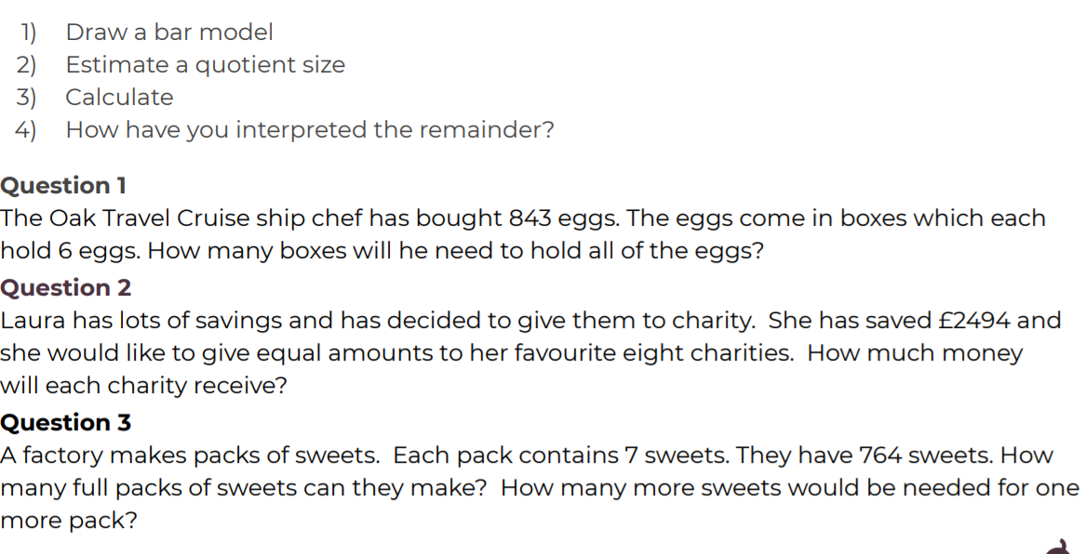
English | Today we continue our book, The Ultimate Guide to Unicorns and Flying Horses by Pie Corbett.  Here is the link:  https://www.talk4writing.com/wp-content/uploads/2021/01/The-Ultimate-Guide-to-Unicorns-Flying-Horses-2.pdf  For our final session, please complete pages 15 and 16, Activity 12: Create a unicorn passport. Then page 17, Activity 13: Draw your chosen species of unicorn or flying horse and label it.  These are the pages below, remember to click on the link for the larger versions.  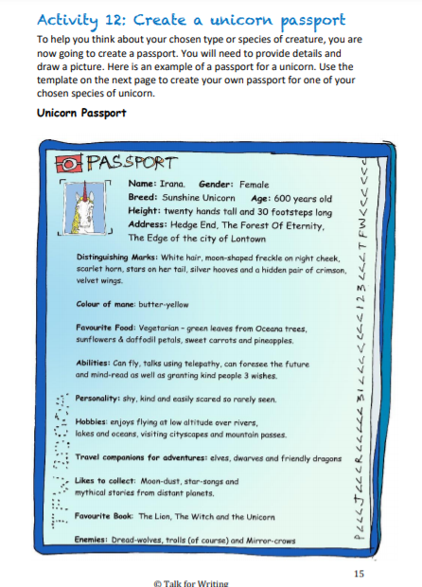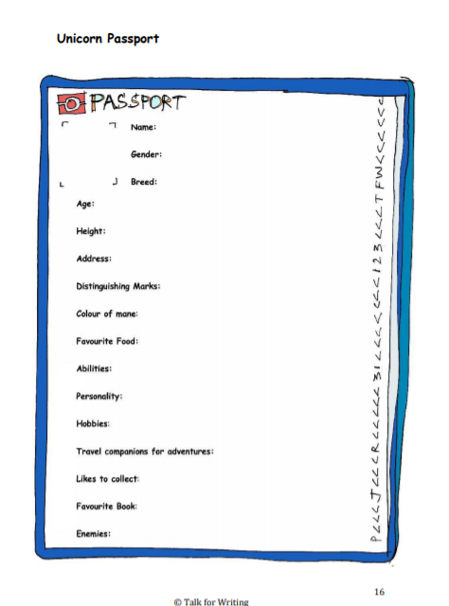  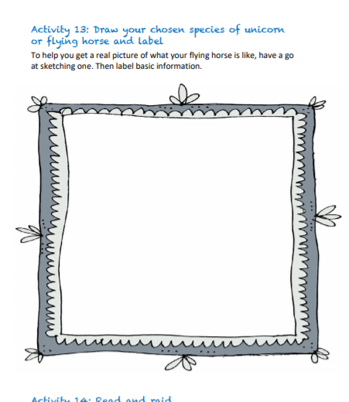
I.C.T | Today, we are going back to scratch programming.  Follow this link:  https://projects.raspberrypi.org/en/codeclub  Click on Scratch module 3.  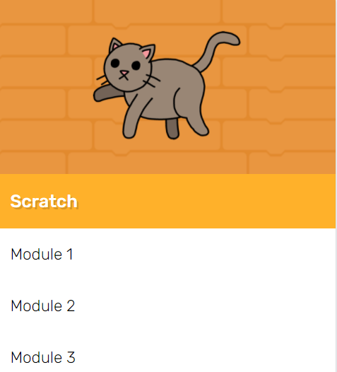  Have a go at the Memory section.  LO: Can I create a game to guide the cats?  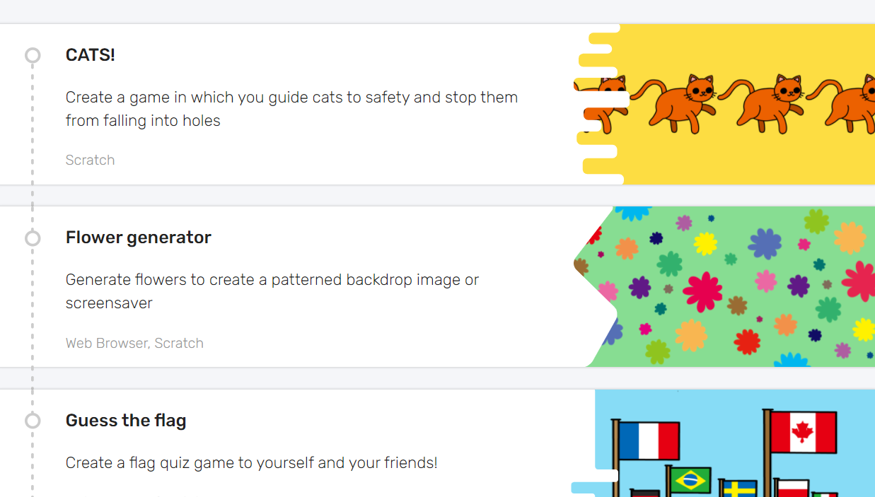  I have enjoyed seeing the clips I have been sent, so feel free to send yours.
Afternoon lessons:  Art | In this session we will build on our work about the artist Jasper Johns, from last week.  In this lesson we are going to be adding lettering and text to our experiments.  Watch the lesson below and have a go:  https://classroom.thenational.academy/lessons/jasper-johns-part-2-ccw3cc  I’d love to see your finished paintings, via the Oak email.
Thanks Oak, I’ll hear from you via the class email.
Remember Miss Wharton has her laptop on all day during the week, like when we are at school, so you can send your work or a message when you like (I can share these with Mrs Wylie), We love hearing from you.
See you all on Monday!

Please ensure that you email completed work to oak@lyng.norfolk.sch.uk so I can provide feedback on certain pieces to ensure progression.

