Morning  Challenge | 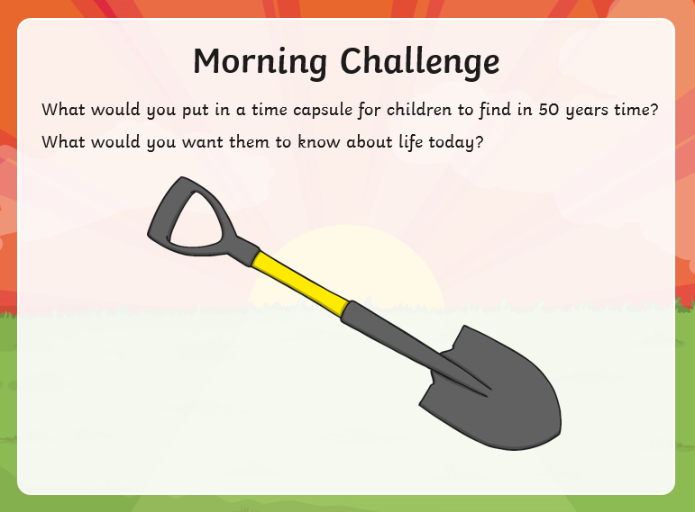
Maths | Morning Year 5, today in this lesson, we will learn how to use the column method in order to solve subtraction equations. We will also learn how to represent equations using bar modelling.  LO: Can I understand how bar modelling can be used in subtraction problems?  Here is the link:  https://classroom.thenational.academy/lessons/subtracting-using-the-column-method-6xj32d  The worksheets are below, remember to watch the lesson first, then take the quiz to check your understanding.  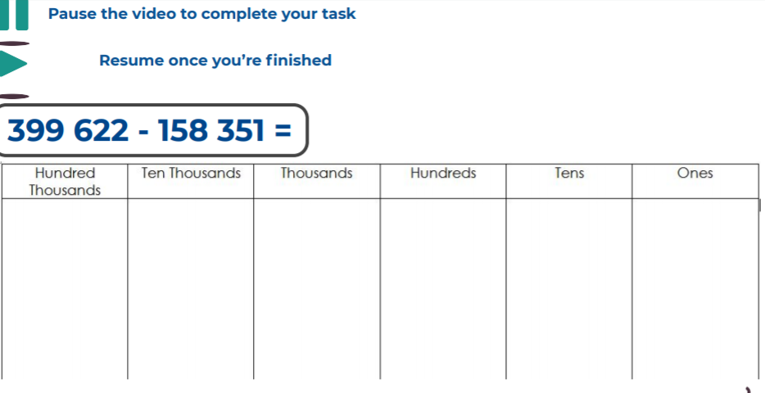  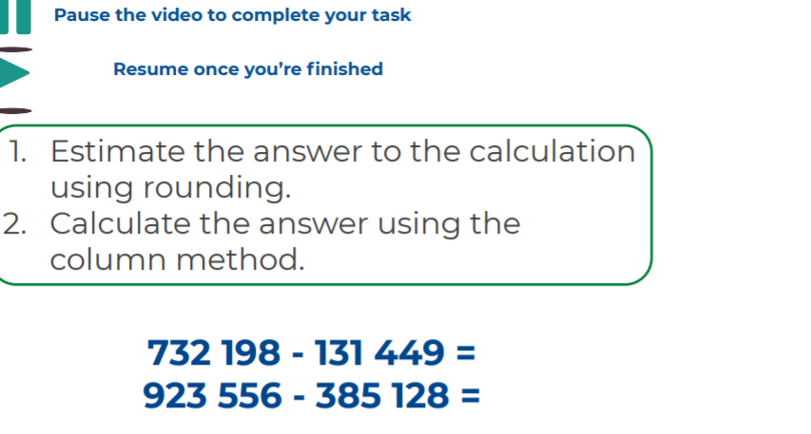  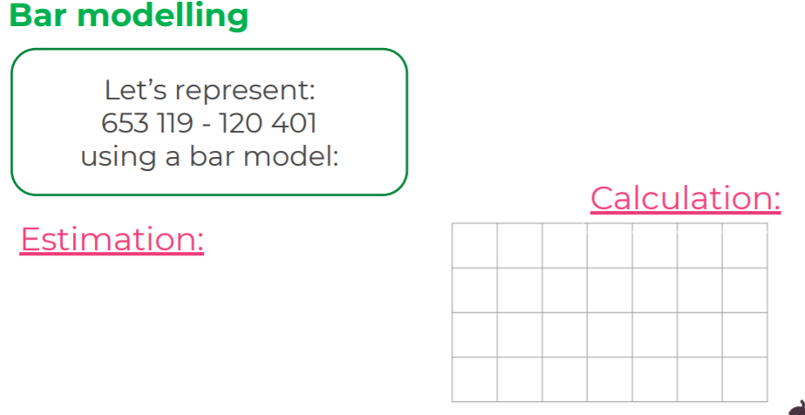  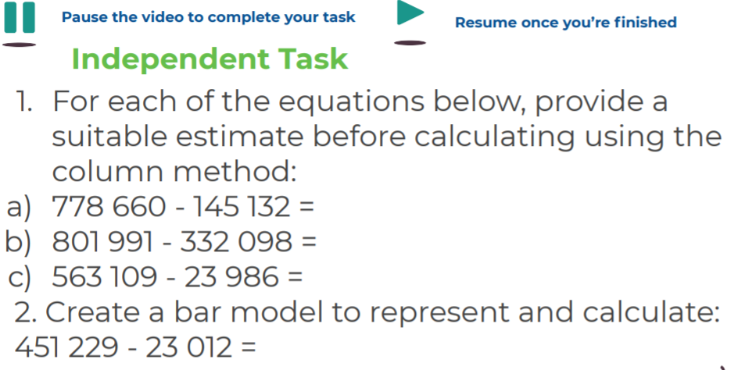
Guided Reading | Please complete the guided reading below:  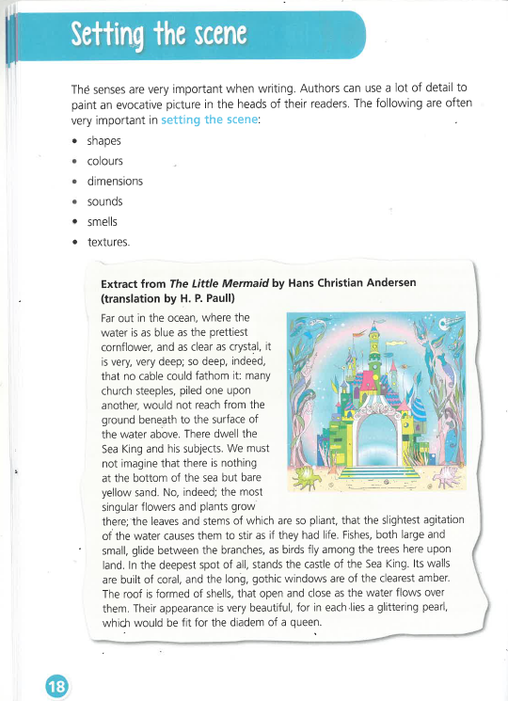  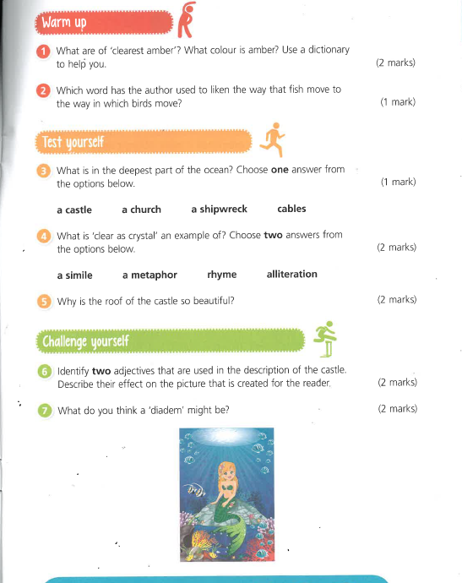
P.E. | I’m sure you are all getting out and about for your daily exercise, if you need other ideas, you could complete a Joe Wicks work out (you tube) or a Cosmic yoga one (you tube).  You can now access real PE at home where families can view the sessions under real PE at home/Supporting docs.
Afternoon lessons:  Topic | In this lesson, we are going to revise the differences in the life cycles of amphibians and insects.  When we return to school, we will move on by learning about the human life cycle. For this lesson, we will revise what life cycles are as well as focusing on metamorphosis.  LO: Can I understand how the lifecycle of an insect compares to an amphibian?  Here is the link:  https://classroom.thenational.academy/lessons/how-does-the-lifecycle-of-an-insect-compare-to-an-amphibian-cmrked  Here are the worksheets from the session, remember to watch the video first.  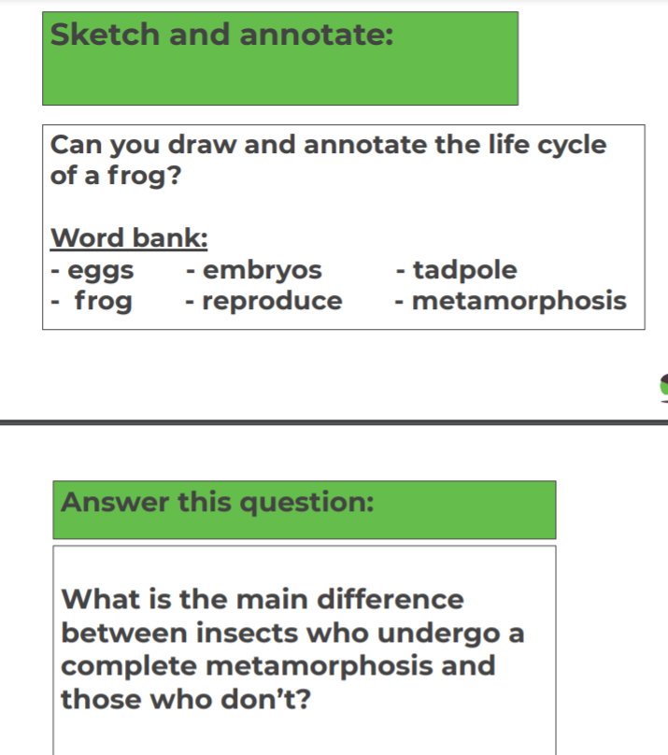  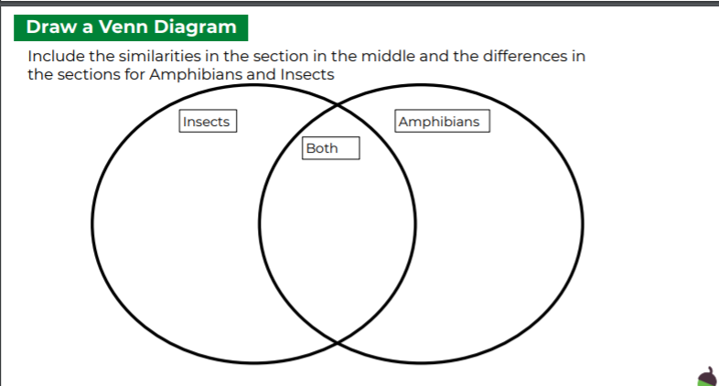  You can find the answers on the slides in the link.  See how you do in the final quiz.
Thanks Oak, I’ll hear from you via the class email.
Remember Miss Wharton has her laptop on all day during the week, like when we are at school, so you can send your work or a message when you like (I can share these with Mrs Wylie), We love hearing from you.

Please ensure that you email completed work to oak@lyng.norfolk.sch.uk so I can provide feedback on certain pieces to ensure progression.

