Today is World Book Day 2021.
I have included an art job at the end, if you’d like to have a go.
We will have a ‘late’ World book day’ when we return to class next week.

Morning  Challenge | 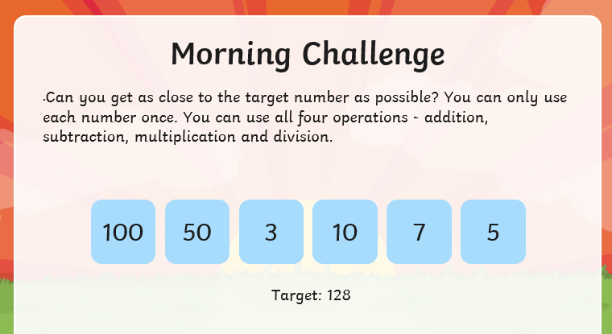
Maths | Morning Year 5, today in this lesson, we will learn how to apply our understanding of the column method to find and fix errors and completing unfinished column method calculations.  LO: Can I solve Problem solving using the column method?  Here is the link:  https://classroom.thenational.academy/lessons/problem-solving-using-the-column-method-c8up6c  The worksheets are below, remember to watch the lesson first, then take the quiz to check your understanding.  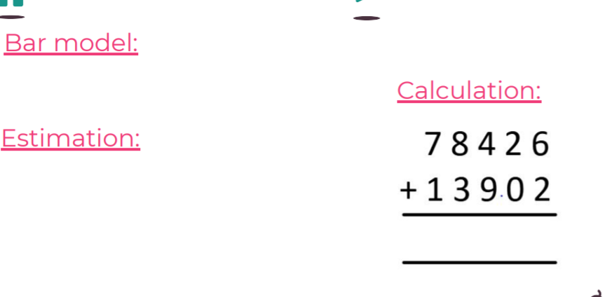  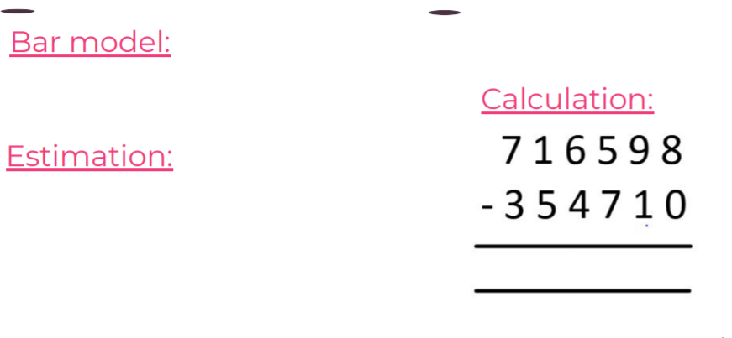  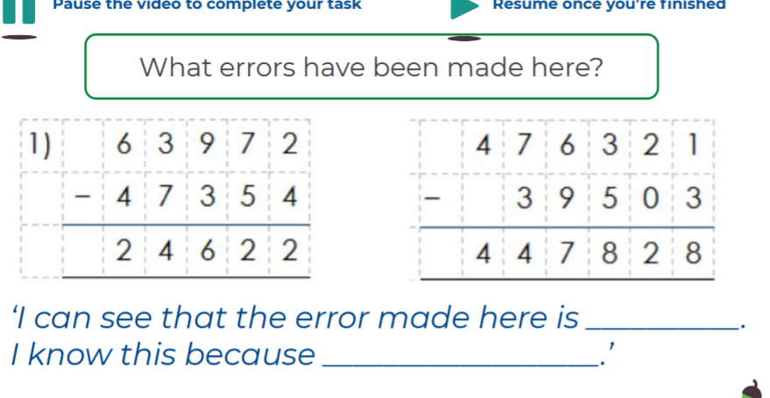  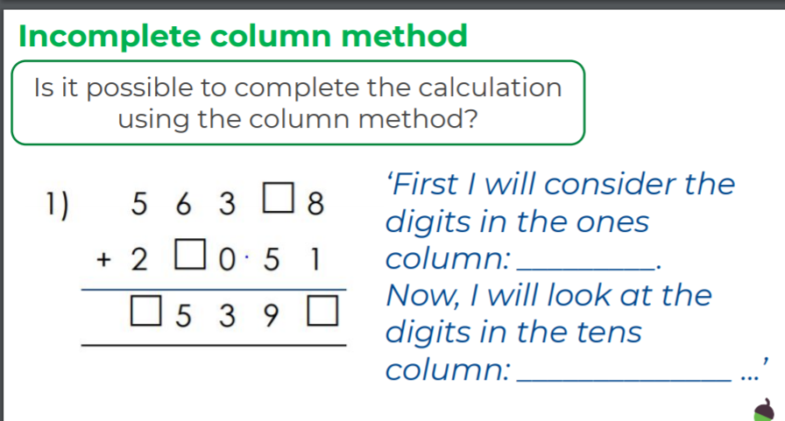  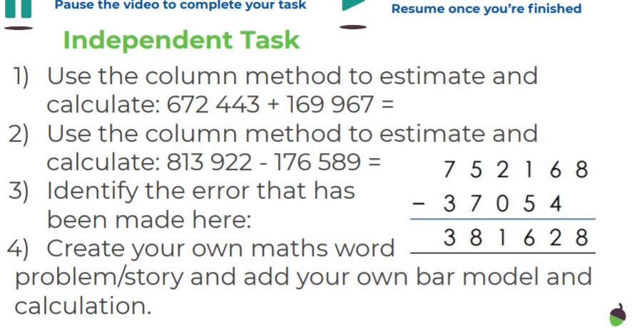
English | We are continuing our new book, Beware of Dragons by Pie Corbett.  Here is the link to the book:  https://www.talk4writing.com/wp-content/uploads/2021/02/5-Dragons.pdf  Today, please complete page 8, Activity 4: draw and label- Have you seen this dragon?  Then please read (read not complete) page 9, Activity 5: Write a newspaper report, ready for Friday’s lesson.  Here are the pages we are working from. Remember to click on the link for the larger versions.  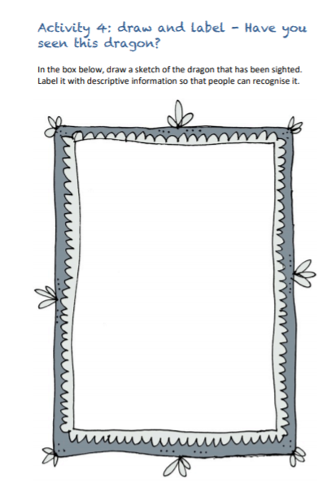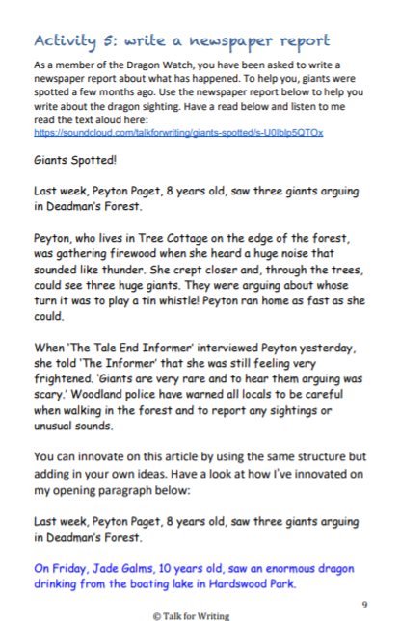
PSHCE | This week we are thinking about returning to school on Monday.  Following on from our class catch-ups on Monday, please complete the sheet below:  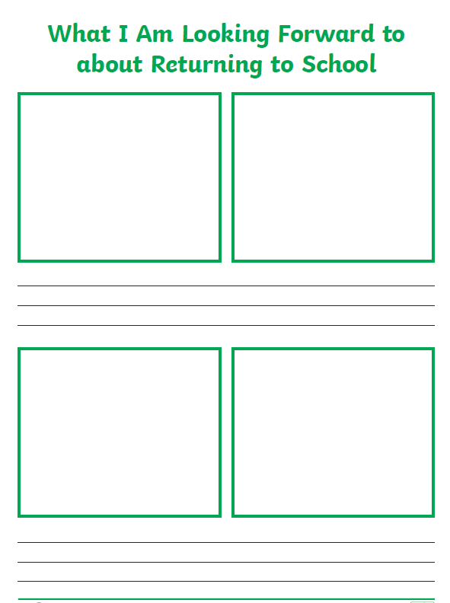
Afternoon lessons:  Science | This week, in science, we will continue to learn about the lives and work of some famous scientists.  Today we are going to learn about Rachel Carson.  In this lesson, we will learn about Rachel Carson's role in inspiring the creation of the US Environmental Agency. We will look at how she used the 'power of the pen' to bring attention to key environmental issues and have a go at using our own pens to write about an important environmental cause!  LO: Can I use my pen, for good, like Rachel Carson?  Here is the link to the session:  https://classroom.thenational.academy/lessons/who-is-rachel-carson-crup6e  Here are the worksheets, remember to watch the video first:  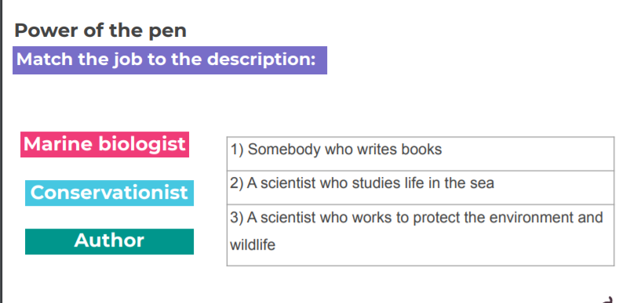  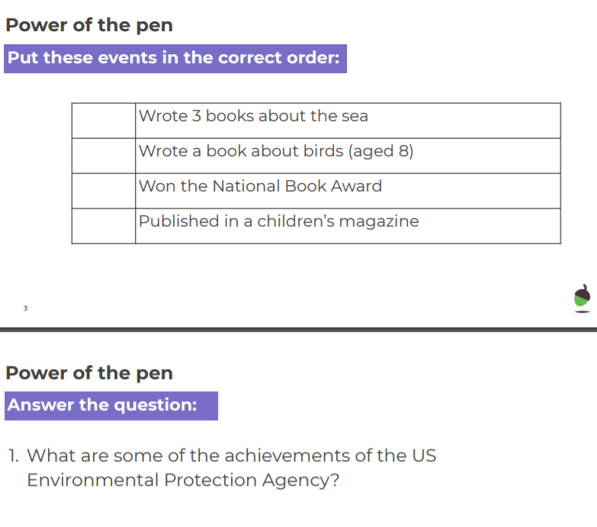  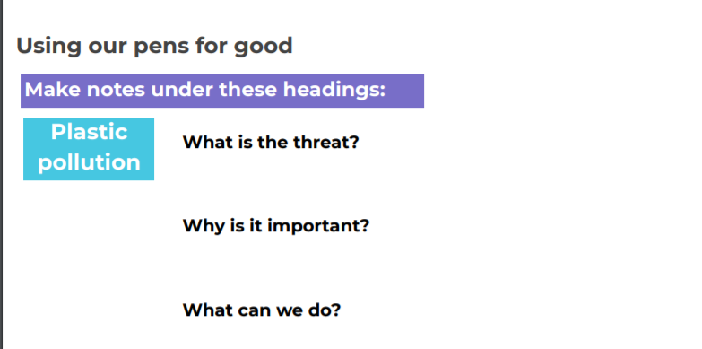  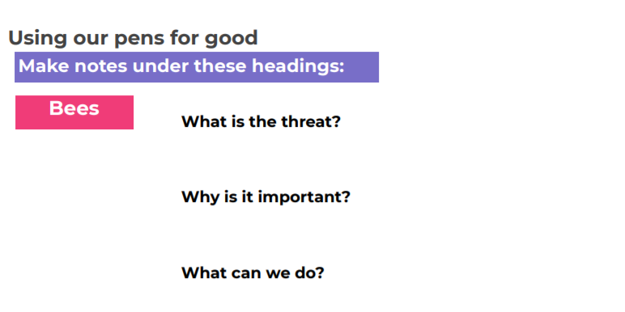  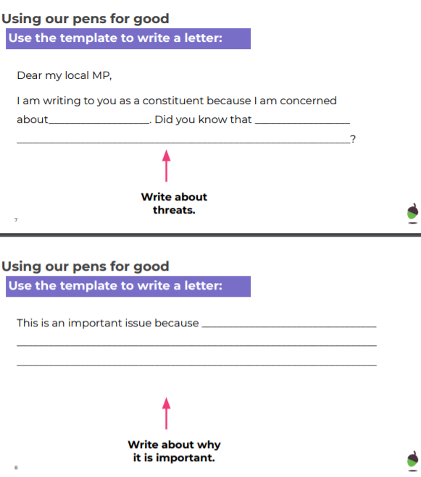  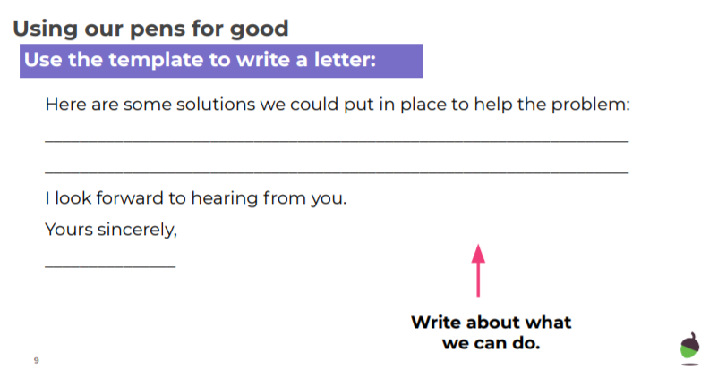I look forward to seeing your letters.
Thanks Oak, I’ll hear from you via the class email.
Remember Miss Wharton has her laptop on all day during the week, like when we are at school, so you can send your work or a message when you like (I can share these with Mrs Wylie), We love hearing from you.
 | 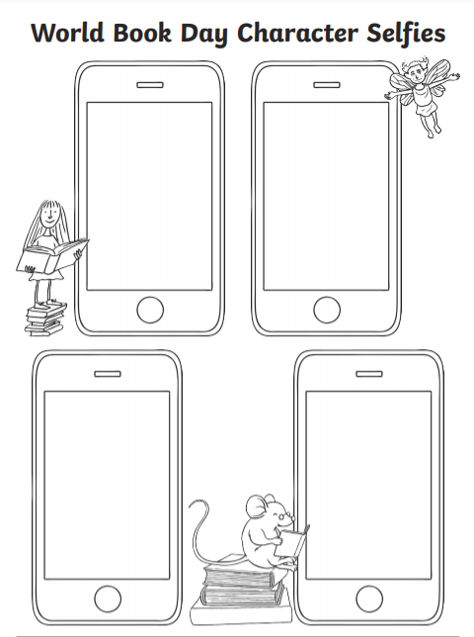

Please ensure that you email completed work to oak@lyng.norfolk.sch.uk so I can provide feedback on certain pieces to ensure progression.

