Morning  Challenge | 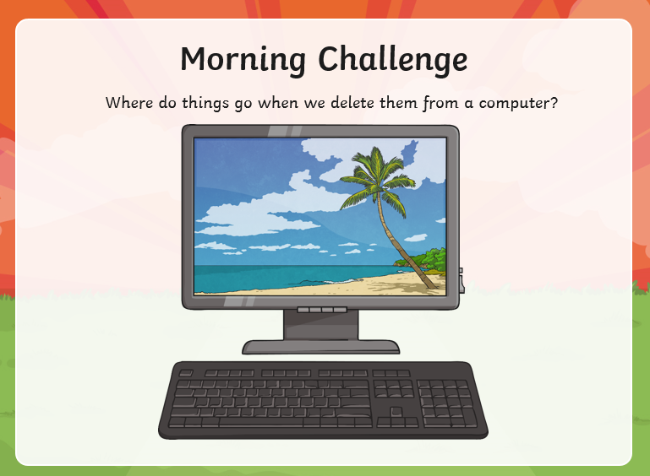
Maths | Morning Year 5, today in this lesson, we will be applying the addition and subtraction strategies that we have learned to word and real-life problems.  LO: Can I solve multi-step addition and subtraction problems?  Here is the link:  https://classroom.thenational.academy/lessons/solving-multi-step-addition-and-subtraction-problems-ctk66d  The worksheets are below, remember to watch the lesson first, then take the quiz to check your understanding.  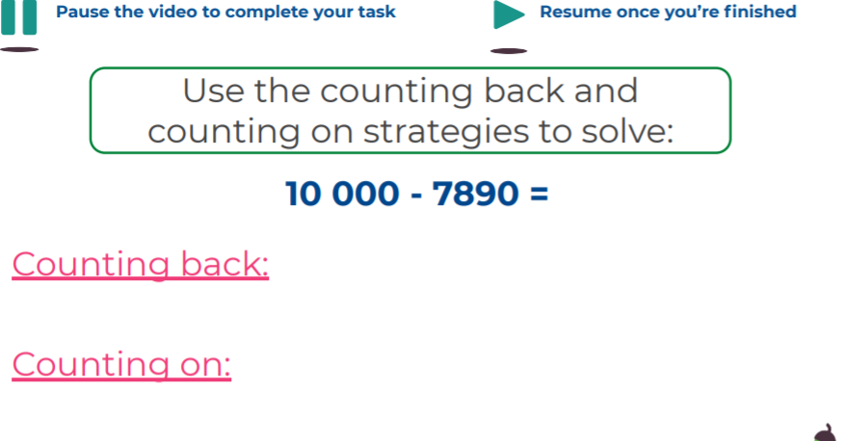  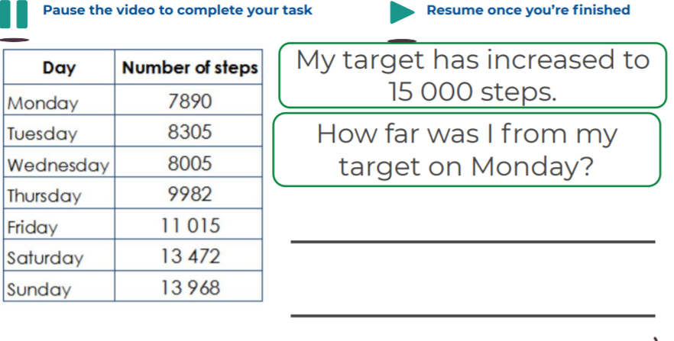  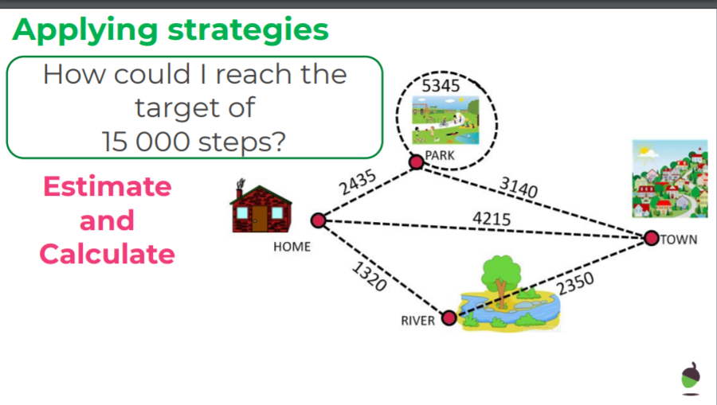  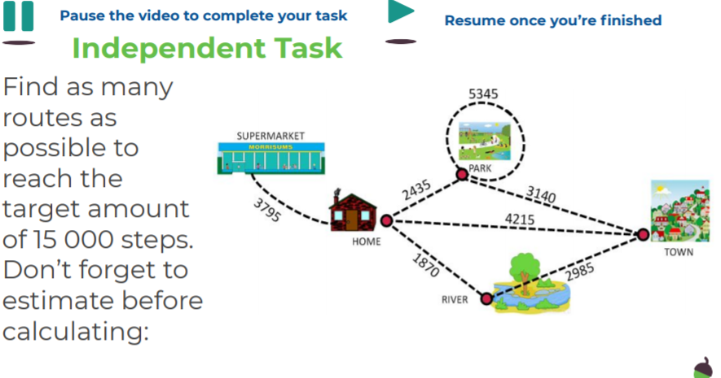
English | We are continuing our book, Beware of Dragons by Pie Corbett.  Here is the link to the book:  https://www.talk4writing.com/wp-content/uploads/2021/02/5-Dragons.pdf  Today, please read page 10, Activity 6: Hiring a dragon Hunter.  Then read page 11. Next, Complete the table on page 12: Planning your advert.  Here are the pages we are working from. Remember to click on the link for the larger versions.  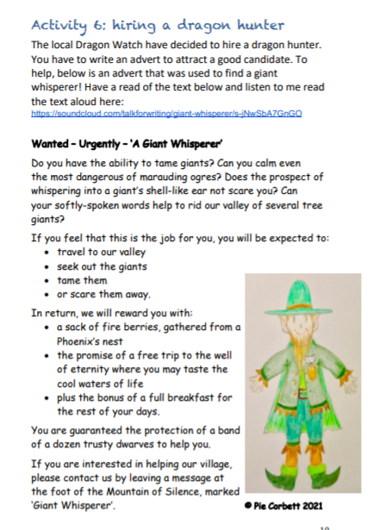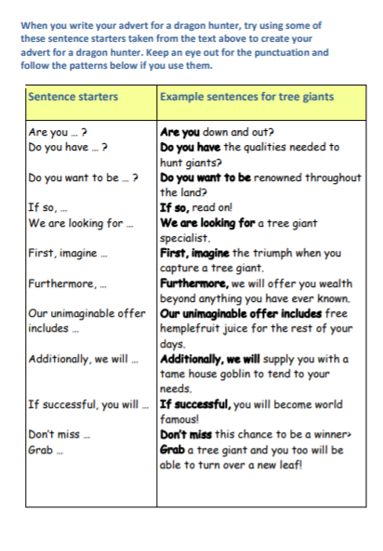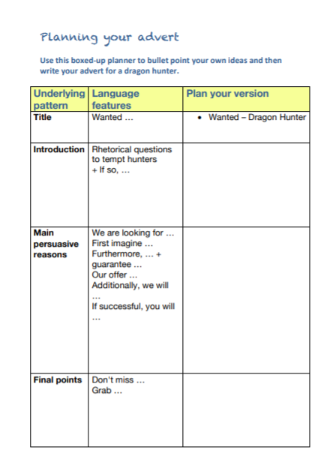
I.C.T | Today, we are going back to scratch programming.  Follow this link:  https://projects.raspberrypi.org/en/codeclub  Click on Scratch module 3.  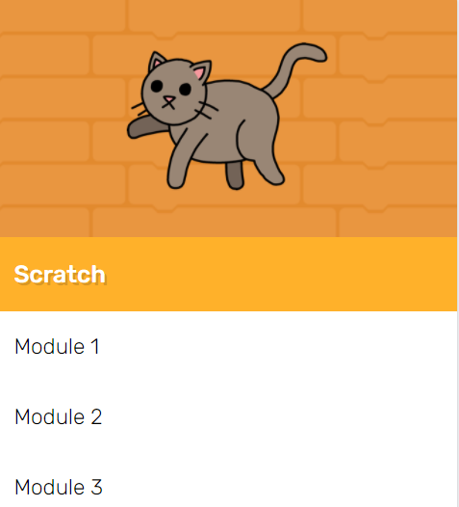  Have a go at the Memory section.  LO: Can I create a game to guide the cats?  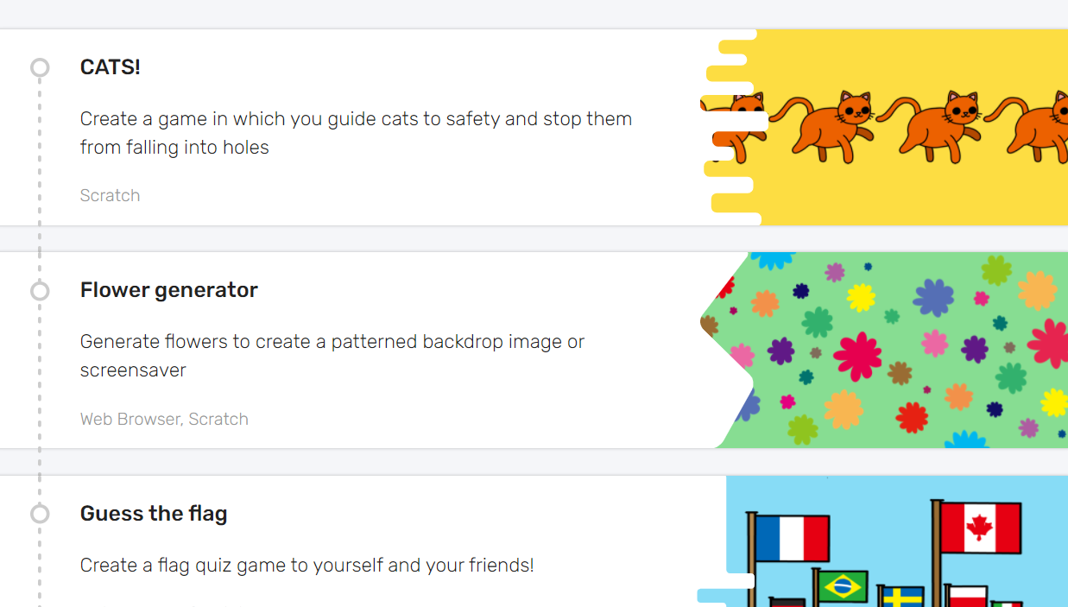  I have enjoyed seeing the clips I have been sent, so feel free to send yours.
Afternoon lessons:  Art | In this session we will build on our work about the artist Jasper Johns, from last week.  In this lesson we are going to be adding lettering and text to our experiments.  Watch the lesson below and have a go:  https://classroom.thenational.academy/lessons/jasper-johns-part-2-ccw3cc  I’d love to see your finished paintings, via the Oak email.
Thanks Oak, I’ll hear from you via the class email.
Remember Miss Wharton has her laptop on all day during the week, like when we are at school, so you can send your work or a message when you like (I can share these with Mrs Wylie), We love hearing from you.
See you all on Monday!

Please ensure that you email completed work to oak@lyng.norfolk.sch.uk so I can provide feedback on certain pieces to ensure progression.

