Wednesday 3rd March 2021 YEAR 2
Enjoy doing the activities listed.
The order to do them in is suggested below but you can change them to suit you. Please send me any work, photos or comments via Tapestry. Thank you.
MORNING  Let’s get started challenge | Get moving and do maths at the same time!  https://www.bbc.co.uk/teach/supermovers/ks1-maths-money/zht4nrd
Maths  Learning objective:  Can I count in groups of 2p, 5p and 10p coins?  Can I record amounts using a multiplication sum? | This week we are learning about MONEY.  So far you have learnt to recognise the coins and notes which we use.  Today you will be practising counting in groups of 2p, 5p and 10p.  Remember this is the same as multiplication  Introduction  - Get out your real coins again. Sort them into groups of 2p, 5p and 10 coin coins.  - First get out one 2p coin. How much is it worth?  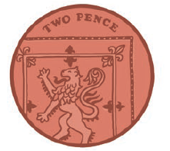  Remember it is one coin but it is worth 2p.  - Now get out another 2p coin.  How much now? Count in twos to help you. 2, 4. So the answer is 4p  This can also be written as 2 x 2p = 4p  Remember it is two coins but it is worth 4p.  - Now get out another 2p coin.  How much now? Count in twos to help you. 2, 4, 6 . So the answer is 6p  This can also be written as 3 x 2p = 6p  Remember it is three coins but it is worth 6p.  - Keep adding two pence coins one at a time until you have 12 and count in twos.  - Continue this written multiplication pattern:  1 x 2p = 2p  2 x 2p = 4p  3 x 2p = 6p  4 x 2p =8p  - Now get out your five pence coins.  - Get out one five pence coin.  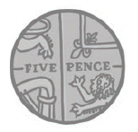  How much is it worth? It is worth 5p.  Remember it is one coin but it is worth 5p this time.  - Now get out another 5p coin.  How much now? Count in fives to help you. 5, 10. So the answer is 10p  This can also be written as 2 x 5p = 10p  Remember it is two coins but it is worth 10p.  - Now get out another 5p coin. You should now have 3x5p  How much now? Count in fives to help you. 5, 10, 15. So the answer is 15p  This can also be written as 3 x 5p = 15p  Remember it is three coins but it is worth 15p.  - Keep adding five pence coins one at a time until you have 12 and count in fives.  - Continue this written multiplication pattern:  1 x 5p = 5p  2 x 5p = 10p  3 x 5p = 15p  4 x 5p =20p  - Now get out your ten pence coins.  - Get out one ten pence coin.  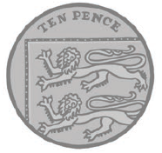  How much is it worth? It is worth 10p.  Remember it is one coin but it is worth 10p this time.  - Now get out another 10p coin.  How much now? Count in tens to help you. 10 20 . So the answer is 20p.  This can also be written as 2 x 10p = 20p  Remember it is two coins but it is worth 20p.  - Now get out another 10p coin.  How much now? Count in tens to help you. 10 20 30 . So the answer is 30p  This can also be written as 3 x 10p = 30p  Remember it is three coins but it is worth 30p.  - Keep adding ten pence coins one at a time until you have 12 lots and count in tens.  - Continue this written multiplication pattern:  1 x 10p = 10p  2 x 10p = 20p  3 x 10p = 30p  4 x 10p =40p  Activities  - Now can you complete the sheets below?
English  Learning objective:  Can I join a word to its meaning? | Introduction  - Yesterday you looked at new words and found out that you could use a dictionary to find out the meanings of words you don’t know. You also learnt how to put words in alphabetical order.  - Today you will continue to look at words and their meanings. Turn to page 11 of your pack.  - Can you see that powerful means strong and confident?  Activity:  - Work through the rest of the words on page 11 joining up each word to its meaning.  - Now put the words into sentences –page 12
Handwriting/ spellings, grammar, punctuation or phonics  Learning objective.  Can I put a possessive apostrophe in the correct place in the sentence? | Introduction:  - On Monday you started learning about POSSESSIVE APOSTOPHES.  - Possessive apostrophes are used to show belonging.  The cat’s tail was bushy.  - By putting the apostrophe it shows that the tail belonged to the cat.  - Where do you think the apostrophe will go in this sentence?  The dogs ears picked up when he heard the noise.  Were you right?  The dog’s ears picked up when he heard the noise.  Activities –  Try putting the apostrophe in the sentences below.
 | Lunchtime!
AFTERNOON  Reading | It is World Book Day on March 4th.  The World Book Day website has some great resources.  https://www.worldbookday.com/2020/09/world-book-day-2021-announcements/  Listen to a story every day this week:  https://www.worldbookday.com/share-a-story-corner/
PE | “For PE this week, login to Real PE using the login that has been sent to you.  Login, and then click on EYFS/Key Stage 1  Now, click on the picture of the monkey to go into the jungle! This week you will be practicing your seated balance skill.  First- click on the compass picture to go on a jungle adventure! This will be your warm up. Keep going with this as long as you want to, as you did last week.  Next- Click on the dice picture. You are going to play 2 different games today.  Game 1- Throw the Fruit  Game 2 – Monkey Tricks  Lastly today, I want you to practice your ‘skills’. Click the skills button (the picture of a person with 2 hands up throwing a ball)  You will start off on the yellow challenge. There is a video for support to show children what they need to do if they don’t understand from the description. Move onto the green challenge if they are able to do the yellow challenge!  Enjoy!”
Story/ yoga/ mindfulness activity | Do something that makes you happy. It might be playing with some toys, going for a walk, drawing, doing a dance or singing. If you would like to sing join in with ‘If you’re happy and you know it’.  https://www.youtube.com/watch?v=71hqRT9U0wg
Additional notes for parents. | Well done! Only 2 more days to go!

Maths : Can I work out the value by counting in groups of 1p, 2p, 5p and 10p?
Level 1 challenge

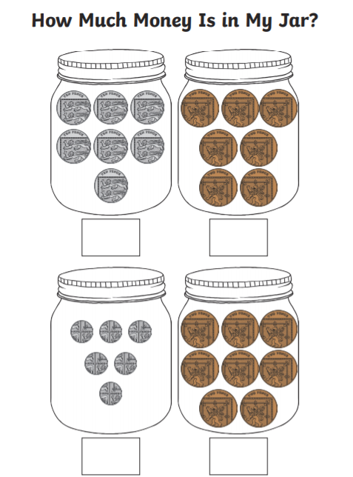

Level 2 challenge
Can I record the amounts in each jar by writing a multiplication sum?
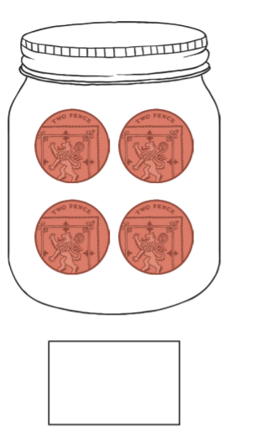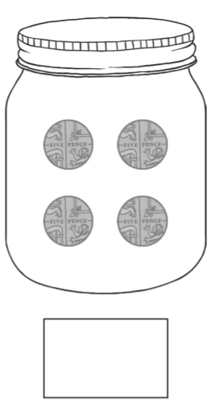

4 x 2p = 8p

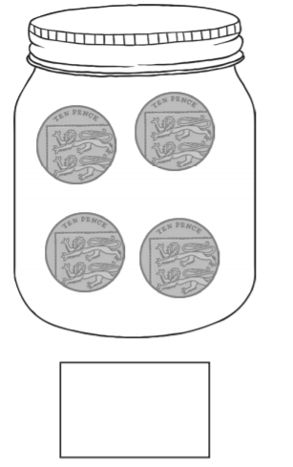
If 3 x 5p = 15p
What would 3 x 50p equal? ………………

If 4 x 2p = 8p
What would 4 x 20p equal? ………………

Punctuation
Can I put a possessive apostrophe in the correct place in the sentence?

Sams glove was lost.

The cars headlight was broken.

Mrs. Tebbutts pencil snapped.

