Wednesday 3rd March 2021 YEAR 1
Enjoy doing the activities listed.
The order to do them in is suggested below but you can change them to suit you. Please send me any work, photos or comments via Tapestry. Thank you.
MORNING  Let’s get started challenge | Get moving and do maths at the same time!  https://www.bbc.co.uk/teach/supermovers/ks1-maths-money/zht4nrd
Maths  Learning objective:  Can I count in groups of 2 p coins?  Can I count in groups of 10p coins?  Can I count in groups of 5p coins?  Can I work out the value by counting in groups of 2p, 5p and 10p? | This week we are learning about MONEY.  So far you have learnt to recognise the coins to £1 and found out the value of each coin in 1ps.  Today you will be practising counting in groups of 2p, 5p and 10p.  Introduction  - Get out your real coins again. Sort them into groups of 2p, 5p and 10 coin coins.  - First get out one 2p coin. How much is it worth?  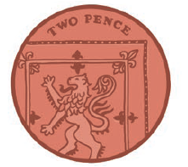  Remember it is one coin but it is worth 2p.  - Now get out another 2p coin. You should now have 2x2p  How much now? Count in twos to help you. 2, 4. So the answer is 4p  Remember it is two coins but it is worth 4p.  - Now get out another 2p coin. You should now have 3x2p  How much now? Count in twos to help you. 2, 4, 6 . So the answer is 6p  Remember it is three coins but it is worth 6p.  - Keep adding two pence coins one at a time until you have 10 and count in twos.  - Now get out your five pence coins.  - Get out one five pence coin.  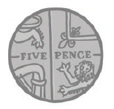  How much is it worth? It is worth 5p.  Remember it is one coin but it is worth 5p this time.  - Now get out another 5p coin. You should now have 2x5p  How much now? Count in fives to help you. 5, 10 . So the answer is 10p  Remember it is two coins but it is worth 10p.  - Now get out another 5p coin. You should now have 3x5p  How much now? Count in fives to help you. 5, 10, 15 . So the answer is 15p  Remember it is three coins but it is worth 15p.  - Keep adding five pence coins one at a time until you have 10 and count in fives.  - Now get out your ten pence coins.  - Get out one ten pence coin.  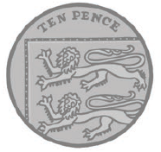  How much is it worth? It is worth 10p.  Remember it is one coin but it is worth 10p this time.  - Now get out another 10p coin. You should now have 2x10p  How much now? Count in tens to help you. 10 20 . So the answer is 20p.  Remember it is two coins but it is worth 20p.  - Now get out another 10p coin. You should now have 3x10p  How much now? Count in tens to help you. 10 20 30. So the answer is 30p  Remember it is three coins but it is worth 30p.  - Keep adding ten pence coins one at a time until you have 10 lots and count in tens.  Activities  - Now can you complete the sheets below?
English  Learning objective:  Can I write a ‘Thank you’ letter? | Introduction  - Often it is good to write a ‘Thank You’ letter.  - On page 13 of the pack the monkeys have written a letter saying thank you to Bertha, Curtis and Gertie.  - Read it with an adult. Think about how it links to the story.  - Now imagine the swarm of bees or the mice had written a Thank You letter. What do you think it would say?  Remember think it, say it,  - Next write it.  - Finally check it.  Activity:  Write a thank you letter from the bees or the mice. Look at page 13 to help you.  There are some lines below to use if you would like to.
Handwriting/ spellings or phonics  Learning objective:  Can I use the ir sound to read and spell? | Introduction:  - This week you have recapped the er sound  - It can also be made by ir  - Read these words  birthday thirsty first  Activities –  - Watch Mr Thorne does phonics – ir sound to recap  https://www.youtube.com/watch?v=c_09njG46O0  - Find the ir sounds on the letter below
 | Lunchtime!
AFTERNOON  Reading | It is World Book Day on March 4th.  The World Book Day website has some great resources.  https://www.worldbookday.com/2020/09/world-book-day-2021-announcements/  Listen to a story every day this week:  https://www.worldbookday.com/share-a-story-corner/
PE | “For PE this week, login to Real PE using the login that has been sent to you.  Login, and then click on EYFS/Key Stage 1  Now, click on the picture of the monkey to go into the jungle! This week you will be practicing your seated balance skill.  First- click on the compass picture to go on a jungle adventure! This will be your warm up. Keep going with this as long as you want to, as you did last week.  Next- Click on the dice picture. You are going to play 2 different games today.  Game 1- Throw the Fruit  Game 2 – Monkey Tricks  Lastly today, I want you to practice your ‘skills’. Click the skills button (the picture of a person with 2 hands up throwing a ball)  You will start off on the yellow challenge. There is a video for support to show children what they need to do if they don’t understand from the description. Move onto the green challenge if they are able to do the yellow challenge!  Enjoy!”
Story/ yoga/ mindfulness activity | Do something that makes you happy. It might be playing with some toys, going for a walk, drawing, doing a dance or singing. If you would like to sing join in with ‘If you’re happy and you know it’.  https://www.youtube.com/watch?v=71hqRT9U0wg
Additional notes for parents. | Well done! Only 2 days to go!
Maths : Can I work out the value by counting in groups of 2p, 5p and 10p?
Level 1 challenge

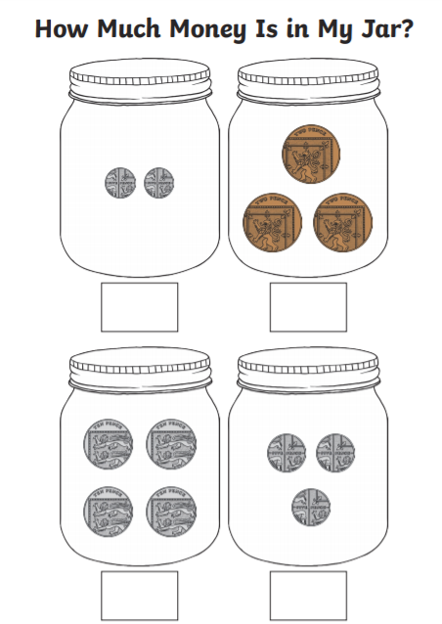
Level 2 challenge

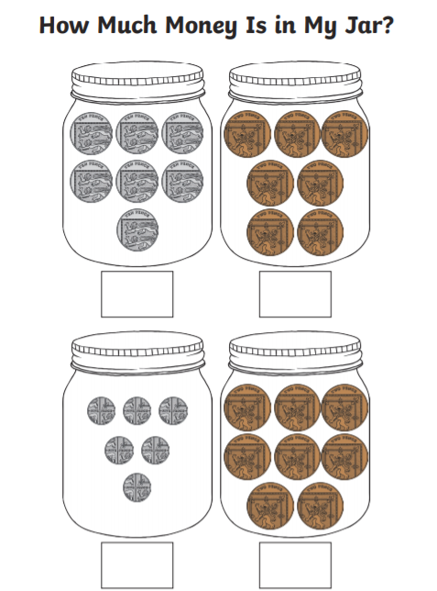

English
Can I write a ‘Thank You’ letter from the bees or the mice to Bertha, Curtis and Gertie?

Dear Bertha, Curtis and Gertie

______________________________________________

_______________________________________________

_______________________________________________

______________________________________________

_______________________________________________

_______________________________________________

Love from …………………………………………………………………………………………………

Phonics

