Tuesday 2nd March 2021 YEAR 2
Enjoy doing the activities listed.
The order to do them in is suggested below but you can change them to suit you. Please send me any work, photos or comments via Tapestry. Thank you.
MORNING  Let’s get started challenge | 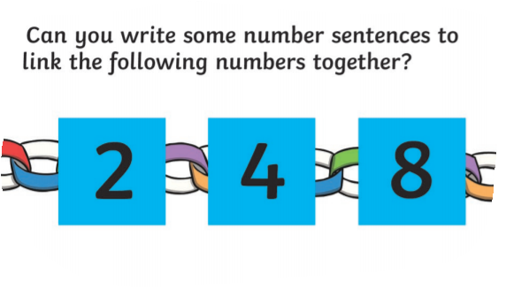  See below for enlarged versions
Music | Introduction:  - Join in with music service sessions  https://www.norfolkmusichub.org.uk/site/ugly-bug-ball-resources/  Or https://www.bbc.co.uk/teach/school-radio/music-ks1-lakshmi-and-the-clever-washerwoman-1/zf29cqt
English  Learning objective:  Can I arrange words in alphabetical order? | Introduction  - There were a lot of new words in the story.  - Look at these and check you understand what they each mean.  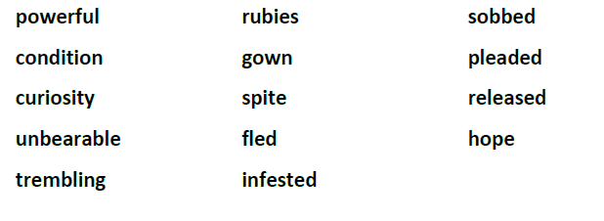  - If you are not sure you could look them up in a dictionary.  - A dictionary has words arranged in alphabetical order.  - To arrange words in alphabetical order first look at the initial letter.  zoo cart apple  put any beginning with A first, then work through the other letters in order  apple cart zoo  - If 2 words begin with the same letter look at the second or even third letters.  clock cart zoo apple  so  apple cart clock zoo  Activity:  Now put the words on page 10 of your pack in alphabetical order.
Handwriting/ spellings or phonics  Learning objective:  Can I learn the tricky words pass, class, grass? | Introduction:  - This term you will learn some new words.  - First go through the tricky words from last week:  wild child children  - Today we will be concentrating on  pass grass class  - Last week you learnt how to use one word as a base for other words.  - Look at how the spelling changes in this pattern  pass  class  grass  - practise using the ways you have been taught e.g. saying aloud, writing over and over again, building as a pyramid, making up a funny sentence, words within words or using word patterns.  Activity  - Learn the words  pass class grass  - Write a sentence for each word.
 | Lunchtime!
AFTERNOON  Reading | It is World Book Day on March 4th.  The World Book Day website has some great resources.  https://www.worldbookday.com/2020/09/world-book-day-2021-announcements/  Listen to a story every day this week:  https://www.worldbookday.com/share-a-story-corner/.
Topic  Learning objective:  Can I read facts about the sense of smell?  Can I remember at least 3 facts?  Can I use my sense of smell to create a perfume?  Computing  Learning objective:  Can I follow the rules of the cyber snake's game, can you recognise the Do’s and Don'ts on keeping safe when using online games? | Introduction:  - Clue 8 is an old perfume bottle.  - It is helping us to think more about our sense of SMELL  - We smell with our noses.  - Here are some facts about our noses and sense of smell.  Activities.  - Read the facts on the sheet below.  - Make your own perfume using things you can find outside.  Collect leaves, flowers, herbs etc. and mix with water.  Does it smell nice?  Maybe you could make a label for your bottle.  Computing.  Introduction:  This game will help you understand the Do’s and Don’ts of online safety, think about how to use the internet responsibly and which information to keep private.  Activity:  Play the Cyber snakes! Game it’s a bit like snakes and ladders. You will need a dice and counters (if you don’t have these there is sheet for you to make them yourself) Take it turns with a grown up to roll the dice, move your counter to the right space and see what you land on. Ask a grown up to help you read the Do’s and Don’ts around the board. Climb the ladder if you land on a Do ✅ and slither down the snake if you land on a Don’t❌.  Get it wrong and you may end up back right at the beginning!!!  Talk about the Do’s and Don’ts with a grown up as you move around the board.  Have fun!  You can always have a go at the SMART Rules Quiz if you want a challenge https://www.childnet.com/young-people/primary/smart-rules-quiz
Story/ yoga/ mindfulness activity | Go outside and listen to the birds. Take a minute to be still.
Additional notes for parents.

Let’s get started challenge

Topic
Can I read facts about the sense of smell? Can I remember at least 3 facts?
Smelling
Smelling is one of our 5 senses.
Did you know that humans have the ability to tell the difference between approximately 10,000 smells?
Your sense of smell helps you to also taste and enjoy things.

How do we smell?
Things have a smell because they give off particles called molecules. Sniff something and these travel up your nose to tiny hairs called cilia.
When they reach the top of your nose they dissolve in mucus (often called snot).
They then travel to the smell receptors. The receptors then send a message to your brain which either recognizes the smell or remembers if as something new.
Humans can smell many different types of smells, some are pleasant and some aren’t! They help us to sense danger, such as something burning.
Dogs have an even better sense of smell and can smell things we can’t.

Interesting fact!
A nose can make 1 litre of mucus a day!

Computing

