Tuesday 2nd March 2021 YEAR 1
Enjoy doing the activities listed.
The order to do them in is suggested below but you can change them to suit you. Please send me any work, photos or comments via Tapestry. Thank you.
MORNING  Let’s get started challenge | 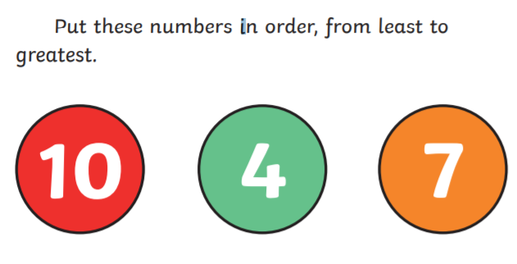  See below for enlarged versions
Music | Introduction:  - Join in with music service sessions  https://www.norfolkmusichub.org.uk/site/ugly-bug-ball-resources/  Or https://www.bbc.co.uk/teach/school-radio/music-ks1-lakshmi-and-the-clever-washerwoman-1/zf29cqt
English  Learning objective:  Can I design my own picnic rug? | Yesterday you learnt the song ’Teddy bear’s Picnic’ and thought about what you would take on a picnic.  Introduction  - To go on a picnic you will need a rug.  - What would your rug look like? Use the ideas on page 12 of your pack to help you.  Activity:  Draw or make a picnic rug. You can be a creative and imaginative as you like.
Handwriting/ spellings or phonics  Learning objective:  Can I learn the tricky words put and push? | Introduction:  - Last week you learnt some new words pull full  Can you remember them? If you found them tricky start by practising them again.  - Today we will be learning put push  - Look at the word put  - What makes it tricky? Try and learn the word put  - Now look at push. Can you see how the u letter makes the same sound as in put?  - practise using the ways you have been taught e.g. saying aloud, writing over and over again, building as a pyramid, making up a funny sentence, words within words.  Activity  Write 2 sentences, one sentence using the word put and one sentence using the word push.
 | Lunchtime!
AFTERNOON  Reading | It is World Book Day on March 4th.  The World Book Day website has some great resources.  https://www.worldbookday.com/2020/09/world-book-day-2021-announcements/  Listen to a story every day this week:  https://www.worldbookday.com/share-a-story-corner/
Topic  Learning objective:  Can I read facts about the sense of smell?  Can I remember at least 3 facts?  Can I use my sense of smell to create a perfume?  Computing  Can I follow the rules of the cyber snake's game, can you recognise the Do’s and Don'ts on keeping safe when using online games? | Introduction:  - Clue 8 is an old perfume bottle.  - It is helping us to think more about our sense of SMELL  - We smell with our noses.  - Here are some facts about our noses and sense of smell.  Activities.  - Read the facts on the sheet below.  - Make your own perfume using things you can find outside.  Collect leaves, flowers, herbs etc. and mix with water.  Does it smell nice?  Maybe you could make a label for your bottle.  Computing.  Introduction:  This game will help you understand the Do’s and Don’ts of online safety, think about how to use the internet responsibly and which information to keep private.  Activity:  Play the Cyber snakes Game, it’s a bit like snakes and ladders. You will need a dice and counters (if you don’t have these there is sheet for you to make them yourself) Take it turns with a grown up to roll the dice, move your counter to the right space and see what you land on. Ask a grown up to help you read the Do’s and Don’ts around the board. Climb the ladder if you land on a Do ✅ and slither down the snake if you land on a Don’t❌.  Get it wrong and you may end up back right at the beginning!!!  Talk about the Do’s and Don’ts with a grown up as you move around the board.  Have fun!  Read the story of Digiduck’s Big Decision from Childnet and find out how to be a good friend online https://www.childnet.com/resources/digiduck-stories/digiducks-big-decision.
Story/ yoga/ mindfulness activity | Go outside and listen to the birds. Take a minute to be still.
Additional notes for parents.

Let’s get started challenge

Topic
Can I read facts about the sense of smell?
Can I remember at least 3 facts?
Smelling
Smelling is one of our 5 senses.
It is the special cells in a nose which helps us to smell. Noses have 2 nostrils. Inside each nostril are tiny hairs which trap the dust in the air.
Humans can smell many different types of smells, some are pleasant and some aren’t! They help us to sense danger, such as something burning.
Dogs have an even better sense of smell and can smell things we can’t.

Computing

