Morning  Challenge | 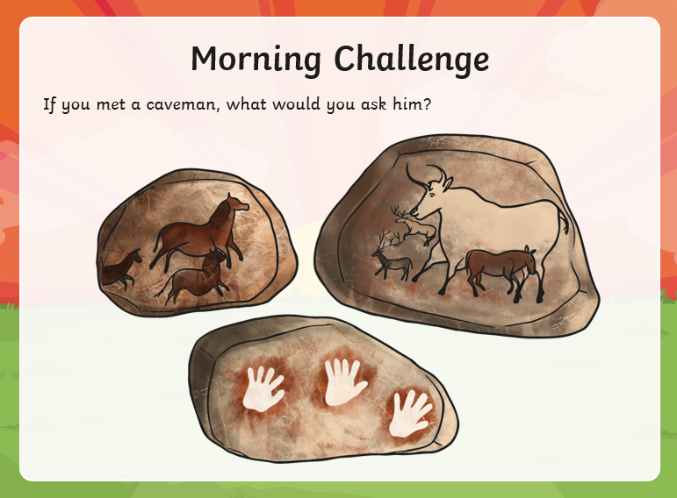
Maths | Morning Year 6, in this lesson by looking closely at the digits in 7-digit numbers we will gain an understanding of how they are composed and how they can be decomposed.  LO: Can I understand how the digits in a number indicate its structure?  Watch the session from Oak academy, linked below:  https://classroom.thenational.academy/lessons/understanding-how-the-digits-in-a-number-indicate-its-structure-71gp6e  The worksheets are below, remember to watch the lesson first.  Then take the quiz, to check your understanding.  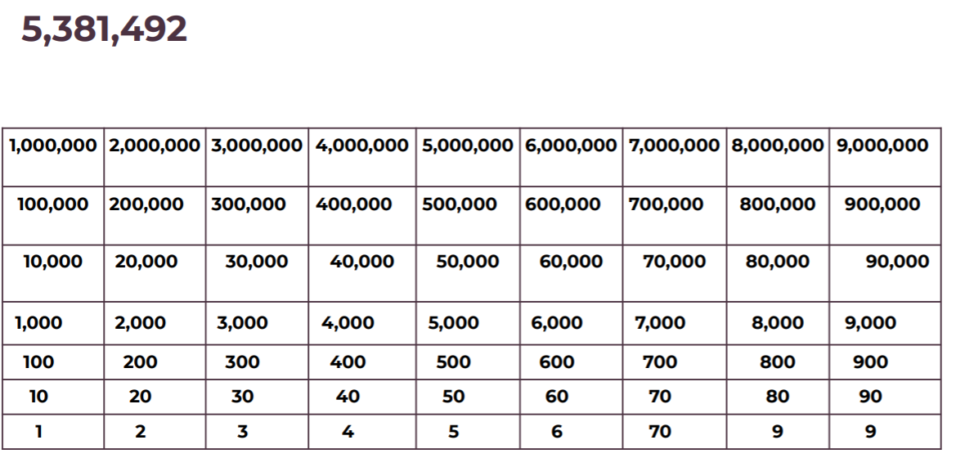  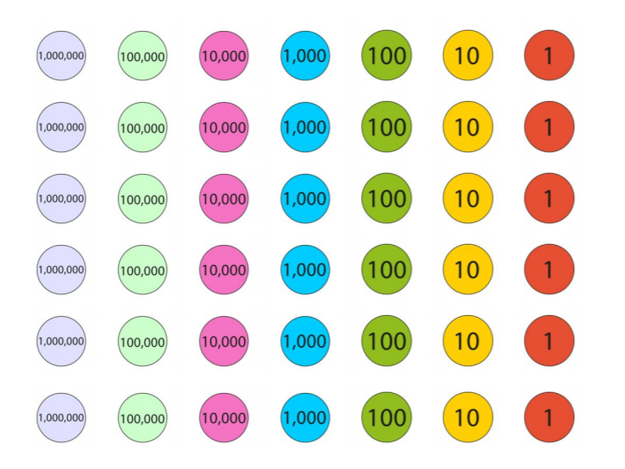
Guided Reading | Today is guided reading, please read the extract and answer the questions.  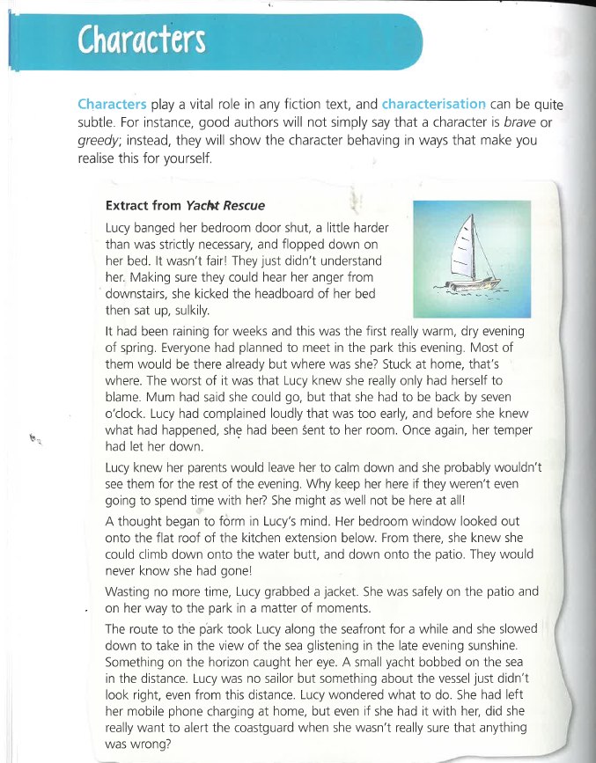  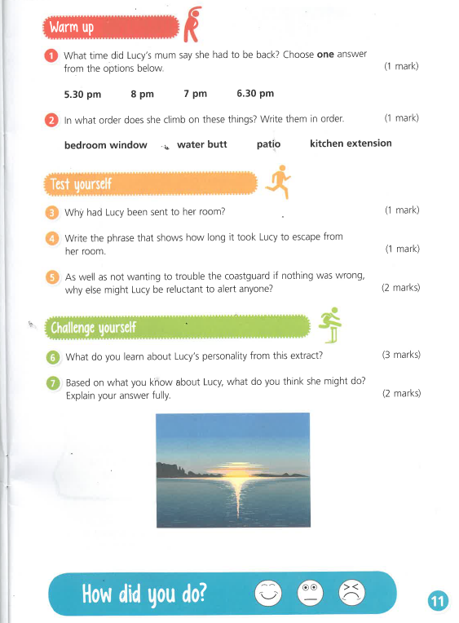
P.E. | I’m sure you are all getting out and about for your daily exercise, if you need other ideas, you could complete a Joe Wicks work out (you tube) or a Cosmic yoga one (you tube).  You can now access real PE at home where families can view the sessions under real PE at home/Supporting docs.  Mrs Rudd should have sent an email with login details.
Afternoon lessons:  Topic | In this lesson, we will revise the differences between humans and other animals. We will first recap about vertebrates and invertebrates, followed by the differences of animals who use lungs and gills to breathe. Then, we will briefly compare brains of animals. Finally, we will complete some application questions.  LO: Can I understand how human anatomy compares to other animals?  Here is the link:  https://classroom.thenational.academy/lessons/how-does-human-anatomy-compare-to-other-animals-6rvk4e  Here are the worksheets from the session, remember to watch the video first.  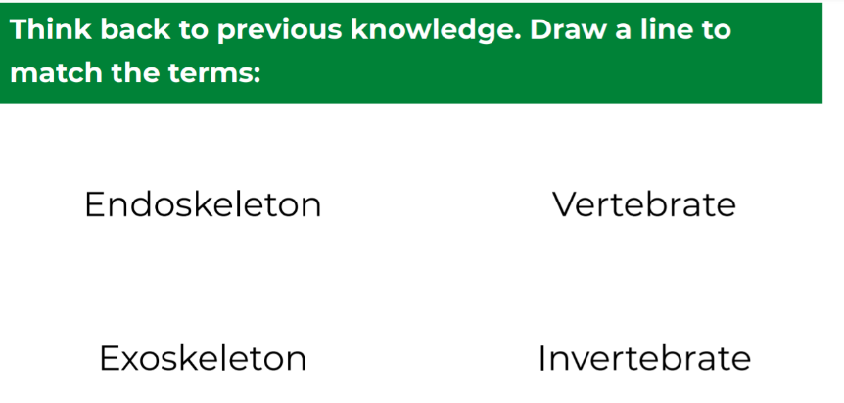  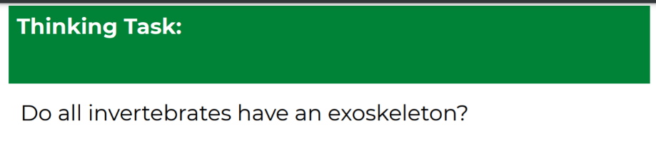  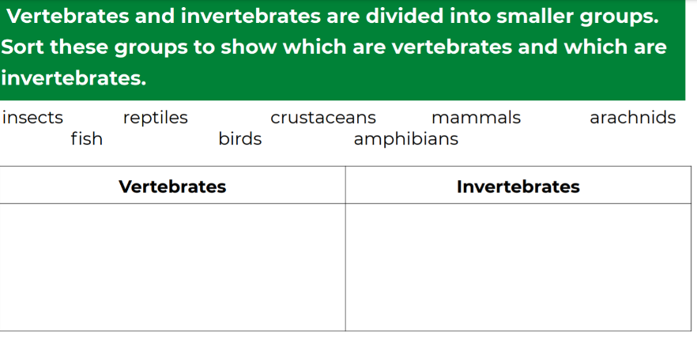  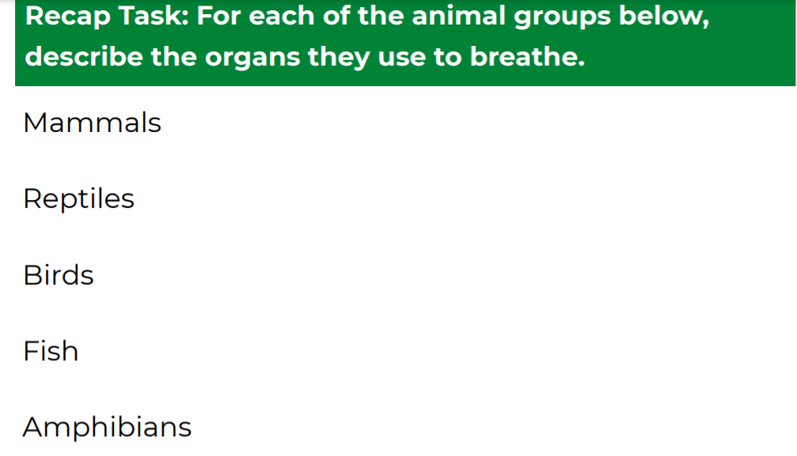  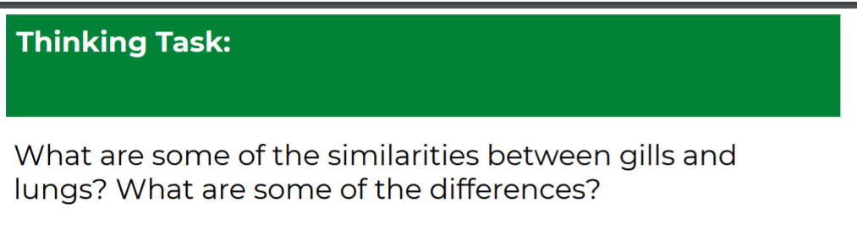  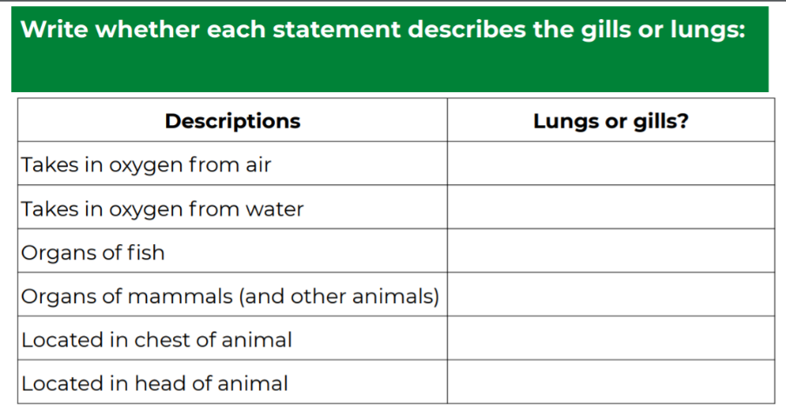  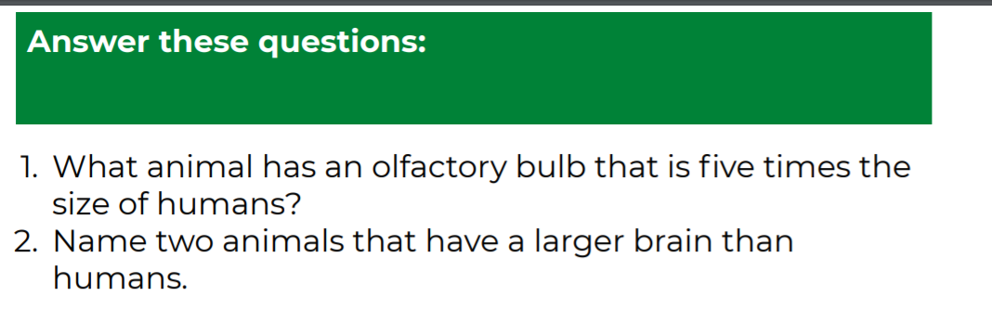  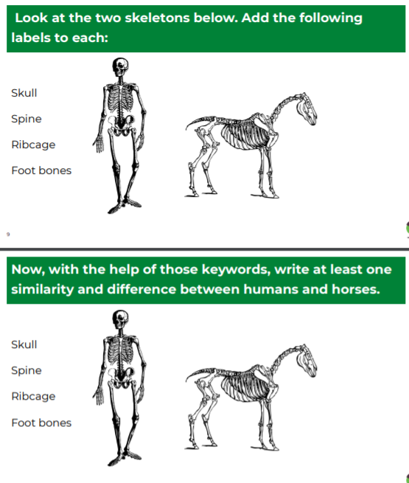  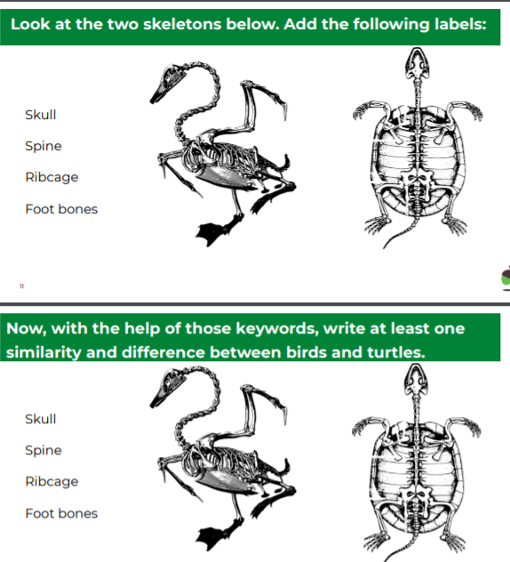  See how you do in the final quiz.
Thanks Oak, I’ll hear from you via the class email.
Remember Miss Wharton has her laptop on all day during the week, like when we are at school, so you can send your work or a message when you like (I can share these with Mrs Wylie), We love hearing from you.

Please ensure that you email completed work to oak@lyng.norfolk.sch.uk so I can provide feedback on certain pieces to ensure progression.

