Morning Challenge | 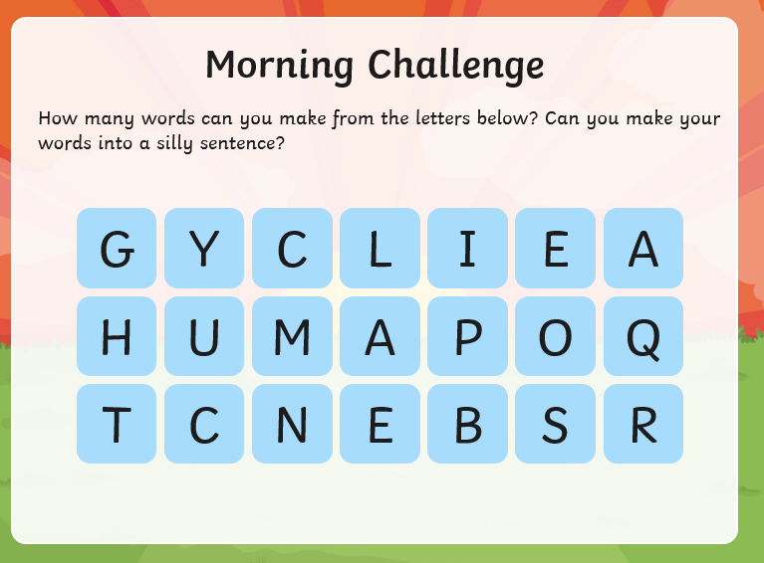
Maths | Morning Year 6, in this lesson we establish a relational understanding of the relative magnitude of one million. We will learn to read 7-digit numbers and practice writing them in words and numerals before applying their learning in a matching task.  LO: Can I read and write 7-digit numbers and understand them?  Watch the session from Oak academy, linked below:  https://classroom.thenational.academy/lessons/reading-and-writing-7-digit-numbers-6dk62c  The worksheets are below, remember to watch the lesson first.  Then take the quiz, to check your understanding.  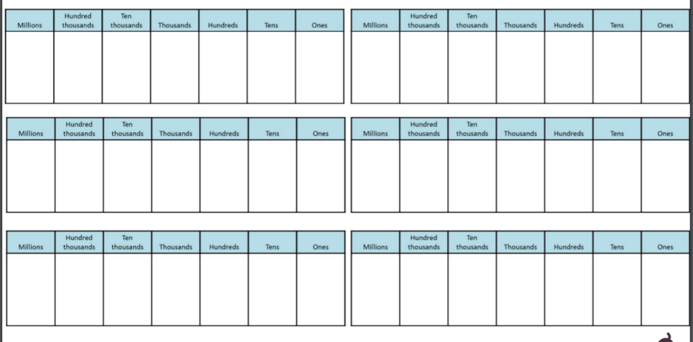  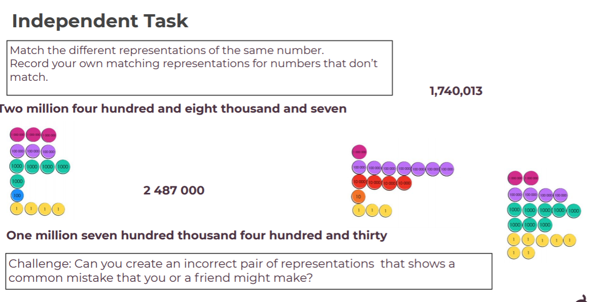
English | Today we continue our book, ‘The City of Silence’ by James Walker.  Here is the link:  https://www.talk4writing.com/wp-content/uploads/2020/04/Y6-James.pdf  Today, please complete page 18, Activity 14: Performing one of your pieces of work. If you would like to get someone to record you, then email them to me I would love to see them.  If you would like an extension today you could practise your neatest joined handwriting by copying the piece on page 19.  These are the pages below, remember to click on the link for the larger versions.  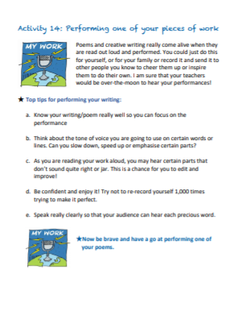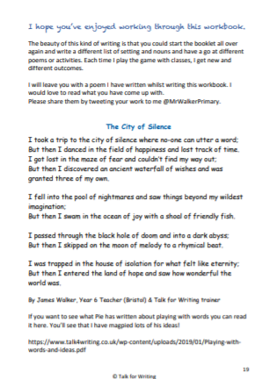
Spelling | In this lesson, we will recap the rules associated with adding the suffixes -le, -el, -al and -il and learn a spelling practice strategy. The 10 spelling words set in the previous lesson will be revisited and tested.  LO: Can I score 10/10 on the test?  Here is the link:  https://classroom.thenational.academy/lessons/to-investigate-suffixes-le-el-al-il-including-test-cct32c
Afternoon lessons:  French | 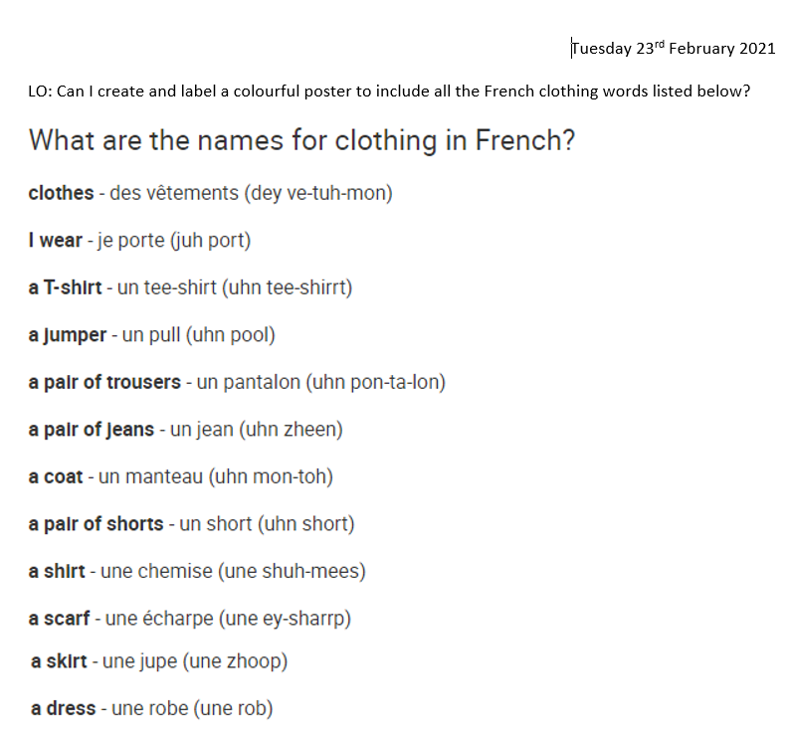  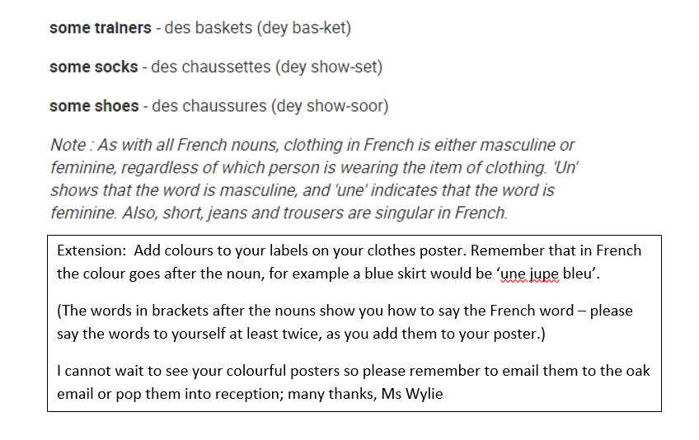
Music | For music Ms Burners has recommended we take a look at the BBC ten pieces site.  Click the link below:  https://www.bbc.co.uk/teach/ten-pieces/ten-pieces-musical-menu/zmypxbk  This week you will be exploring the Musical Menu Themes: Lyrics, rhyming, couplets, street art and home.  You have :’listen’, ‘learn’ then ‘do’ videos to look at.
Thanks Oak, I’ll hear from you via the class email.
Remember Miss Wharton has her laptop on all day during the week, like when we are at school, so you can send your work or a message when you like (I can share these with Mrs Wylie), We love hearing from you.

Please ensure that you email completed work to oak@lyng.norfolk.sch.uk so I can provide feedback on certain pieces to ensure progression.

