Morning  Challenge | 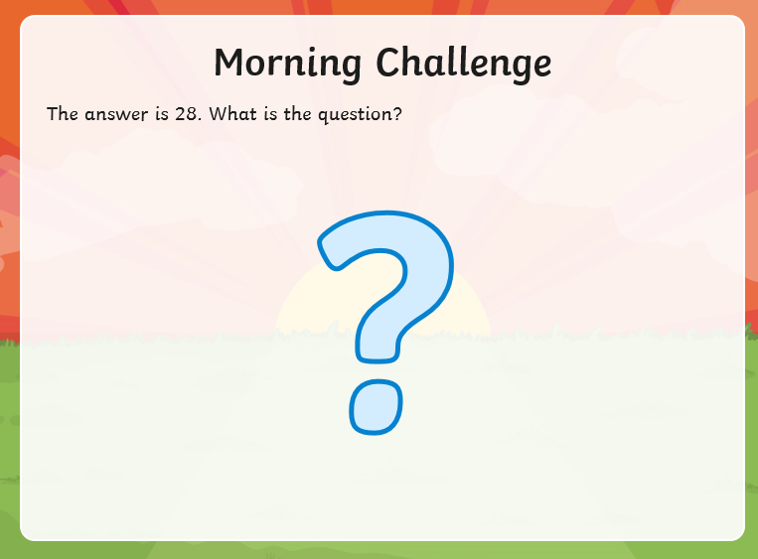  Can you come up with at least 10 questions?
Maths | Morning Year 6, the focus of this lesson is to build on your understanding of numbers to 10 million through comparing and ordering lists of numbers. Depth of understanding is demonstrated by moving fluently between different representations and by using them to justify comparison statements.  LO: Can I compare and order numbers to ten million?  Watch the session from Oak academy, linked below:  https://classroom.thenational.academy/lessons/compare-and-order-numbers-to-ten-million-c4w6ac  The worksheets are below, remember to watch the lesson first.  Then take the quiz, to check your understanding.  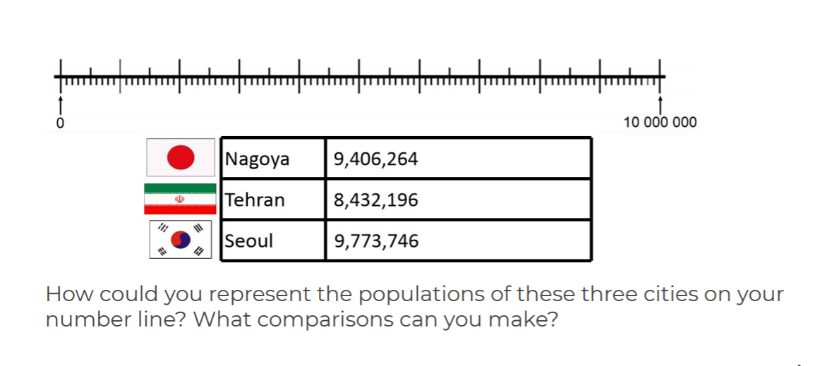  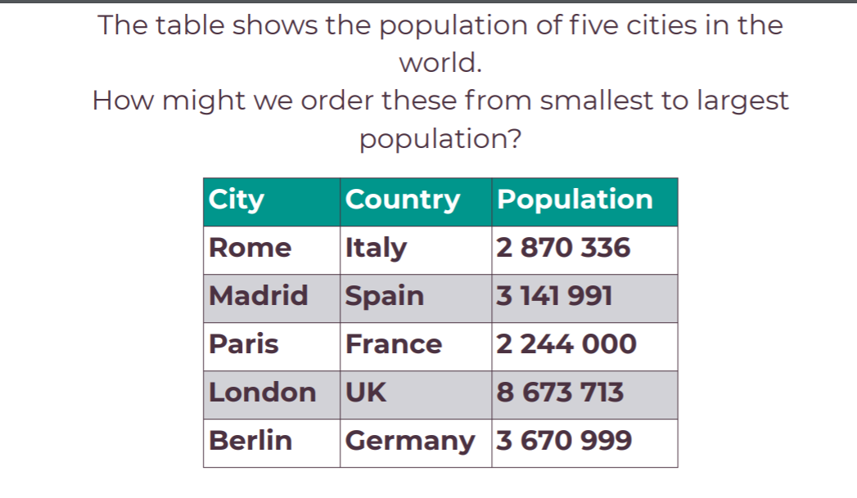
English | Today we start a new book,  Here is the link:  https://www.talk4writing.com/wp-content/uploads/2021/01/The-Ultimate-Guide-to-Unicorns-Flying-Horses-2.pdf  Please read pages 1, 2 and 3, then complete page 4: Activity 1: Match the words to the definitions.  If you would like an extension you could practice writing the definitions in your neatest, joined handwriting.  These are the pages below, remember to click on the link for the larger versions.  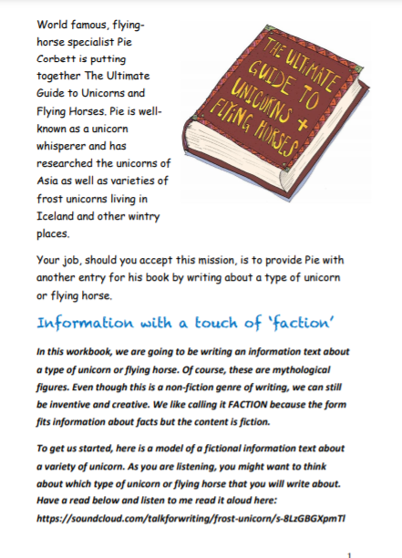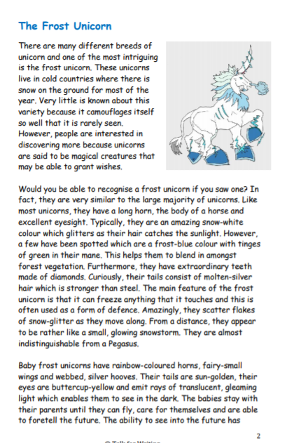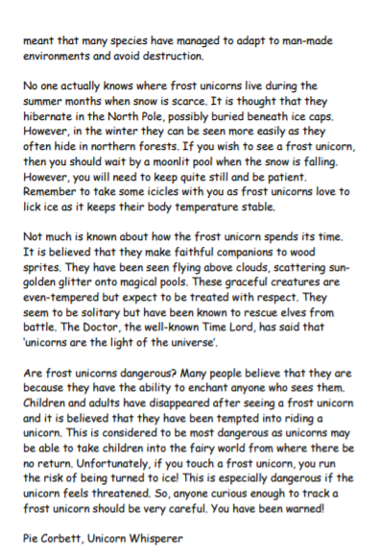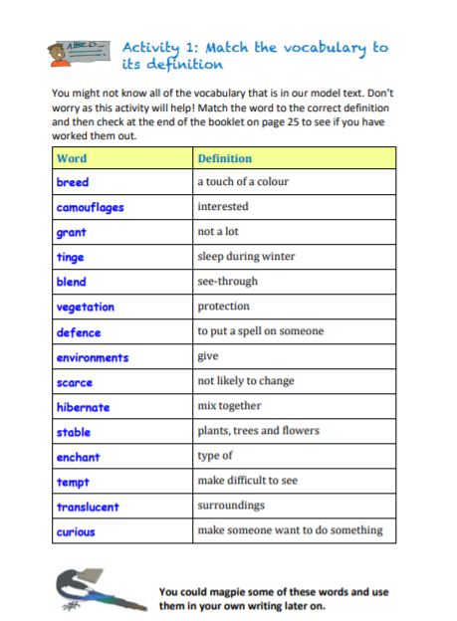
PSHCE | This week we are continuing to think about mindfulness.  Have a go at the challenge below:  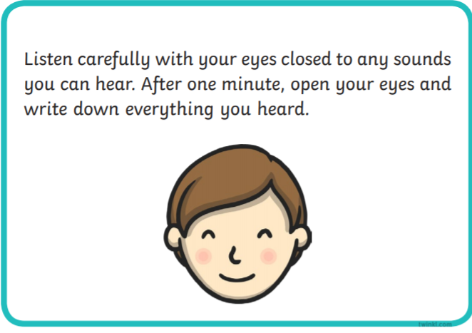  Then, complete the sheet below:  LO: Can I think of things I am grateful for, as I complete the sheet?  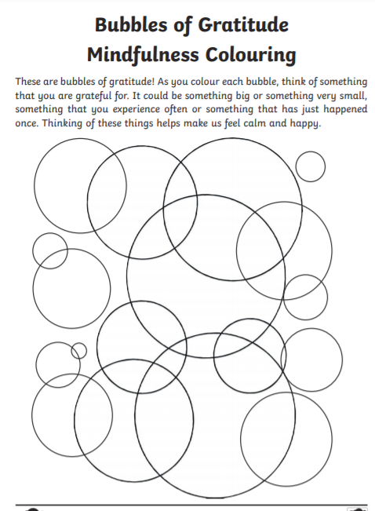
Afternoon lessons:  Science | This week, in science, we will continue to learn about the lives and work of some famous scientists.  Today we are going to learn about Stephen Hawking.  In this lesson, we will learn about why Stephen Hawking is one of the most well-known scientists of the 21st Century. We will take on the role of a science presenter, write our own scripts and present a science topic of our choice.  LO: Can I write my own script and present a science topic of my choice?  Here is the link to the session:  https://classroom.thenational.academy/lessons/who-is-stephen-hawking-crr3jt  Here is the worksheet, remember to watch the video first:  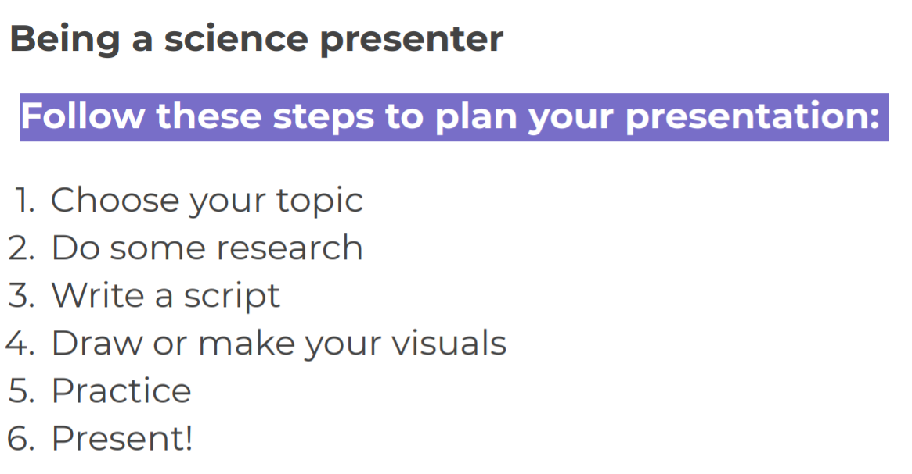I look forward to seeing your presentations.
Thanks Oak, I’ll hear from you via the class email.
Remember Miss Wharton has her laptop on all day during the week, like when we are at school, so you can send your work or a message when you like (I can share these with Mrs Wylie), We love hearing from you.

Please ensure that you email completed work to oak@lyng.norfolk.sch.uk so I can provide feedback on certain pieces to ensure progression.

