Morning  Challenge | 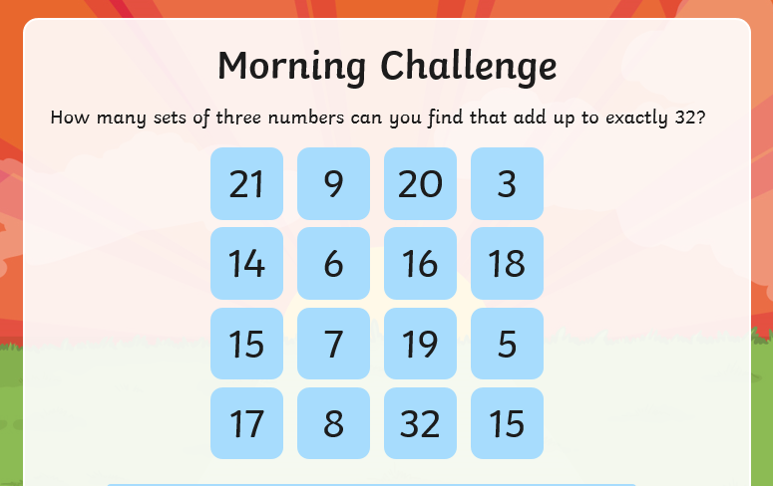
Maths | Morning Year 6, this week we embed our division knowledge. In this lesson, we will use long division to complete equations.  LO: Can I use the formal written method of long division to solve appropriate calculations?  Watch the session from Oak academy, linked below:  https://classroom.thenational.academy/lessons/use-the-formal-written-method-of-long-division-to-solve-appropriate-calculations-c8wk0c  The worksheet is below, remember to watch the lesson first.  Then take the quiz, to check your understanding.  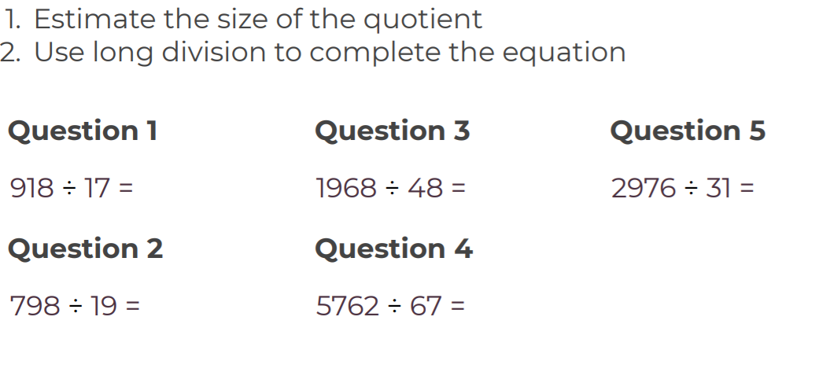
English | Today we continue our new book, The Ultimate Guide to Unicorns and Flying Horses by Pie Corbett.  Here is the link:  https://www.talk4writing.com/wp-content/uploads/2021/01/The-Ultimate-Guide-to-Unicorns-Flying-Horses-2.pdf  Please complete page 7, Activity 4: Unicorn’s New Year Wishes and page 8, Activity 5: Six things a Unicorn can do.  These are the pages below, remember to click on the link for the larger versions.  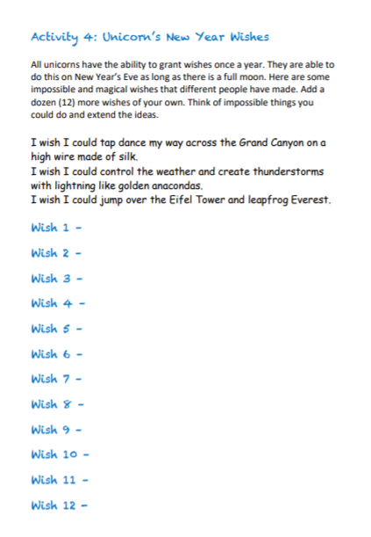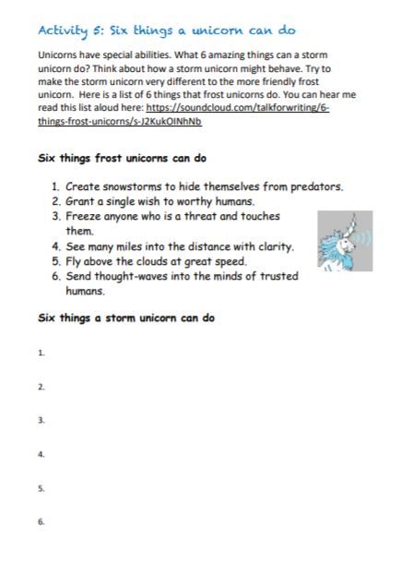
Spelling | In this lesson, we will explore the rules associated with adding the suffix -ous. 10 spelling words will be explained and set to learn.  LO: Can I investigate the suffix: -ous?  Here is the link:  https://classroom.thenational.academy/lessons/to-investigate-the-suffix-ous-ccu3et
Afternoon lessons:  R.E | We are continuing our unit in R.E.  - In this unit we will encounter people who followed the example of Jesus both in the past and as contemporary followers world-wide.  - We will consider the impact of Christian belief on peoples’ lives in terms of their jobs and daily life.  Today we are going to learn about St Francis of Assisi.  Please read the PowerPoint below:  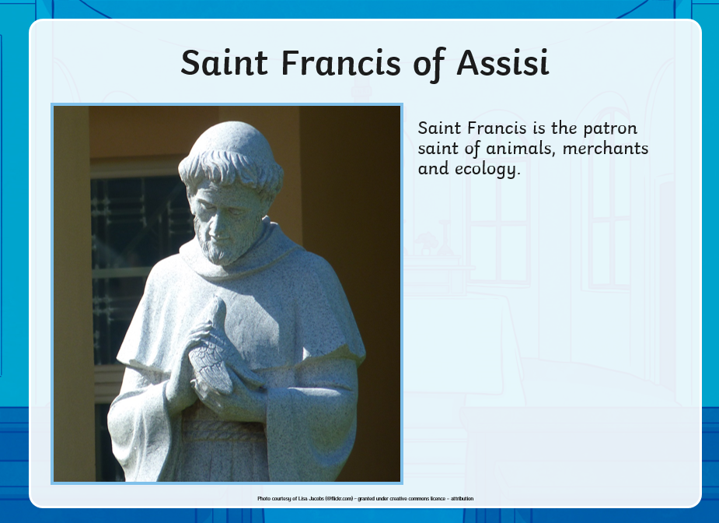  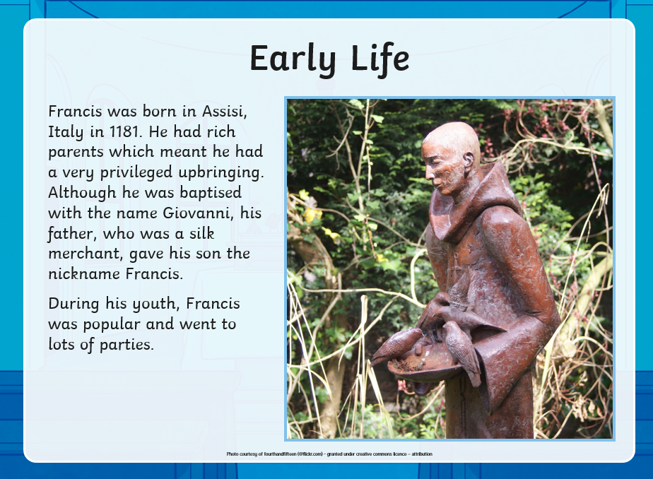  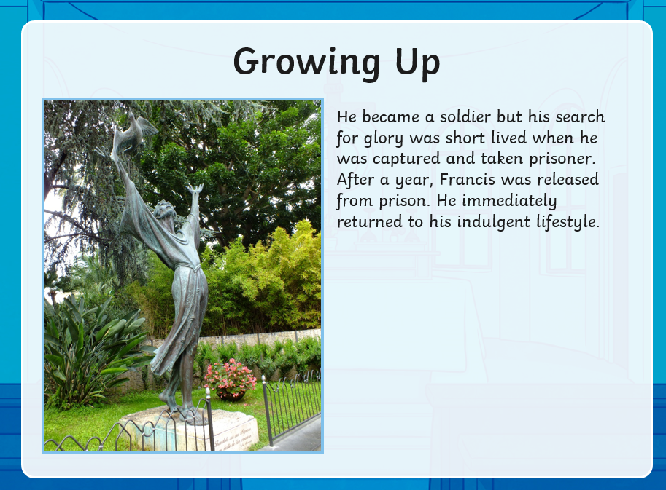  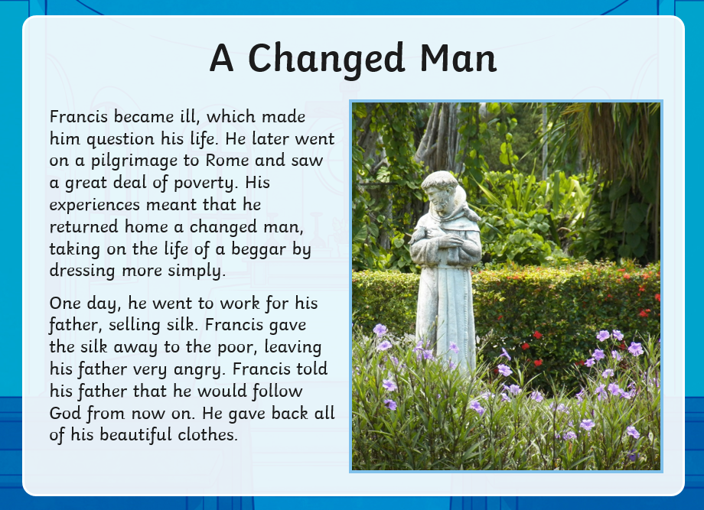  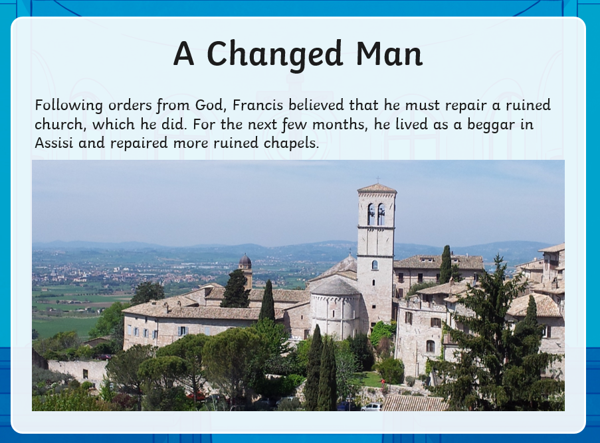  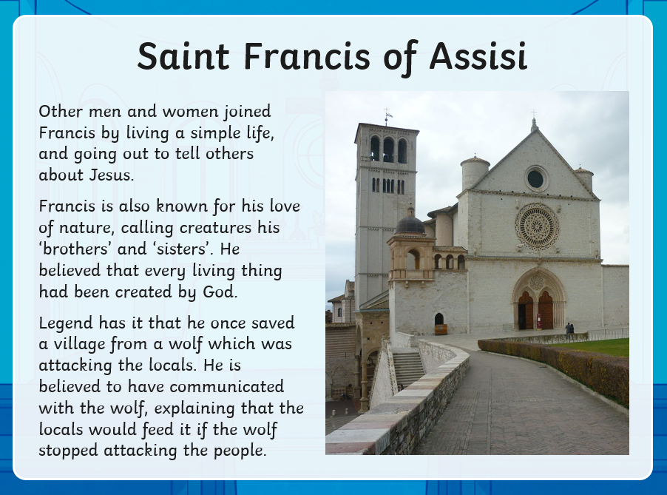  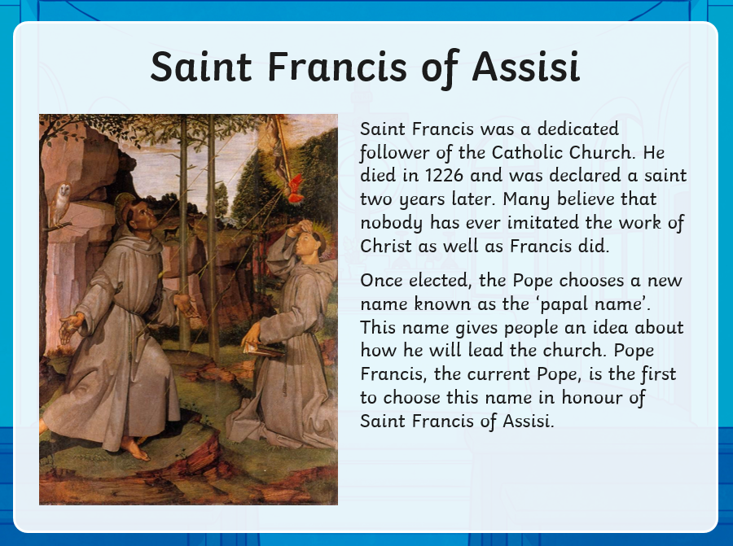  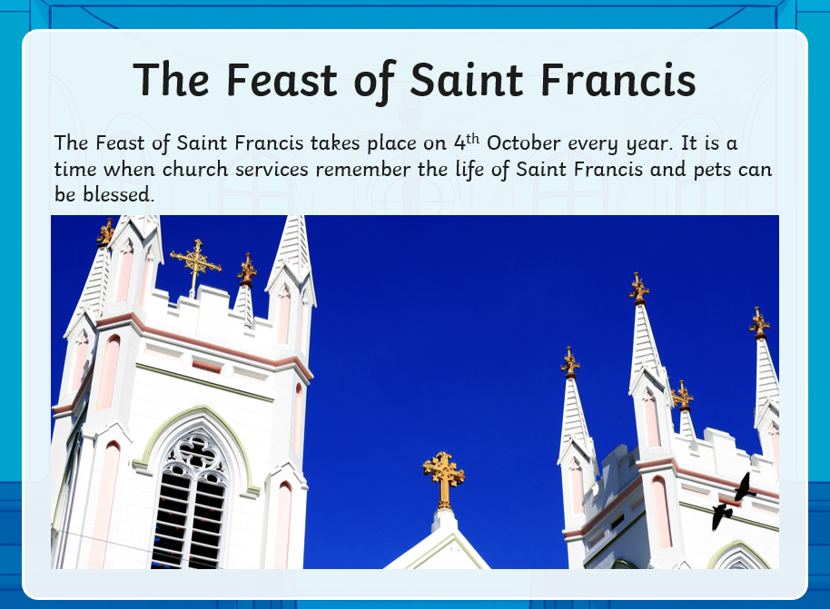  Your task is to make a poster about St Francis of Assisi’s life and achievements.  LO: Can I make a poster to show the achievements of St Francis of Assisi?
P.E | I’m sure you are all getting out and about for your daily exercise, if you need other ideas, you could complete a Joe Wicks work out (you tube) or a Cosmic yoga one (you tube).  You can now access real PE at home where families can view the sessions under real PE at home/Supporting docs.  You should have your login details.
Thanks Oak, I’ll hear from you via the class email.
Remember Miss Wharton has her laptop on all day during the week, like when we are at school, so you can send your work or a message when you like (I can share these with Mrs Wylie), We love hearing from you.

Weekly Art Challenge. | Some of Oak, have requested that we continue our weekly art challenge, that we work on during the week.  Please feel free to join in and send me your finished pieces.  This week our challenge is: Can you draw a picture of a memory of when you were younger?

Please ensure that you email completed work to oak@lyng.norfolk.sch.uk so I can provide feedback on certain pieces to ensure progression.

