Morning  Challenge | 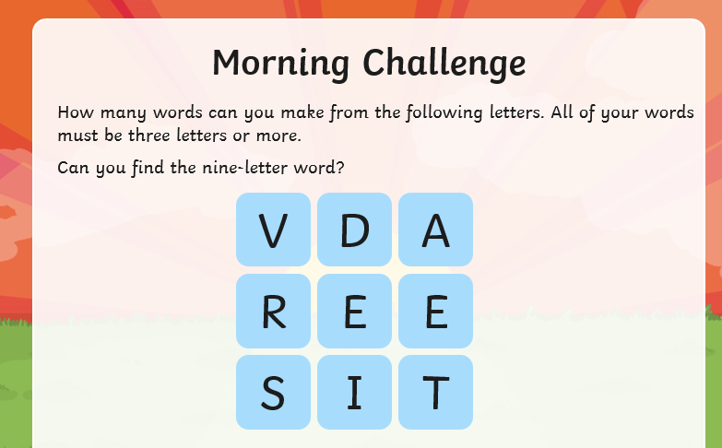
Maths | Morning Year 6, we will start this lesson by considering why estimates and rounding might be useful. We will explore rounding 7-digit numbers to the nearest multiple of 100,000 with varying degrees of accuracy.  LO: Can I round numbers to a required degree of accuracy?  Watch the session from Oak academy, linked below:  https://classroom.thenational.academy/lessons/rounding-to-a-required-degree-of-accuracy-6wu32t  The worksheets are below, remember to watch the lesson first.  Then take the quiz, to check your understanding.  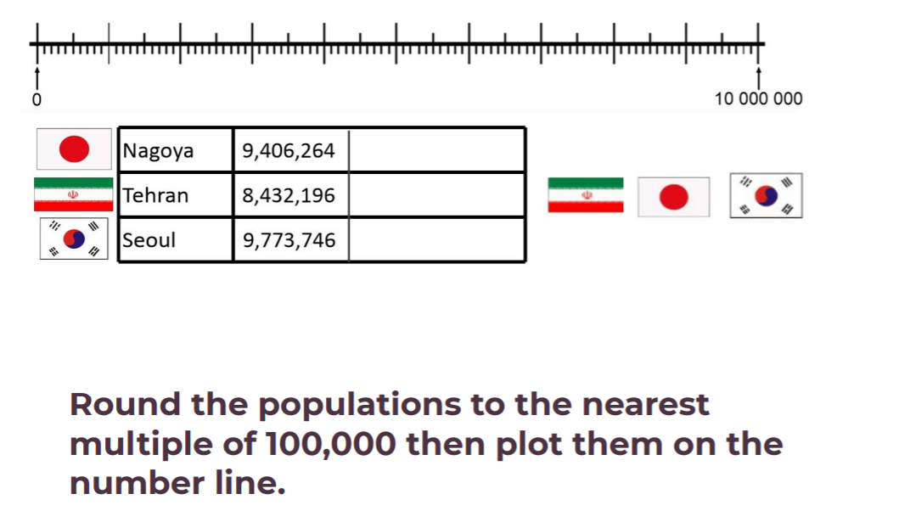  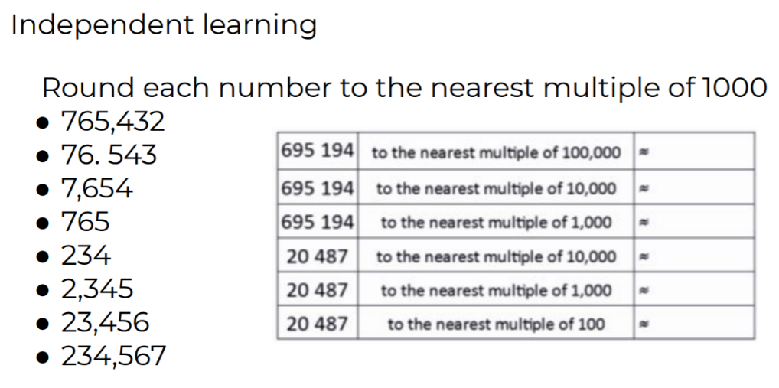
English | Today we continue our new book, The Ultimate Guide to Unicorns and Flying Horses by Pie Corbett.  Here is the link:  https://www.talk4writing.com/wp-content/uploads/2021/01/The-Ultimate-Guide-to-Unicorns-Flying-Horses-2.pdf  Please complete page 5, Activity 2: Draw a frost unicorn, then page 6, Activity 3: Where do frost Unicorns live?  These are the pages below, remember to click on the link for the larger versions.  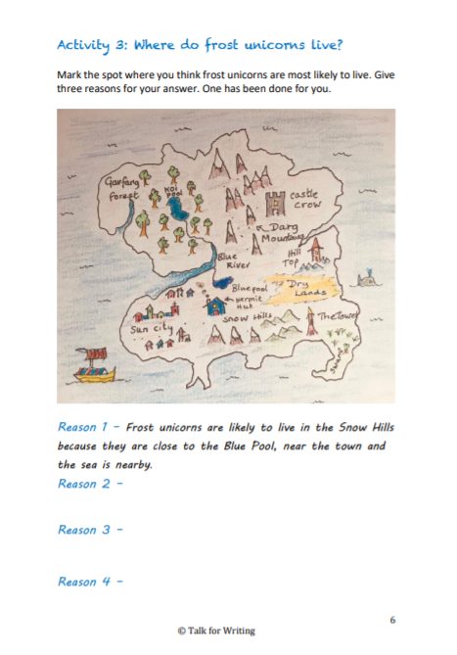
I.C.T | Today, we are going back to scratch programming.  Follow this link:  https://projects.raspberrypi.org/en/codeclub  Click on Scratch module 2.  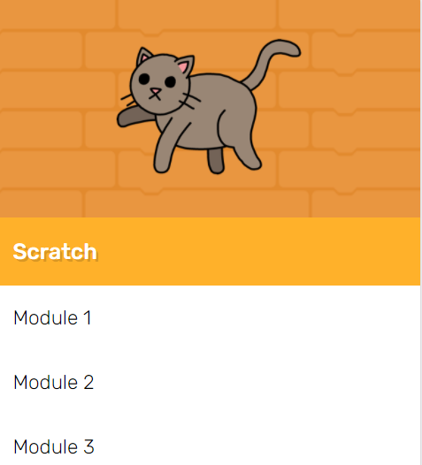  Have a go at the Memory section.  LO: Can I create a colour changing sequence using Scratch?  I have enjoyed seeing the clips I have been sent, so feel free to send yours.
Afternoon lessons:  Art | In this session we will learn about the artist Jasper Johns.  In this lesson we are going to be experimenting with textures and media.  Watch the lesson below and have a go:  https://classroom.thenational.academy/lessons/jasper-johns-part-1-70u3ad  I’d love to see your finished paintings, via the Oak email.
Thanks Oak, I’ll hear from you via the class email.
Remember Miss Wharton has her laptop on all day during the week, like when we are at school, so you can send your work or a message when you like (I can share these with Mrs Wylie), We love hearing from you.

Please ensure that you email completed work to oak@lyng.norfolk.sch.uk so I can provide feedback on certain pieces to ensure progression.

