Morning Challenge | 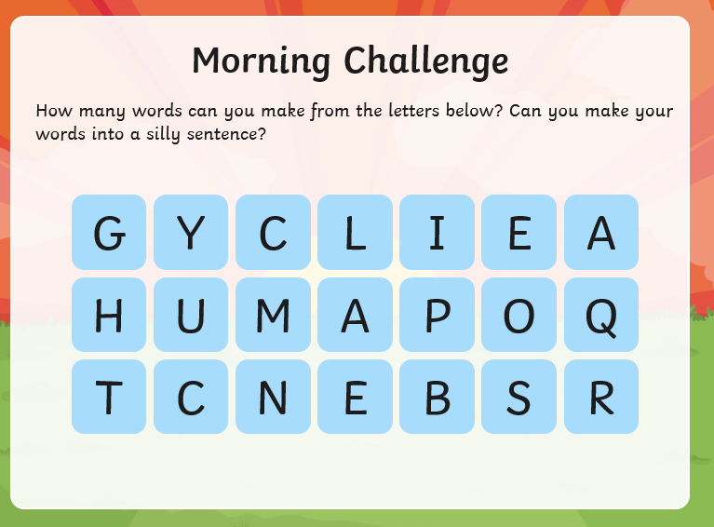
Maths | Morning Year 5, in this lesson, we will be using number lines to round 5-digit numbers to the nearest multiple of 100, 1000 and 10 000. We will also investigate rounding in the context of word problems.  LO: Can I round 5-digit numbers to the nearest 100, 1000 and 10 000?  Here is the link:  https://classroom.thenational.academy/lessons/rounding-5-digit-numbers-to-the-nearest-100-1000-and-10-000-6hgk2d  The worksheets are below, remember to watch the lesson first, then take the quiz to check your understanding.  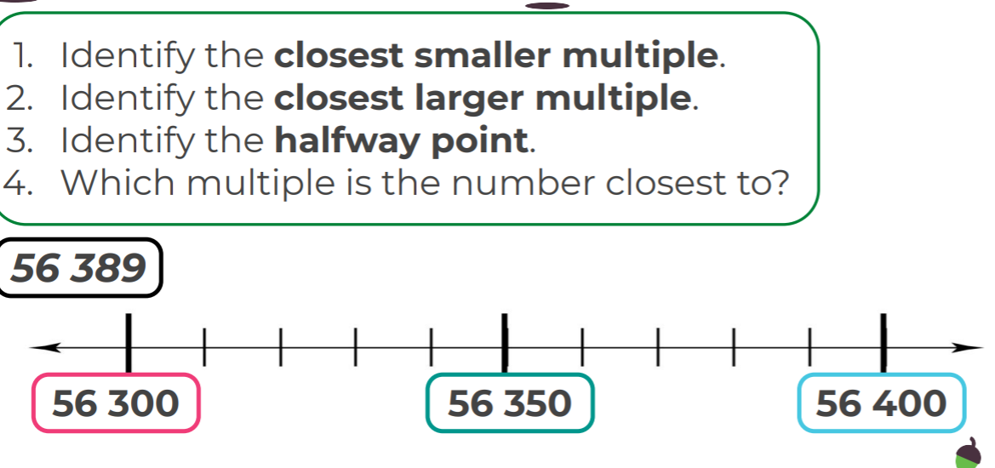  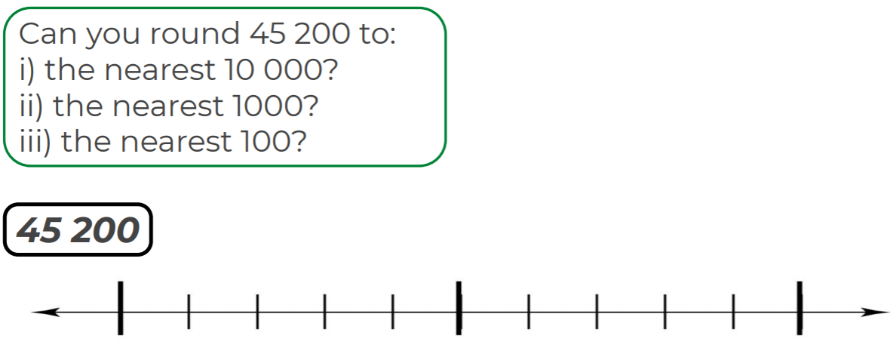  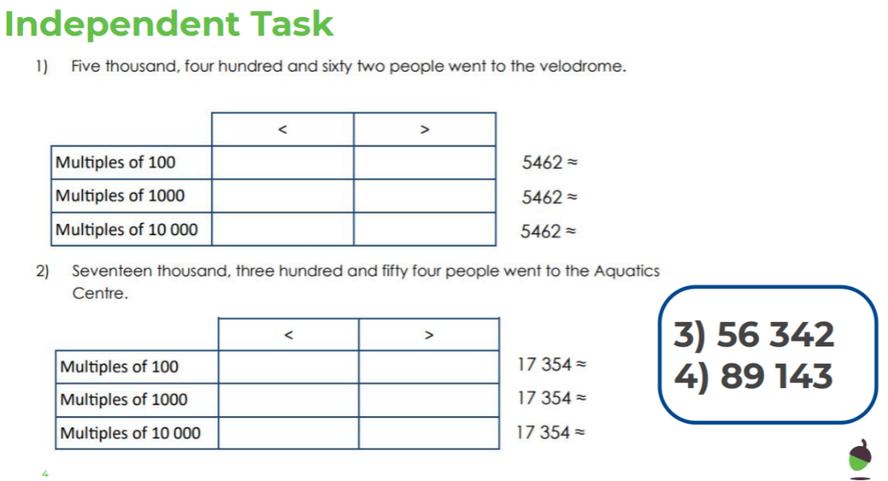
English | Today we are continuing to work through the ‘talk for writing’ English books.  Here is the link:  https://www.talk4writing.com/wp-content/uploads/2020/05/Y5-One-Chance.pdf  One Chance by Dean Thompson  Today, please complete pages 24 and 25.  We are going to write our story and make a book, I think we need two sessions for this. We will start today and finish on Thursday (after guided reading on Wednesday).  Here are the pages we are working from. Remember to click on the link for the larger versions.  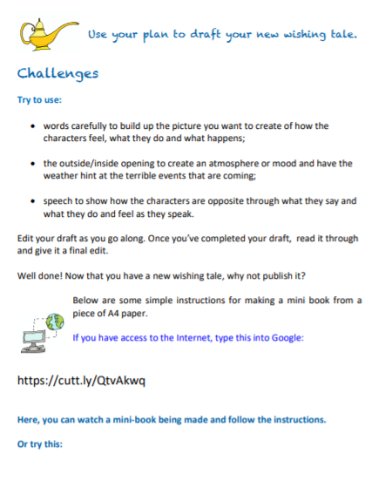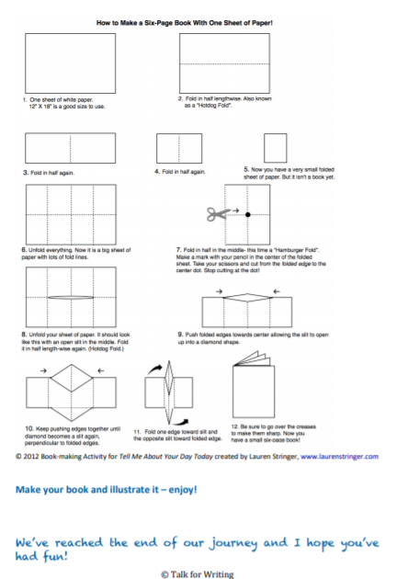
Spelling | In this lesson, we will practise and apply our knowledge of the suffixes -tion, -ssion, -sion and -cian.  LO: Can I score 10/10 on the test?  Here is the link:  https://classroom.thenational.academy/lessons/to-practise-and-apply-knowledge-of-suffixes-tion-cian-sion-ssion-6ngp4c
Afternoon lessons:  French | 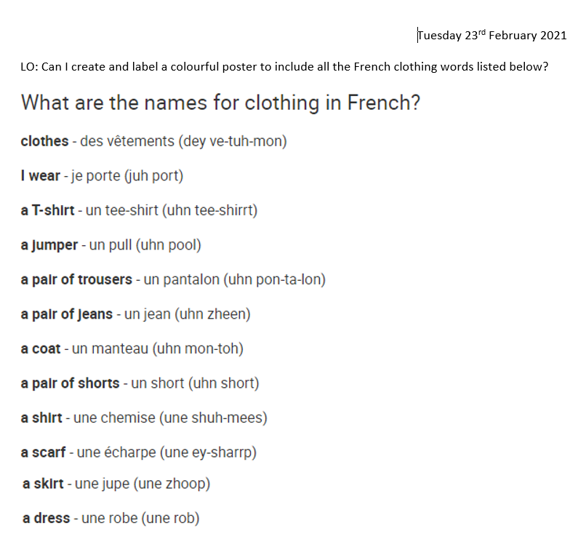  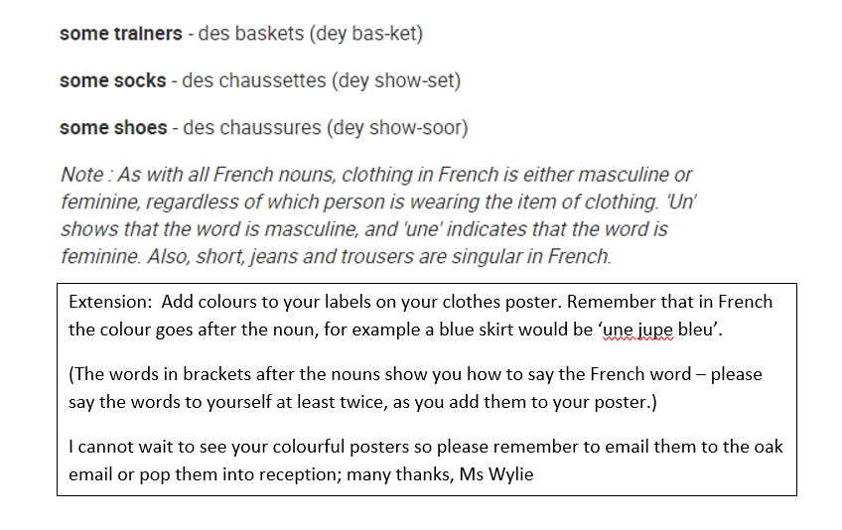
Music | For music Ms Burners has recommended we take a look at the BBC ten pieces site.  Click the link below:  https://www.bbc.co.uk/teach/ten-pieces/ten-pieces-musical-menu/zmypxbk  This week you will be exploring the Musical Menu Themes: Lyrics, rhyming, couplets, street art and home.  You have :’listen’, ‘learn’ then ‘do’ videos to look at.
Thanks Oak, I’ll hear from you via the class email.
Remember Miss Wharton has her laptop on all day during the week, like when we are at school, so you can send your work or a message when you like (I can share these with Mrs Wylie), We love hearing from you.

Please ensure that you email completed work to oak@lyng.norfolk.sch.uk so I can provide feedback on certain pieces to ensure progression.

