Morning  Challenge | 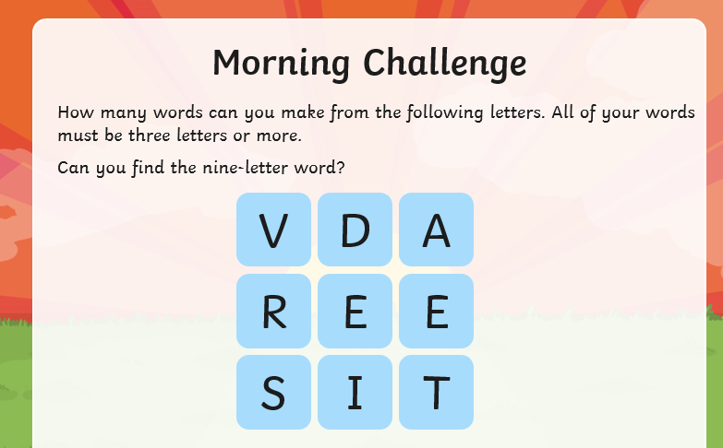
Maths | Morning Year 5, in this lesson, we will be identifying the intervals on incomplete number lines and placing 6-digit numbers on number lines with different scales.  LO: Can I order and compare 6-digit numbers using number lines?  Here is the link:  https://classroom.thenational.academy/lessons/ordering-and-comparing-6-digit-numbers-using-number-lines-cmw3cr  The worksheets are below, remember to watch the lesson first, then take the quiz to check your understanding.  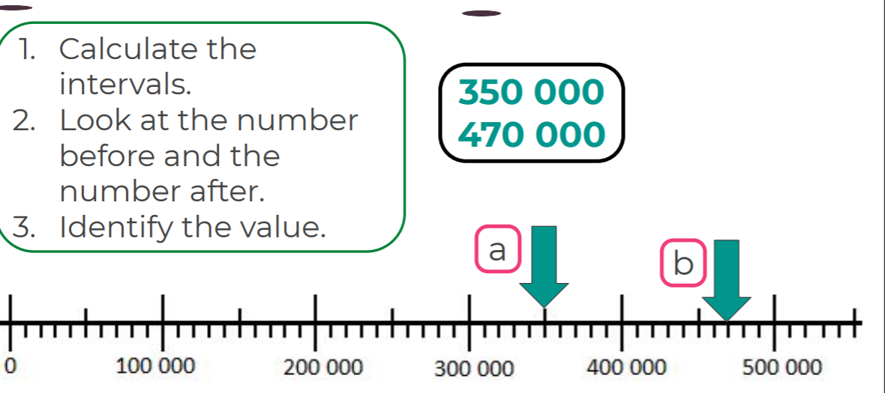  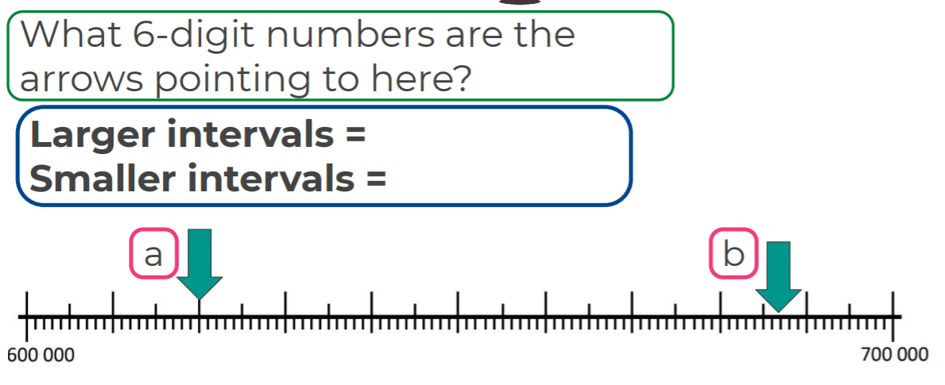  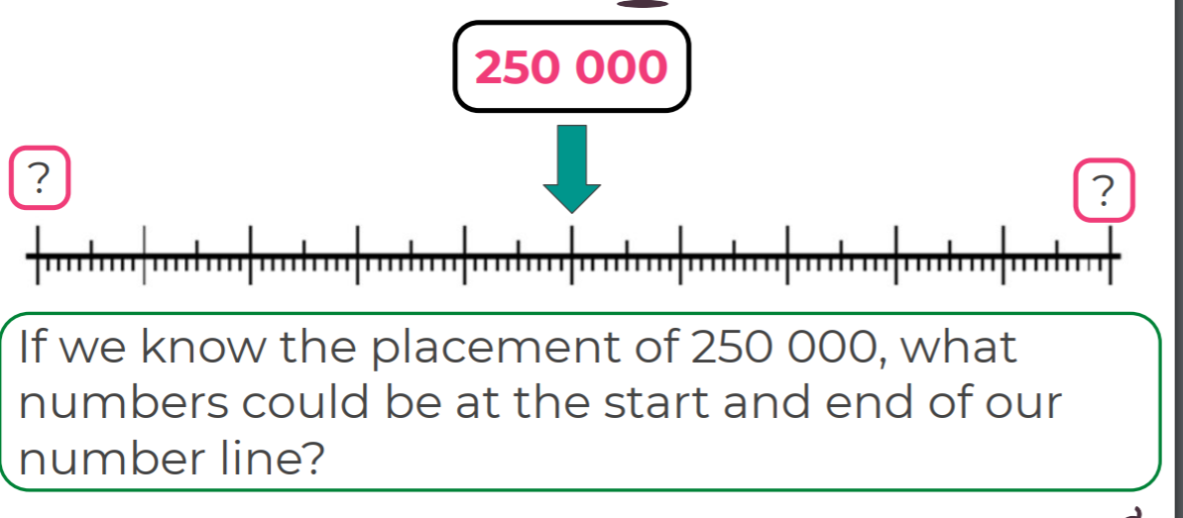  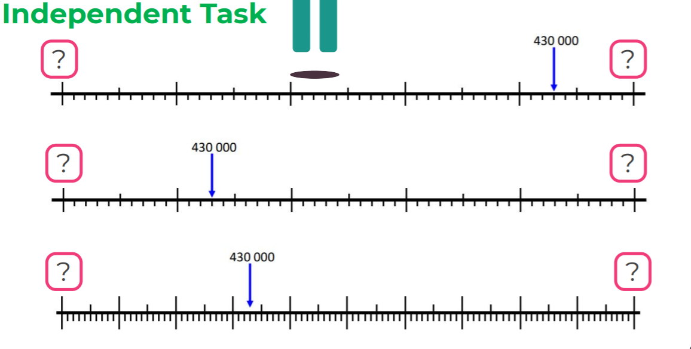
English | Morning Year 5, as we finished our story and book yesterday we will do a one-off English session today and start a new book on Monday.  Today I would like you to write a poem about Winter.  You could draft your ideas first, write a first draft, then when you are happy with your poem, copy it in your neatest handwriting and illustrate the page.  Here is a sheet to help you with ideas for your poem:  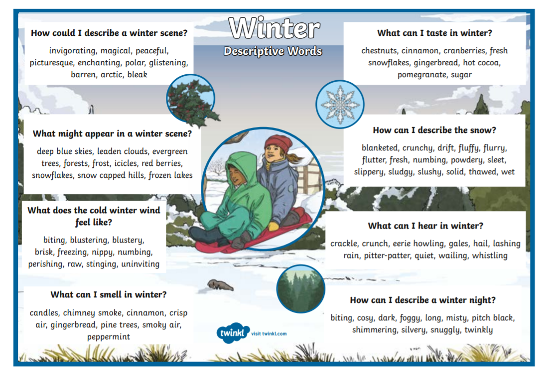  Here is an example of a winter poem, which might help your ideas:  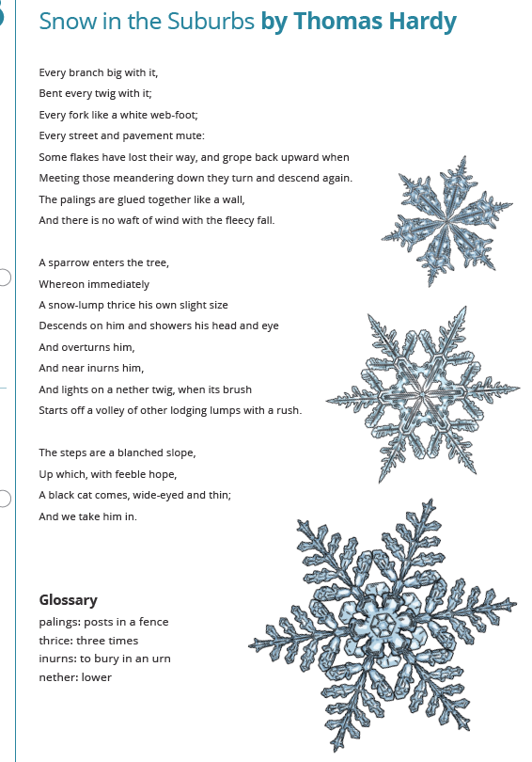  You might like to try to make your poem rhyme, but remember it doesn’t have to.  I look forward to reading your poetry.
I.C.T | Today, we are going back to scratch programming.  Follow this link:  https://projects.raspberrypi.org/en/codeclub  Click on Scratch module 2.  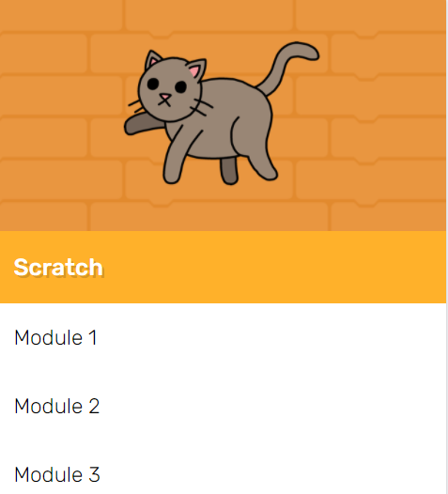  Have a go at the Memory section.  LO: Can I create a colour changing sequence using Scratch?  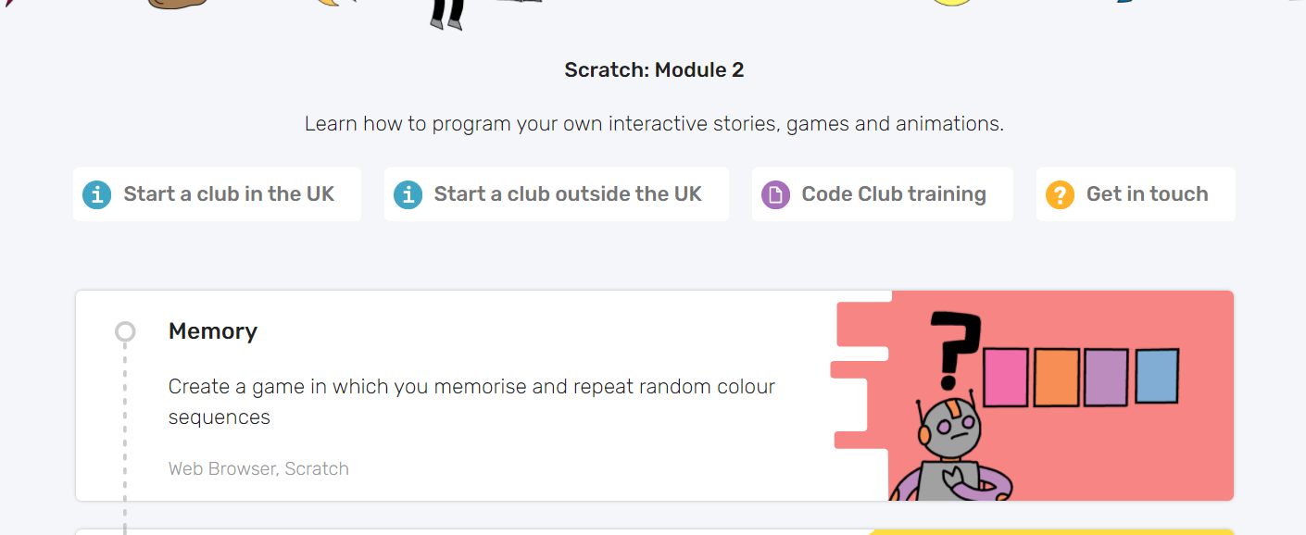  I have enjoyed seeing the clips I have been sent, so feel free to send yours.
Afternoon lessons:  Art | In this session we will learn about the artist Jasper Johns.  In this lesson we are going to be experimenting with textures and media.  Watch the lesson below and have a go:  https://classroom.thenational.academy/lessons/jasper-johns-part-1-70u3ad  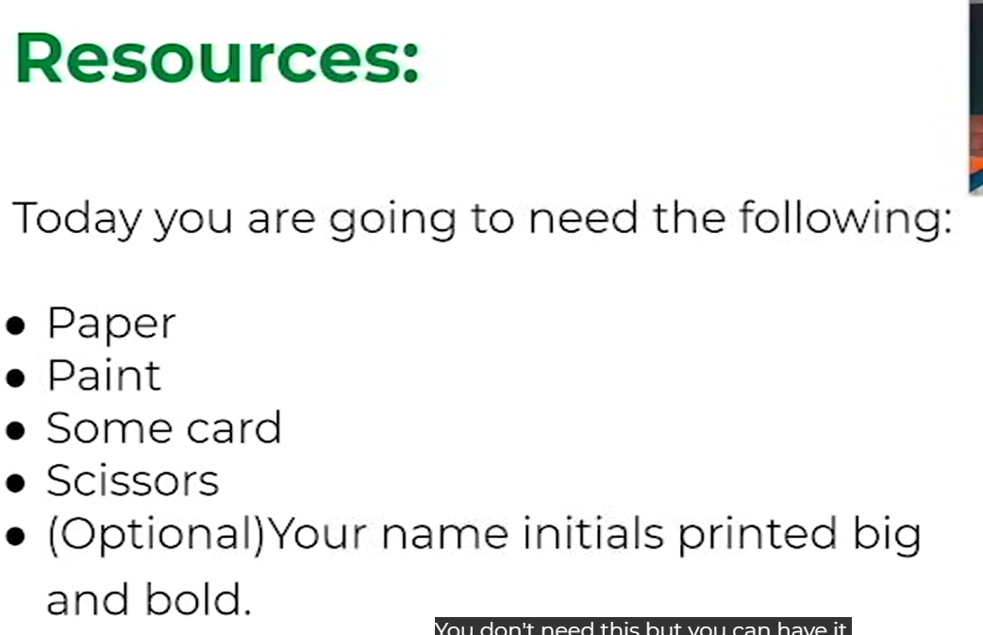  I’d love to see your finished paintings, via the Oak email.
Thanks Oak, I’ll hear from you via the class email.
Remember Miss Wharton has her laptop on all day during the week, like when we are at school, so you can send your work or a message when you like (I can share these with Mrs Wylie), We love hearing from you.

Please ensure that you email completed work to oak@lyng.norfolk.sch.uk so I can provide feedback on certain pieces to ensure progression.

