Willow class – additional notes for next week
(Week commencing 1.3.21)
- On Monday we will be carrying out a science experiment to investigate our sense of smell.
Your child will be trying to guess the name of different smells without looking!
It would be helpful if you could have:
- A scarf or blind fold
- At least 4 different smells e.g. vinegar, toothpaste, curry powder, an onion, perfume, lavender.
- Some containers to put them in.

- Next week we will be learning about MONEY in maths.
Please could you get a collection of change together?
One of each coin would be useful as well as a collection of 1p 2p 5p 10p 20p coins.
Thank you.
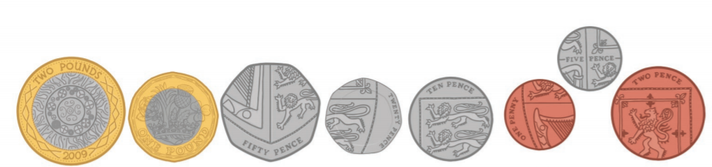

Many thanks
Mrs Tebbutt

