Wednesday 3rd February 2021 YEAR 2
Enjoy doing the activities listed.
The order to do them in is suggested below but you can change them to suit you. Please send me any work, photos or comments via Tapestry. Thank you.
MORNING  Let’s get started challenge | Have a change from Joe by trying out these! Make a choice to suit you and how you are feeling!  https://imoves.com/the-imovement
Maths  Learning objective:  All children  Can I write a repeated addition and a multiplication sum for each picture problem?  Some children  Can I learn the x10 table? | This week we will be counting in groups of 2, 5 and 10 and seeing the link between repeated addition and multiplication  Introduction  - Today we will be looking at counting in groups of 10 and the x10 table.  - First practice counting on in tens.  Repeat it until you are confident  0 10 20 30 40 50 60 70 80 90 100  - What do you notice about the final digit in each number?  TOP TIP: when counting in groups of 10 the final digit will  always be 0  - If you are not sure look at it on a 100 square and complete the pattern (see sheet in work below)  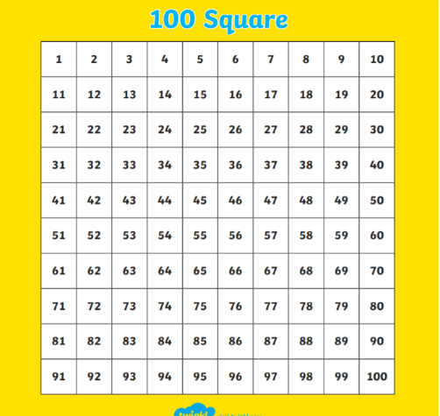  - Look at this question: How many sticks of 10 altogether?  We can work it out by counting aloud in tens.  - BUT…. how can we show it as a sum?  We could write  10 + 10 + 10 = 30  OR we could write it as 3 x 10 = 30  Remember: the first number is the number of groups (in this case sticks) and the second number is the number in each group.  - You can also show it like this  +10 +10 +10  0 10 20 30  - Arrays 3 rows of 10  - Try writing 2 sums for this problem.  First write a repeated addition sum and then write a multiplication sum.  How many sticks?  Does your answer look like this:  10 + 10 + 10 + 10 = 40  4 x 10 = 40  Now can you show it on a number line and as an array?  Activities  All children  - Write sums for the pictures as you have been doing above (see worksheet below).  Most children  - Watch https://www.bbc.co.uk/bitesize/topics/zqbg87h/articles/zq3rk2p  - try the activities on the same page  - learn x10 table using mathletics  go to explore  then videos  then scroll down to x10 song  or this movement times table song!  https://www.bbc.co.uk/teach/supermovers/ks1-maths-the-10-times-table-with-webster-the-spider/zm32cqt
English  Learning objective:  Can I create a superhero pet and describe him? | Introduction  - Today is the final day of the pack.  - Every good superhero needs a superhero pet!  - Imagine you could have superhero pet. What sort of pet would he be? What would you call him?  - What would be his superpowers?  Activity:  Fill in page 16 of your pack.
Handwriting/ spellings, grammar, punctuation or phonics  Learning objective:  Can I add inverted commas to a sentence? | Introduction  - On Monday we learnt about INVERTED COMMAS (sometimes called speech marks)  - “ ” They look like 66 and 99.  - Today we will have a go at spotting where they should go in a sentence before you try on your own on Friday.  Remember: inverted commas are put in to show what a person is saying.  - Look at this sentence. Where do you think the inverted commas will go?  Help, shouted the boy.  - Are you correct?  “Help” shouted the boy.  Remember: the only word which is being said is Help.  - Now try this sentence. Where do you think the inverted commas will go?  The children were playing in the park.  Sam said this is fun.  - Are you correct?  The children were playing in the park.  Sam said “this is fun”.  Activities  - Watch https://www.bbc.co.uk/bitesize/topics/zvwwxnb/articles/ztcp97h  - Then try the first activity on that webpage  - Next add the inverted commas in the sheet below.
 | Lunchtime!
AFTERNOON  Reading | Read at least 3 pages of your reading book.
PE | You have a choice - it may depend on the weather!  - Go for a walk or bike ride.  - Make up a new game or challenge e.g can I get the ball into the bucket 6 times out of 8. Can you improve?  - Do a cosmic yoga session https://www.youtube.com/user/CosmicKidsYoga  - Complete a Joe Wicks challenge  OR new for this week  https://www.youthsporttrust.org/primary-pe-activities
Story/ yoga/ mindfulness activity | Listen to some music and quietly relax
Additional notes for parents. | Well done! Half way through another week of home learning!

.

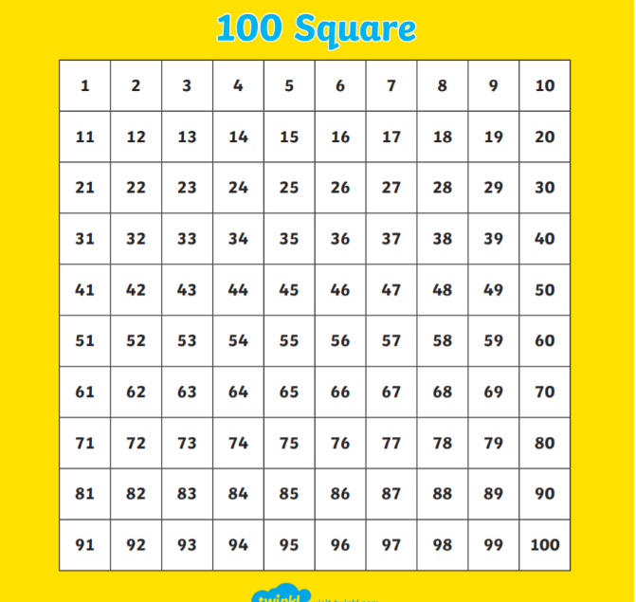

Maths Level 1 challenge:
Can I write a repeated addition and a multiplication sum for each picture problem?
Example Here is an example.

10 + 10 + 10 + 10 = 40

4 x 10 = 40
Now your turn

Now draw some a picture to match this sum 7 x 10 =70

Maths level 2 challenge
Mathletics

Punctuation
Can I add inverted commas to a sentence?

Wait for me said Sam to his friend.

Sally said I can’t wait to come to your party.

