**Wednesday 24th February 2021** **YEAR 2**

Enjoy doing the activities listed.

The order to do them in is suggested below but you can change them to suit you. Please send me any work, photos or comments via Tapestry. Thank you.

|  |  |
| --- | --- |
| MORNING  Let’s get started challenge | Practise the days of the week song and move along with it.  <https://www.bbc.co.uk/teach/supermovers/ks1-english-days-of-the-week/zd8njhv> |
| Maths  *Learning objective:*  Can I say the months of the year in the correct order?  Can I say when my birthday is?  Can I complete an activity which shows my understanding of the months of the year? | This week we are learning about TIME.  On Monday you learnt the days of the week in order.  Today you will learn the months of the year and know when your birthday is.    **Introduction**   * Can you remember all the months of the year and say them in the right order? * Look around your house – have you got a calendar to help you? * If not here are the months to help you.   January  February  March  April  May  June  July  August  September  October  November  December   * Read through the power point   OR   * Follow the lesson on Oak Academy   <https://classroom.thenational.academy/lessons/naming-and-ordering-the-months-of-the-year-crwp2d>  Activities- choose the activity that best suits you depending on how confident you are in naming the months of the year.  Level 1 challenge (less confident)   1. Cut and stick months of the year in order -worksheet below 2. Word search – worksheet below.   Or interactive word search <https://www.twinkl.co.uk/go/resource/months-of-the-year-interactive-word-search-tg-121-newlink>  Level 2 challenge (more confident)   1. Test your knowledge of the months of the year – see worksheet below. |
| English  *Learning objective:*  Can I use my imagination to draw my own ideas of the evil that was in the box?  Extension: can I explain my thoughts? | Introduction   * This week you have been reading about Pandora and her box. * Yesterday you imagined what might be in her box and why. * Today read the next part of the story at the bottom of page 6 and top of page 7 of your pack. It looks like this:        * Think about what you have read.   What words in the first sentence show that Pandora was nervous opening the box?  What did she imagine was going to be inside the box?  Was it the same as your ideas?  Can you explain what did come out of the box?  How did Pandora feel after she had opened the box? Explain.  Activity:  Imagine what the bad things looked like that came out of the box.  Maybe they looked like this?    Make up your own evil that came out of the box. |
| Handwriting/ spellings, grammar, punctuation or phonics  Learning objective.  Can I merge 2 words into one using an apostrophe? | Introduction:   * On Monday you started learning about APOSTOPHES. * Apostrophes can be used to merge 2 words into one e.g. **do not** can become   **don’t.** Can you see the **o** in **not** is taken away and replaced with an apostrophe **‘**   * On Monday you learnt how to merge 2 words into one word by removing one letter. Sometimes more than one letter needs to be taken out before being replaced with an apostrophe. * e.g. **she will** can become   **she’ll.** Can you see the **w** and **i** in **will** is taken away and replaced with an apostrophe **‘**  Activities –   1. Have a go at turning these 2 words into a shorter word using an apostophe.   **he will**  **can not**   1. Watch the LEARN video <https://www.bbc.co.uk/bitesize/articles/z3j4vwx> 2. Complete the sheet below. |
|  | Lunchtime! |
| AFTERNOON  Reading | Read at least 3 pages of your reading book.  Remember you can borrow a book pack from school. |
| PE | For PE this week, login to Real PE using the login that has been sent to you.  Login, and then click on EYFS/Key Stage 1  Now, click on the picture of the monkey to go into the jungle! This week you will be practicing your seated balance skill. First- click on the compass picture to go on a jungle adventure! This will be your warm up. Keep going with this as long as you want to. Next- Click on the dice picture. You are going to play 2 games today.  Game 1- Monkey Mirror Game 2 – Cheeky Monkey Says  Enjoy!" |
| Story/ yoga/ mindfulness activity | Make the clock that you will need for tomorrow. (see attachment on class learning page) |
| Additional notes for parents. | Well done! Half way through another week of home learning! |

**Maths Level 1 challenge**

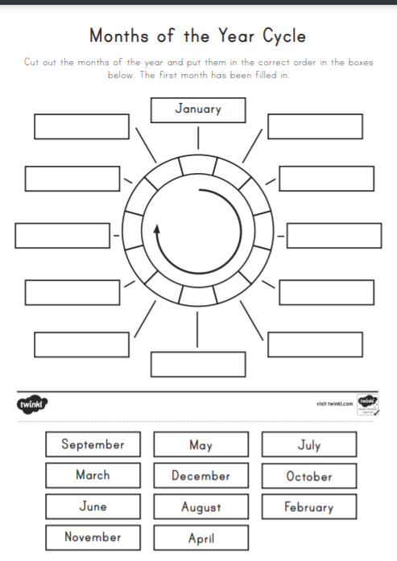

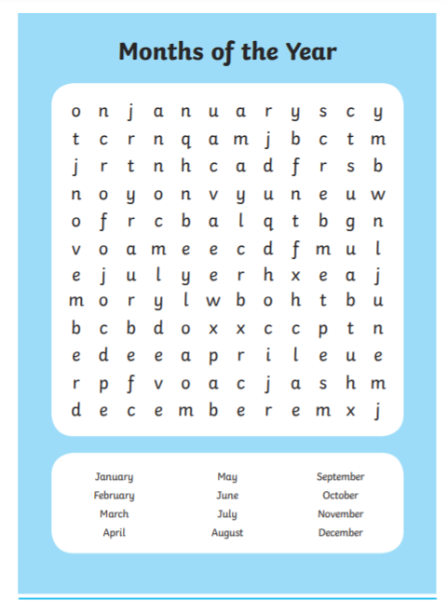

**Level 2 challenge**

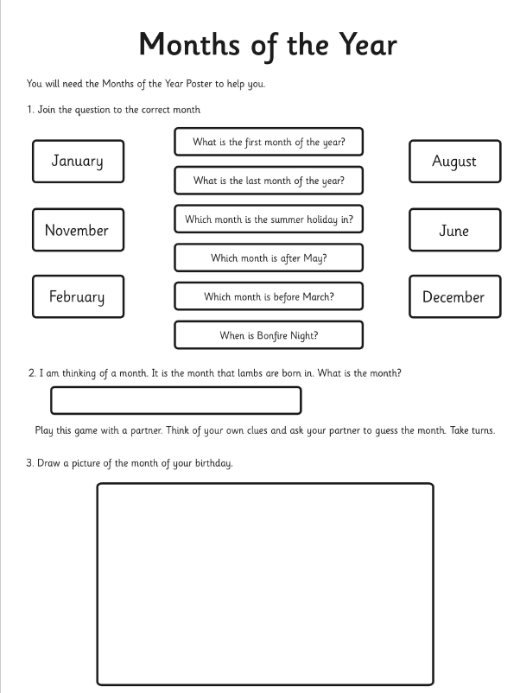

**Punctuation**

Can I match the contraction to the write pair of words?

Cut out the words at the bootom of the page and stick into the correct box.

