Wednesday 10th February 2021 YEAR 2
Enjoy doing the activities listed.
The order to do them in is suggested below but you can change them to suit you. Please send me any work, photos or comments via Tapestry. Thank you.
MORNING  Let’s get started challenge | Have a change from Joe by trying out these! Make a choice to suit you and how you are feeling!  https://imoves.com/the-imovement
Maths  Learning objective:  All children  Can I write a repeated subtraction and a division sum for groups of 10?  Some children  Can I show the link with multiplication? | This week we will be grouping into groups of 2, 5 and 10 and seeing the link between repeated subtraction and division.  Introduction  - Today we will be looking at grouping into groups of 10 and be more confident in seeing the link between repeated subtraction and division.  - Look at this question: How many groups of 10 bricks?  First count the total - 30  - We can work it out by splitting them into equal groups of ten  - So the answer is 3 groups  - We could count back to check as a repeated subtraction sum  30 - 10 - 10 - 10 = 0  - Or we can write is as 30 ÷ 10 = 3.  This can be read as ‘how many groups of 10 are there in 30?’  . Here are some different ways to work out division :  -10 -10 -10  0 10 20 30  jump in groups of 10, 3 times from 30  - Arrays  - 30 divided into groups of 10 is 3  Remember  - It helps to know your x10 table by heart!  - when dividing by 10 answers will always end in 0.  - It can’t be done in any order.  - It can be checked by multiplying.  Activities  All children  - Write sums for the pictures, as you have been doing above (see worksheet below).  Most children  Try the sheet
English  Learning objective:  Can I write a fact file for Louis Braille? | Introduction  - Look back at your mind map and all the facts you have learnt about Louis Braille.  - Today you will turn these facts into longer sentences  e.g. lived in France  Louis Braille was born in France in 1809.  Activity:  Write your own fact file by using ONE of the writing frames below and your mind map to help you.  Remember think it, say it, write it, check it
Handwriting/ spellings, grammar, punctuation or phonics  Learning objective:  Can I complete the sentences using the list of conjunctions? | Introduction  - This week you are exploring co-ordinating conjunctions.  - On Monday you watched a video to explain how you can use words like because to join 2 parts of a sentence together to make it more interesting.  - Today you will be practising what your learnt.  Activities  - Go to https://www.bbc.co.uk/bitesize/articles/z6rvbdm activity 1 - can you spot the conjunctions (joining words)?  - Now try activity 2- watch the video and then complete the sentences (these are also copied below)
 | Lunchtime!
AFTERNOON  Reading | Explore the work of Rob Biddolph, children’s author and illustrator.  Use his You Tube videos -Draw with Rob - to learn how to draw characters  http://www.robbiddulph.com/draw-with-rob
PE | You have a choice - it may depend on the weather!  Check out some new links below.  - Go for a walk or bike ride.  - https://www.nhs.uk/10-minute-shake-up/shake-ups  - Do a cosmic yoga session https://www.youtube.com/user/CosmicKidsYoga  - https://www.youthsporttrust.org/primary-pe-activities
Story/ yoga/ mindfulness activity | Have fun in the snow!  Can you catch a snowflake on your tongue?  Can you make a snowman?  Or go for a hunt in the snow (see idea sheet below)
Additional notes for parents.

Maths Level 1 challenge:
Can I write a repeated subtraction and a division sum for each picture problem?

Here is an example total 40

40 - 10 - 10 - 10 - 10 = 0
40 ÷ 10 = 4
Now your turn

Now draw some pictures to match this sum 40 ÷10 = 4
Maths level 2 challenge

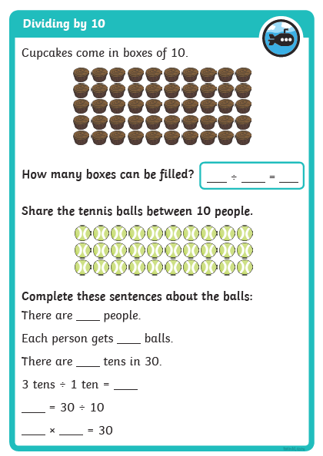

English
Can I write a fact file about Louis Braille?

Louis Braille
………………………………………………………………………………………………………………………..
………………………………………………………………………………………………………………………….
………………………………………………………………………………………………………………………..
………………………………………………………………………………………………………………………….
………………………………………………………………………………………………………………………..
………………………………………………………………………………………………………………………….
………………………………………………………………………………………………………………………..
………………………………………………………………………………………………………………………….

……………………………………………………….

………………………………………………………

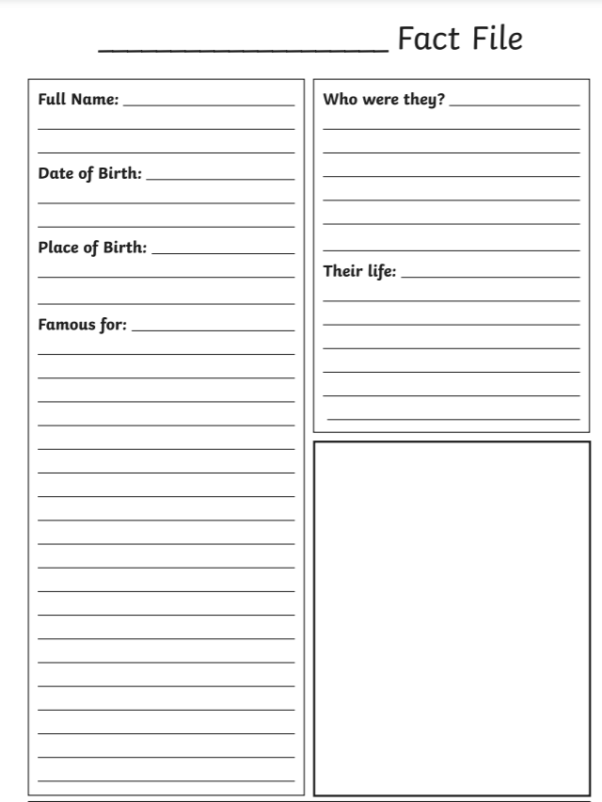

Grammar
Can I complete the sentences using the list of conjunctions?
The first one has been done for you.

and, because, and, but, and, when

- Some fish are big and some fish are small.

- Seaweed looks like a plant ........... it's an algae.

- Seaweed grows close to the surface ........... it uses the sun to make food.

- Plankton is made up of tiny plants ........... animals.

- Ocean habitats are large ........... wet.

- ........... whales need to breathe, they swim to the surface.

Answers below!

