Wednesday 10th February 2021 YEAR 1
Enjoy doing the activities listed.
The order to do them in is suggested below but you can change them to suit you. Please send me any work, photos or comments via Tapestry. Thank you.
MORNING  Let’s get started challenge | Have a change from Joe by trying out these! Make a choice to suit you and how you are feeling!  https://imoves.com/the-imovement
Learning objective:  All children  Can I put objects into groups of 10?  Can I count BACKWARDS in groups of 10 from 100? | Last week you learnt how to count forwards in groups of 2, 5 and 10. This week we will be counting backwards in the same groups.  We will also be learning how to share which will help you with division in year 2.  For this lesson you may find it useful to have somethings to count with e.g. buttons, counters or even pairs of socks!  Introduction  - First a quick quiz!  Finish the pattern:  0 10 20 30 ___ ____ ____ _____ ___  What’s missing?  0 10 20 30 40 _____ 60 70  What’s my mistake? Can you explain what I have done wrong?  40 50 16 70 80 90 100  - Use the number line to count BACK in tens.  - Start at 20 and each time make a jump of 10.  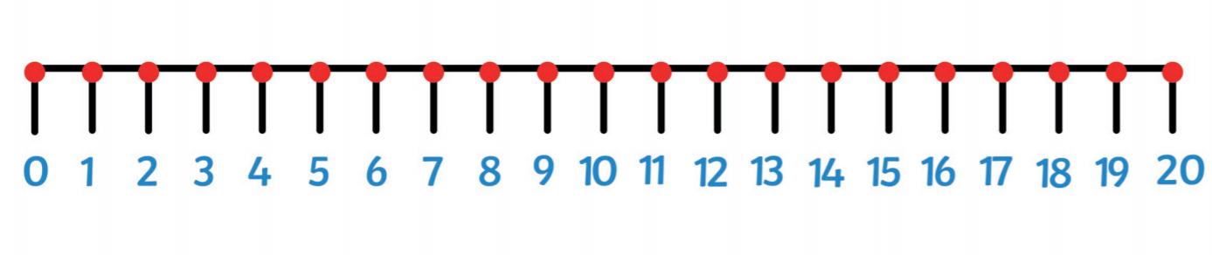  - Can you continue counting BACK in jumps of 10 on the number line to 50 below?  Top tip: when you count in tens the last digit will always be 0  - Which numbers do you land on? Say them lots of times until they are fixed in your head.  - Now turn the number line over. Can you still say the numbers you would land on if you counted BACK in tens?  Go to activity 1 OR  - If you would like another challenge try the same thing on a 100 square. This time colour the squares that you land on.  - What do you notice?  What do you notice about the numbers? Are they the same as counting FORWARDS in tens?  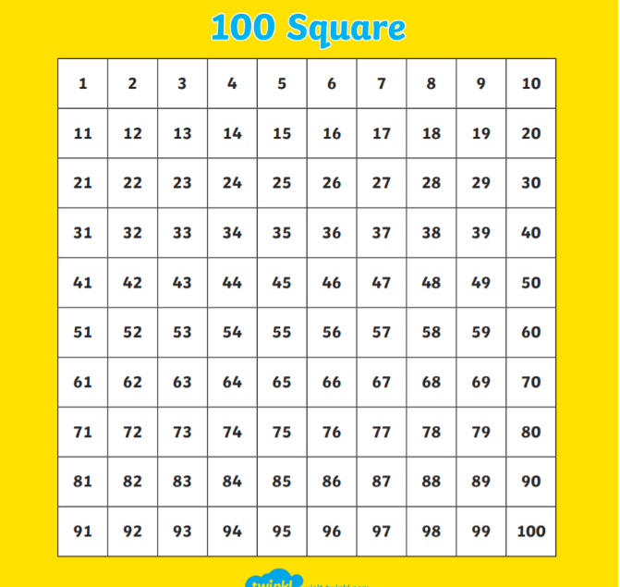  Can you count backwards in tens from 100?  Activities  All children  - Get out 20 counters (or similar) and put them into groups of 10. You may find it easier to put them in dishes.  Start at 20 and count BACK in 10’s as you take away a group of ten at a time- until you end up at 0  20 10 0  - Repeat but this time start with 30 counters. Put into groups of ten and take way a group at a time. Count BACK in 10’s as you go until you have no objects left.  30 20 10 0  - Repeat and record your answers using the worksheet below.  Top tip: use the 100 square to help you if you find it tricky to remember how to count back in tens.
English  Learning objective:  Can I use the facts on the mind map to write a fact file about snails? | Introduction  - Yesterday you finished a mind map about snails. Today you are going to use these facts to help you write a fact file.  - First think about where it lives. Have you got the answer on your fact file? Now say what you think the answer is in a full sentence.  - Next write it on page 15 of your pack. (The page is also copied below).  - Finally check it.  Activity:  Continue to fill in the fact file on page 15 of your pack (or below) and remember to use your mind map to help you.  Remember think it, say it, write it, check it
Handwriting/ spellings or phonics  Learning objective:  Can I read and write words containing the oy sound? | Introduction  - On Monday you recapped this sound oi  - oi can also be made with the diagraph oy  - read these words  boy enjoy destroy  OR test your reading on the oy power point  Activities  - Watch Mr Thorne does phonics oy  https://www.youtube.com/watch?v=aodJQr-WJLk  - Now complete the sheet below to write the oy  words.  - Finally check that you can read oy words by sorting the real from the nonsense words (see sheet below)
 | Lunchtime!
AFTERNOON  Reading | Explore the work of Rob Biddolph, children’s author and illustrator.  Use his You Tube videos -Draw with Rob - to learn how to draw characters  http://www.robbiddulph.com/draw-with-rob
PE | You have a choice - it may depend on the weather!  Check out some new links below.  - Go for a walk or bike ride.  - https://www.nhs.uk/10-minute-shake-up/shake-ups  - Do a cosmic yoga session https://www.youtube.com/user/CosmicKidsYoga  - https://www.youthsporttrust.org/primary-pe-activities
Story/ yoga/ mindfulness activity | Have fun in the snow!  Can you catch a snowflake on your tongue?  Can you make a snowman?  Or go for a hunt in the snow (see idea sheet below)
Additional notes for parents. | There is an option to make spider biscuits in English tomorrow or Friday (or leave until the holidays)  The recipe in advance can be found here:  https://www.bbcgoodfood.com/recipes/spider-biscuits

Cut the strips out and stick together to make a number line 0-50.
Then jump in groups of 10

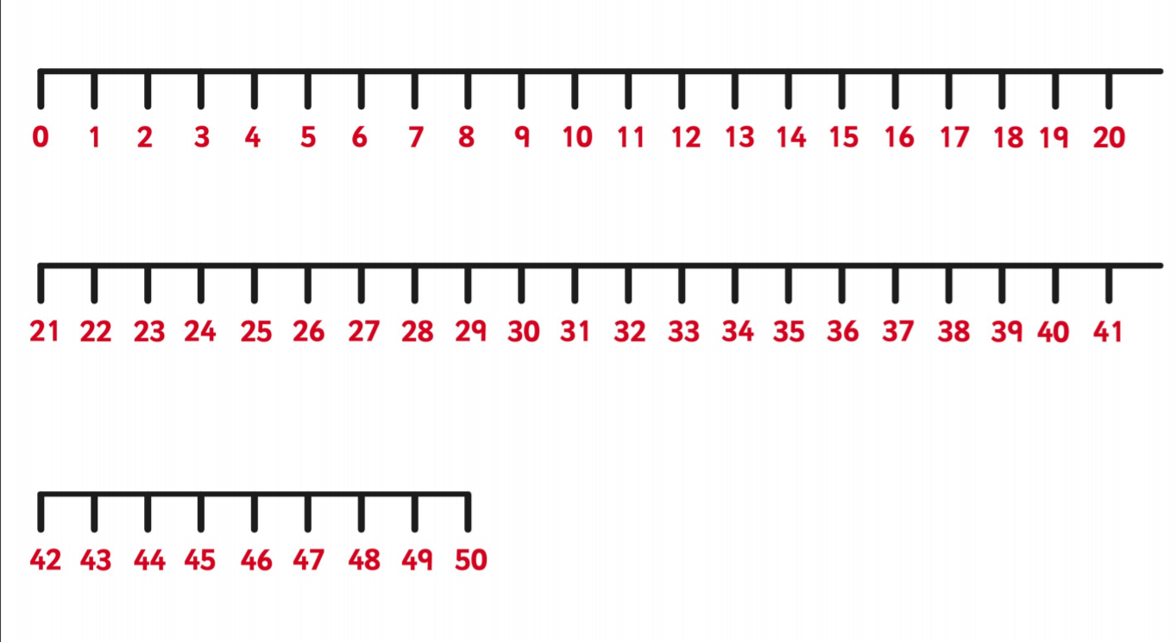

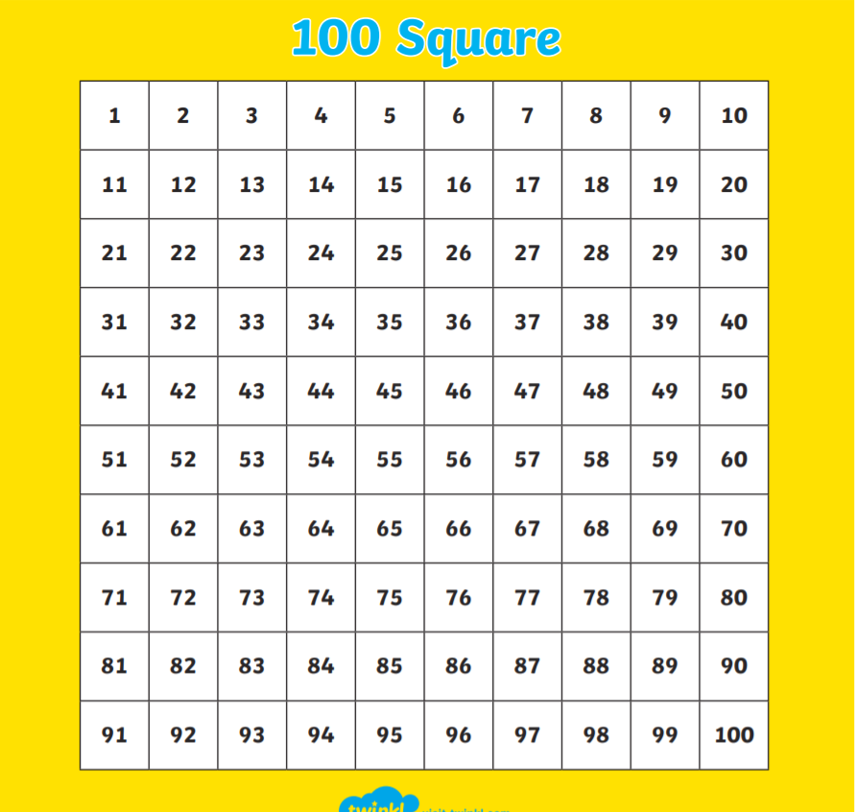

Maths

Can I put objects into groups of 10?
Can I count BACKWARDS in groups of 10 from 100?
Find 40 objects e.g. counters or similar.
Put them into groups of 10 (you may find it easier to put them into dishes). Draw your groups of objects here.

Now take away a group at a time until you have no objects left. As you do write the number pattern:

40 30 _____ ______ _______

Can you count back in 10’s from 100? Write down the pattern here.

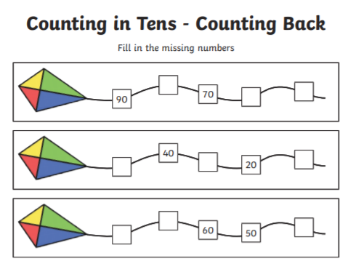

English
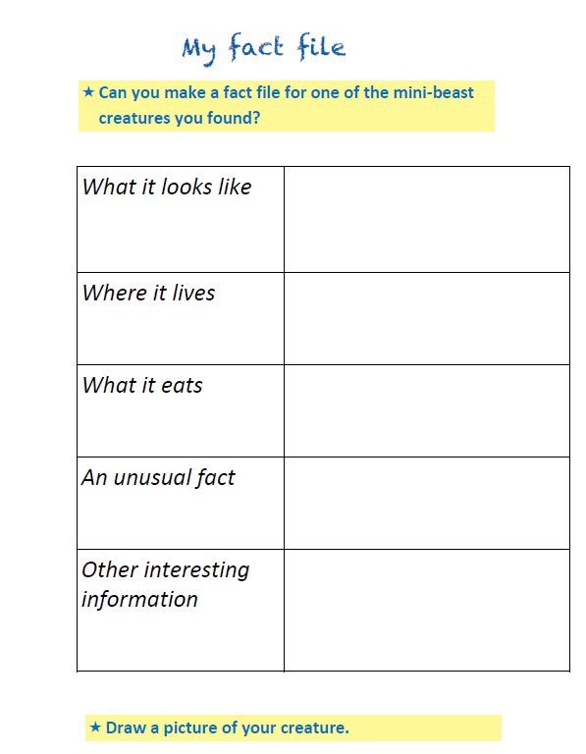

Phonics
Can I read and write words containing the oi sound?

Write the sound- be careful! Remember the o sits on the line and the tail of the y goes below.

oy____________________________________________________

Write the words to match these pictures.

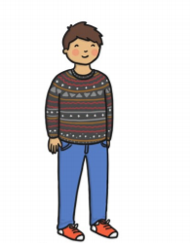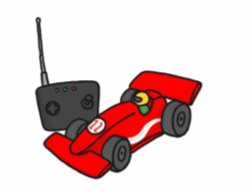

_________________ ________________________
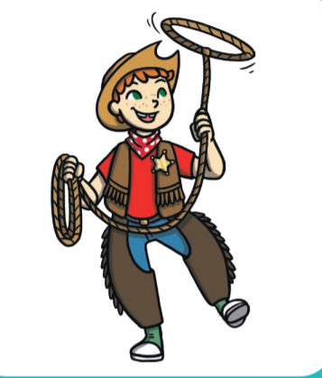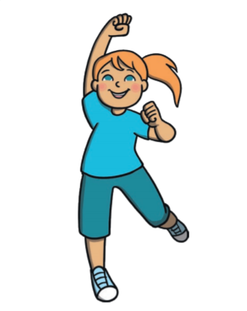
________________ __________________

Read the words containing oy
