Tuesday 2nd February 2021 YEAR 2
Enjoy doing the activities listed.
The order to do them in is suggested below but you can change them to suit you. Please send me any work, photos or comments via Tapestry. Thank you.
MORNING  Let’s get started challenge | 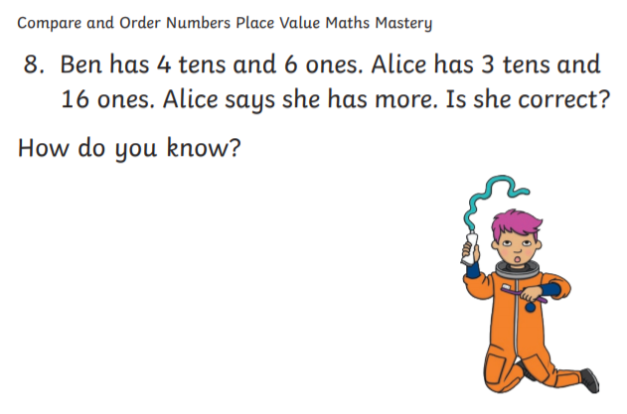  See below for enlarged versions
Music | Introduction:  - Join in with music service sessions  https://www.norfolkmusichub.org.uk/site/ugly-bug-ball-resources/  THEY HAVE REQUESTED THAT YOU DON’T SHARE THE PASSWORD ON SOCIAL MEDIA  Or https://www.bbc.co.uk/teach/school-radio/music-ks1-anansi-and-the-moss-covered-rock-2/zhrspg8  Activity: see website
English  Learning objective:  Can I move for 20 minutes and record what I have done? | Introduction  - Yesterday you imagined your superpower was listening.  - Today your superpower is sport. Your challenge is to do 20 minutes of moving or sport.  - Discuss with a grown up what you could do. There are some ideas on page 15 of the pack.  - After this you will record what you have done.  Activity:  - 20 minutes of sport or moving  - Record what you have done on page 15 or on paper  - Explain why you do or don’t like sport.  Remember the links I have given you in PE before.
Handwriting/ spellings or phonics  Learning objective:  Can I learn the tricky words water and half? | Introduction:  - So far you have learnt these new words.  both mind find  cold kind every  told behind everybody  - Today’s words are:  water half  - First- read the words.  - Second- look at the words- what do you notice?  - Third- think about how you could remember them  Top Tip: you have learnt lots of different ways to remember words which we can’t sound out.  Activity  1. Choose a way which suits you best to remember those 2 new tricky words.  2. Write a sentence for each of those words.  When you have time go over the tricky words from last term which are:  door poor  floor  fast last  past  great break  steak  again Christmas
 | Lunchtime!
AFTERNOON  Reading | Read at least 3 pages of a book
Topic  Learning objective:  Can I design a pair of glasses?  Computing  Can I understand how to use the coding cards to help the pirate gather up his treasure? | Introduction:  - Clue 5 is a pair of glasses. We sue glasses if we have problems with our eye sight.  - Our eyes are one of our five senses.  - Glasses come in all shapes and colours.  - Today you are going to design/ make your own funky glasses.  Activities. Choose ONE  Design your own glasses on paper and colour  OR use the template below  Or follow the guide below  Or make your own glasses from pipe cleaners etc.  If you can take a picture of yourself wearing them!  Computing.  Introduction:  Computers use code to follow and complete a task. Codes can be a set of rules or instructions made up of words or numbers to tell the computer what to do.  Watch the clips ‘2nd level What is an algorithm’ using the link www.bbc.co.uk/bitesize/topics/zkcqn39/articles/zqrq7ty to see how algorithms and coding are used to program a toy and how to carry out a science experiment.  Activity:  Follow the treasure map coding command cards (worksheet below) to see where the pirates treasure is on the island. Write or draw your answer in the box I have found....  If you want to challenge yourself, you could make your own set of commands to a piece of treasure of your choice and include it on the map. Test it out on someone to see if they can find the right answer.  Use the link www.bbc.co.uk/bitesize/topics/z3tbwmn/articles/zykx6sg. To play the game ‘Does Not Compute’- identifying what can be programmed.  Have fun!
Story/ yoga/ mindfulness activity | Go for a walk, even if it just around the garden and loosen up after all your hard work.
Additional notes for parents.

Let’s get started challenge

Topic
