Tuesday 2nd February 2021 YEAR 1
Enjoy doing the activities listed.
The order to do them in is suggested below but you can change them to suit you. Please send me any work, photos or comments via Tapestry. Thank you.
MORNING  Let’s get started challenge | 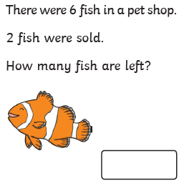  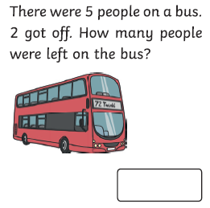  See below for enlarged versions
Music | Introduction:  - Join in with music service sessions  https://www.norfolkmusichub.org.uk/site/ugly-bug-ball-resources/  THEY HAVE REQUESTED THAT YOU DON’T SHARE THE PASSWORD ON SOCIAL MEDIA  Or https://www.bbc.co.uk/teach/school-radio/music-ks1-anansi-and-the-moss-covered-rock-2/zhrspg8  Activity: see website
English  Learning objective:  Can I spot the mistakes in Sidney’s letter?  Can I correct it by putting in capital letters and full stops? | Introduction  - Yesterday you read Sidney’s letter on page 11 of the story pack ‘Sidney Spider’.  - You spotted that there were no capital letters or full stops.  - You learnt how to write a sentence which:  - has a capital letter at the start  - has a full stop at the end  - makes sense  TOP TIP: Remember a sentence is one idea. When you change ideas you need to start a new sentence.  Activity:  - read again the letter on page 11  - look at  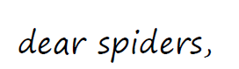  What is the mistake? There is no capital letter.  Can you get a pen and change it on the letter.  - Now look at  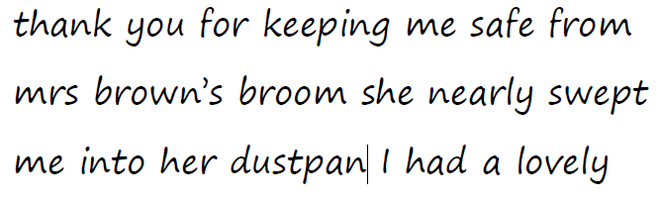  This needs to be broken down into 2 sentences  Thank you for keeping me safe from Mrs Brown’s broom.  and  She nearly swept me into her dustpan.  You can show this by putting a capital letter at the start of each sentence and a full stop at the end.  Activities  Go through the letter and use a pen to put in capital letters where you think a new sentence should start and a full stop at the end.  Extension: people’s names also have capital letters.
Handwriting/ spellings or phonics  Learning objective:  Can I learn the tricky words for this half term? | Introduction:  - You have learnt in the last 4 weeks the tricky words for this term :  here come one  where some they  there your  - Today we will be concentrating on learning the ones we are not sure of.  - Which ones do you find tricky? They are the ones you need to practise using the ways you have been taught e.g. saying aloud, writing over and over again, building as a pyramid, making up a funny sentence, words within words.  Activity  - Practise those tricky words you are not confident in.  Remember learning spellings can be done in different ways.  It could be inside with paper and pens or magnetic letters  Or it could be outside with chalk or sticks in the mud.  Choose your own way!
 | Lunchtime!
AFTERNOON  Reading | Read at least 3 pages of a book  OR listen to the story of ‘The Very Busy Spider’ https://www.youtube.com/watch?v=TfL0g-XRxnA
Topic  Learning objective:  Can I design a pair of glasses?  Computing  Can I understand how to use coding cards to help the pirate gather up his treasure? | Introduction:  - Clue 5 is a pair of glasses. We use glasses if we have problems with our eye sight.  - Our eyes are one of our five senses.  - Glasses come in all shapes and colours.  - Today you are going to design/ make your own funky glasses.  Activities. Choose ONE  Design your own glasses on paper and colour  OR use the template below  Or follow the guide below  Or make your own glasses from pipe cleaners etc.  If you can take a picture of yourself wearing them!  Computing.  Introduction:  Computer code is a set of rules or instructions made up of words or numbers to tell the computer what to do.  We are going to use code today to help the pirate find his treasure.  Activity:  Follow the treasure map coding command cards (worksheet below) to see what treasure is at the end. Write or draw the answers in the box I have found....  Use the link www.bbc.co.uk/bitesize/topics/z3tbwmn/articles/zykx6sg to play the game ‘Does Not Compute’- identifying what can be programmed.  Have fun!
Story/ yoga/ mindfulness activity | Go for a walk, even if it just around the garden and loosen up after all your hard work.
Additional notes for parents.

Let’s get started challenge

Topic
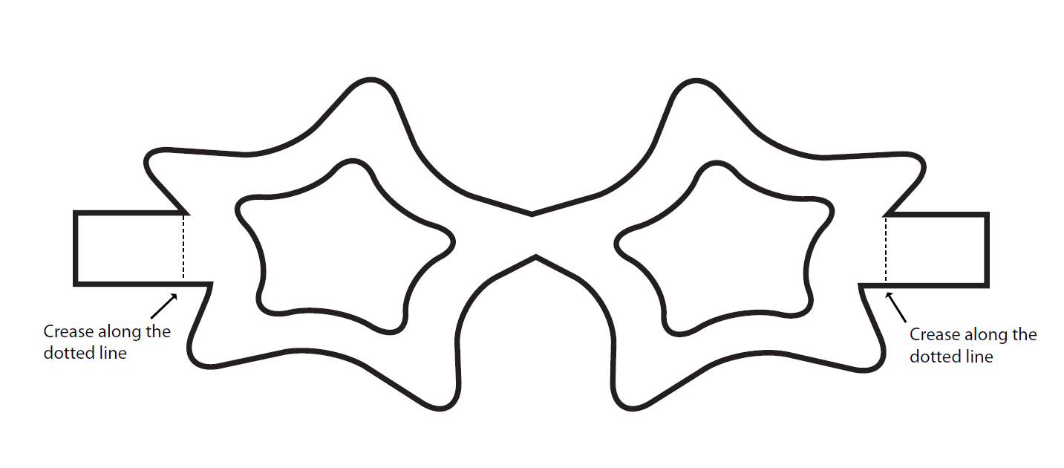

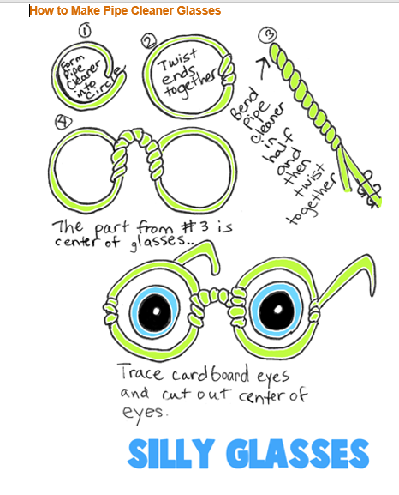

Computing
