Tuesday 23rd February 2021 YEAR 2
Enjoy doing the activities listed.
The order to do them in is suggested below but you can change them to suit you. Please send me any work, photos or comments via Tapestry. Thank you.
MORNING  Let’s get started challenge | 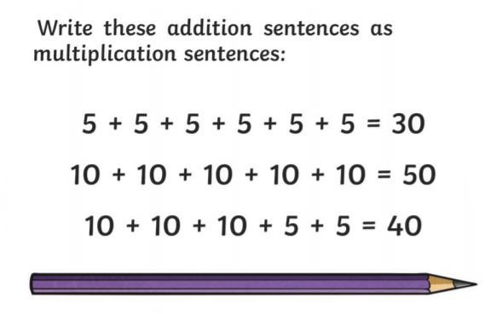  See below for enlarged versions
Music | Introduction:  - Join in with music service sessions  https://www.norfolkmusichub.org.uk/site/ugly-bug-ball-resources/  Or https://www.bbc.co.uk/teach/school-radio/music-ks1-tiddalik-the-frog-2/zv83y9q
English  Learning objective:  Can I explain what might be in the box?  Extension: Can I give reasons based on what I have read? | Yesterday we started a new pack ‘The Magical teaching Box’.  Introduction  - Recap the story so far by thinking about who the main characters are and what happened.  - Read the first part of page 6 only. It looks like this:  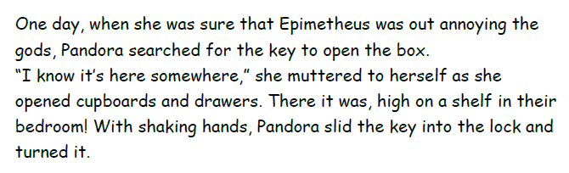  - Think about what could be in the box.  Activity:  Draw your ideas on the sheet below.
Handwriting/ spellings or phonics  Learning objective:  Can I learn the tricky words wild, child, children? | Introduction:  - This term you will learn some new words.  - First go through the tricky words from last half term  here come one  where some they  there your  - Today we will be concentrating on  child wild children  - Look at the word wild  - What makes it tricky? It is the i making the igh sound.  - Look at the word child  - How is it the same as wild?  - Now look at children, can you see how it builds on the word child?  - Practise using the ways you have been taught e.g. saying aloud, writing over and over again, building as a pyramid, making up a funny sentence, words within words Or by building on one word.  Activity  - Learn how to spell child wild children  - Write a sentence for each.
 | Lunchtime!
AFTERNOON  Reading | Read at least 3 pages of a book
Topic  Learning objective:  Can I explore my sense of TOUCH?  Computing  Online safety- Can I say what the safety rules are when playing online games? | Introduction:  - Clue 7 is an old badge  - By using our senses to explore it we can find out more. By using my SIGHT I can see some numbers and letters.  - Thank you for the TOUCH words which you sent me.  I can use these to describe the badge in more detail. It is hard, sharp, rough and a little bendy.  - Today we will find out more about our sense of TOUCH  Activities.  - Watch this short video  https://www.bbc.co.uk/bitesize/clips/zg2vcwx  - Now explore your sense of touch by choosing an activity to do from the list below.  - Play with playdough  - Do some finger /hand painting  - Build a model  - Go on a walk and feel things in nature e.g. crunchy leaves, rough bark, smooth stones etc.  - Make some mud!  - Read the story of Durer (see below)  Computing.  Introduction:  - When playing games online we need to keep safe, we have watched ‘Smartie the Penguin’ and ‘The SMART crew’ whose rules were:  S - Keep safe by being careful not to give out personal information when you’re chatting or posting online. Personal information includes your email address, phone numbers and passwords.  M - Meeting someone you have only been in touch with online can be dangerous; not everyone online is who they say they are. If you like chatting online, it’s best to only chat to your real-world friends and family.  A - Accepting emails, instant and direct messages, or opening files, images or texts from people you don’t know, or trust can lead to problems – they may contain viruses or nasty messages.  R – Information on the internet may not always be true; it may be factually incorrect always check by looking at other websites, in books, or with someone who knows.  T - Tell a parent, carer or a trusted adult if someone, or something, makes you feel upset, worried or uncomfortable.  Can you think of any others?  Activity  - Watch lesson 3: Playing games on www.thinkuknow.co.uk/4_7/online-safety-video-lessons/  - If you can fill in the Keep It Private worksheet with a grown up and say what things you enjoy doing online. These things make a picture of your ‘digital footprint’ (trail of data you create while using the internet).  Don’t worry if you can’t watch the video clip, have a think back to lessons at school where we have talked about online safety and just have a go at the worksheets.
Story/ yoga/ mindfulness activity | Go outside and listen to the birds. Take a minute to be still.
Additional notes for parents.

Let’s get started challenge

English
Can I explain what might be in the box?
Extension: Can I give reasons based on what I have read?
In the box …….

I think these things will be in the box because…..

Topic
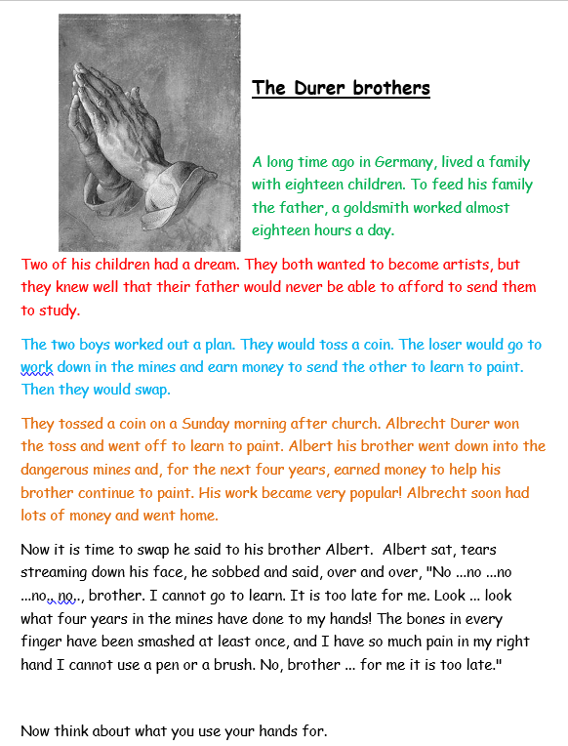

Computing
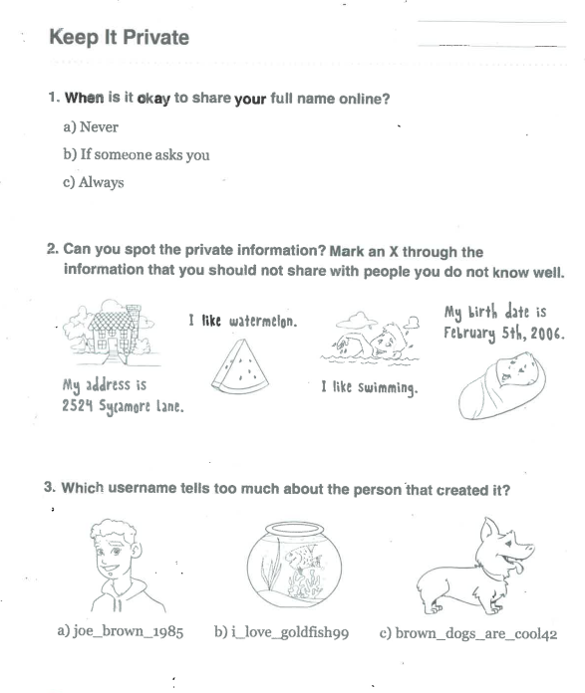

What do you enjoy doing online?

