Tuesday 23rd February 2021 YEAR 1
Enjoy doing the activities listed.
The order to do them in is suggested below but you can change them to suit you. Please send me any work, photos or comments via Tapestry. Thank you.
MORNING  Let’s get started challenge | 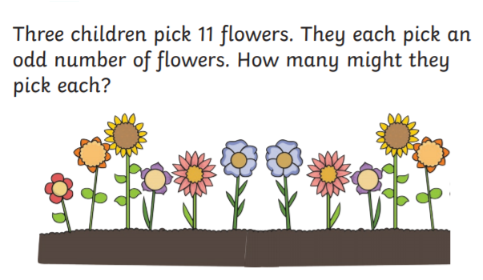  See below for enlarged versions
Music | Introduction:  - Join in with music service sessions  https://www.norfolkmusichub.org.uk/site/ugly-bug-ball-resources/  Or  https://www.bbc.co.uk/teach/school-radio/music-ks1-tiddalik-the-frog-2/zv83y9q  Complete the sequencing sheet below if you would like to  Or colour the animals in the story.
English  Learning objective:  Can I listen carefully to the story and be able to say which character said what? | Yesterday we started a new pack ‘Brian Bear’s Picnic’.  Introduction  - Read the story again or listen to it  https://soundcloud.com/talkforwriting/brian/s-Tdy7BXbHz4i  - As you read or listen think about who said what ready for the activity today.  - Quick quiz. Are you ready? Who said:  “Keep out of their way”  “Um, um, we gave it all away.”  “We need some honey”.  Activity:  Complete page 6 of the pack.
Handwriting/ spellings or phonics  Learning objective:  Can I learn the tricky words pull and full? | Introduction:  - This term you will learn some new words.  - First go through the tricky words from last half term  here come one  where some they  there your  - Today we will be concentrating on pull full  - Look at the word pull  - What makes it tricky? Try and learn the word pull  - Now look at full. Can you see how it is nearly the same as pull?  - Practise using the ways you have been taught e.g. saying aloud, writing over and over again, building as a pyramid, making up a funny sentence, words within words.  Activity  Write 2 sentences, one sentence using the word pull and one sentence using the word full.
 | Lunchtime!
AFTERNOON  Reading | Read at least 3 pages of a book.  Remember you can pick reading book packs up from school.
Topic  Learning objective:  Can I explore my sense of TOUCH?  Computing  Online safety- Can I say what the safety rules are when playing online games? | Introduction:  - Clue 7 is an old badge  - By using our senses to explore it we can find out more. By using my SIGHT I can see some numbers and letters.  - Thank you for the TOUCH words which you sent me.  I can use these to describe the badge in more detail. It is hard, sharp, rough and a little bendy.  - Today we will find out more about our sense of TOUCH  Activities.  - Watch this short video  https://www.bbc.co.uk/bitesize/clips/zg2vcwx  - Now explore your sense of touch by choosing an activity to do from the list below.  - Play with playdough  - Do some finger /hand painting  - Build a model  - Go on a walk and feel things in nature e.g. crunchy leaves, rough bark, smooth stones etc.  - Make some mud!  Computing.  Introduction:  - When playing games online we need to keep safe, we have watched ‘Smartie the Penguin’ and ‘The SMART crew’ whose rules were:  S - Keep safe by being careful not to give out personal information when you’re chatting or posting online. Personal information includes your email address, phone numbers and passwords.  M - Meeting someone you have only been in touch with online can be dangerous; not everyone online is who they say they are. If you like chatting online, it’s best to only chat to your real-world friends and family.  A - Accepting emails, instant and direct messages, or opening files, images or texts from people you don’t know, or trust can lead to problems – they may contain viruses or nasty messages.  R – Information on the internet may not always be true; it may be factually incorrect always check by looking at other websites, in books, or with someone who knows.  T - Tell a parent, carer or a trusted adult if someone, or something, makes you feel upset, worried or uncomfortable.  Can you think of any others?  Activity  - Watch lesson 3: Playing games on www.thinkuknow.co.uk/4_7/online-safety-video-lessons/  - If you can fill in the Keep It Private worksheet with a grown up and say 5 people who can help you when you have a problem online using the A Helping Hand worksheet.  Don’t worry if you can’t watch the video clip, have a think back to lessons at school where we have talked about online safety and just have a go at the worksheets.
Story/ yoga/ mindfulness activity | Go outside and listen to the birds. Take a minute to be still.
Additional notes for parents.
Let’s get started challenge

Music

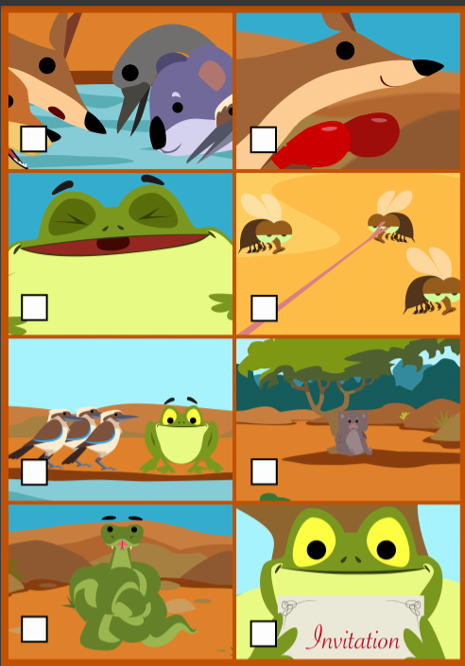

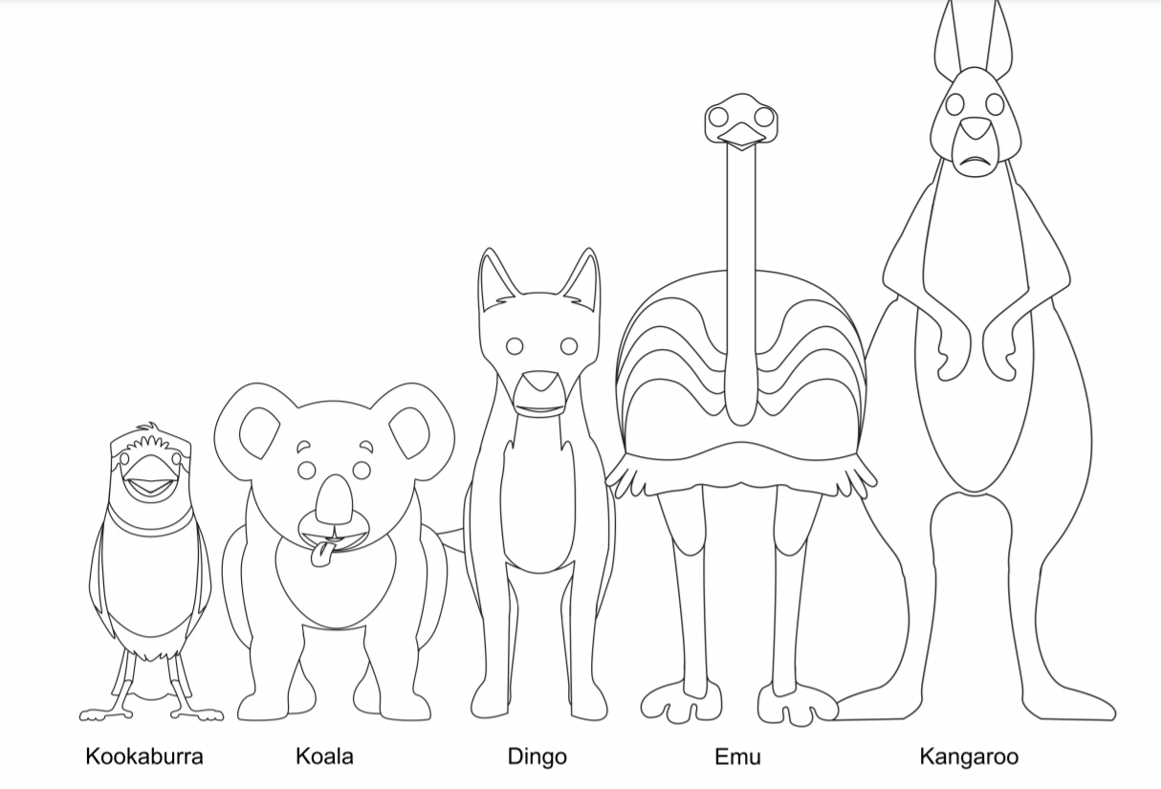

Computing 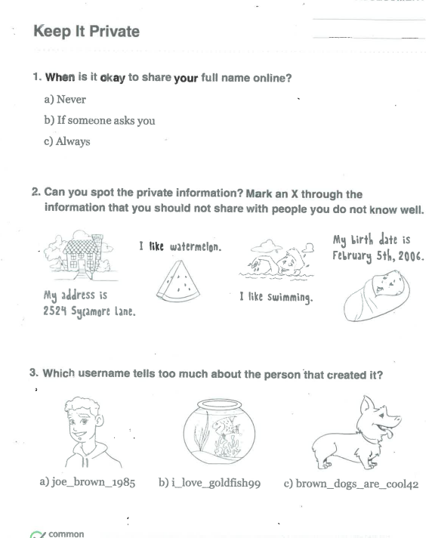

Who helps you when you have a problem on the internet?
Think of 5 people and put one on each finger.

