Thursday 4th February 2021 YEAR 2
Enjoy doing the activities listed.
The order to do them in is suggested below but you can change them to suit you. Please send me any work, photos or comments via Tapestry. Thank you.
MORNING  Let’s get started challenge | 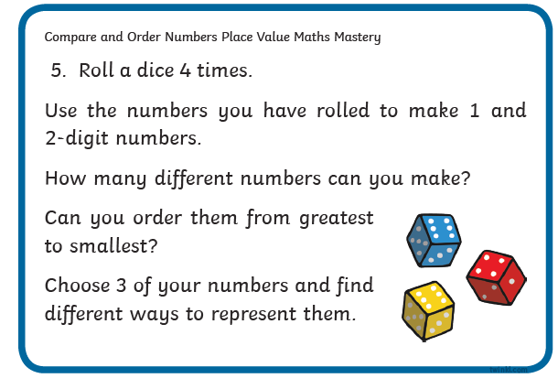  See enlarged versions below
Maths  Learning objective:  All children  Can I write a repeated addition and a multiplication sum for each picture problem?  Some children  Can I learn the x5 table? | This week we will be counting in groups of 2, 5 and 10 and seeing the link between repeated addition and multiplication  Introduction  - Today we will be looking at counting in groups of 5 and the x5 table.  - First practice counting on in fives.  Repeat it until you are confident  0 5 10 15 20 25 30 35 40 45 50 55 60  - What do you notice about the final digit in each number?  TOP TIP: when counting in groups of 5 the final digit will  always be 0 or 5  - If you are not sure look at it on a 100 square and complete the pattern (see sheet in work below)  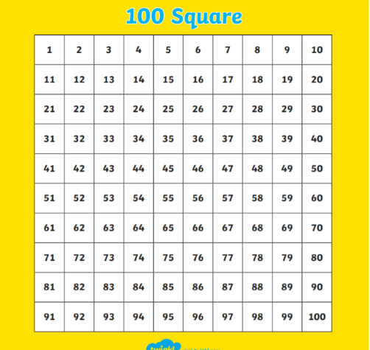  - Look at this question: How many spots altogether?  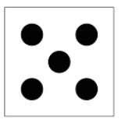  We can work it out by counting aloud in fives.  - BUT…. how can we show it as a sum?  We could write  5 + 5 + 5 = 15  OR we could write it as 3 x 5 = 15  Remember: the first number is the number of groups (in this case dice) and the second number is the number in each group.  +5 +5 +5  0 5 10 15  - Arrays 3 rows of 5  - Try writing 2 sums for this problem.  First write a repeated addition sum and then write a multiplication sum.  How many spots?  Does your answer look like this:  5 + 5 + 5 + 5 = 20  4 x 5 = 20  Now can you show it on a number line and as an array?  Activities  All children  - Write sums for the pictures- as you have been doing above (see worksheet below).  Most children  - Watch https://www.bbc.co.uk/bitesize/topics/zqbg87h/articles/zw8qxfr  - try the activities on the same page  - learn x5 table using mathletics  go to explore  then videos  then scroll down to x5 song  or this movement song!  https://www.bbc.co.uk/teach/supermovers/ks1-maths-the-5-times-table/zhbm47h
English  Learning objective:  Can I join 2 letters? | Introduction  - Today you will be practising the first of your joined letters. You will be joining from the bottom of a letter to the top of the next letter.  - First try making a pattern  - Can you make them an even size?  - Now try doing the same pattern on a line.  _________________________  - Now try  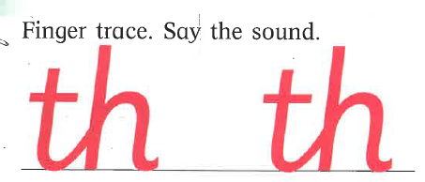  TOP TIP: keep your pencil on until you have joined a l and a h and then go back and add the cross piece for the t  Activity :  Try the page below.
Handwriting/ spellings, grammar, punctuation or phonics  Learning objective:  Can I learn the tricky words for this half term? | Introduction:  - You have learnt in the last 4 weeks the tricky words for this term :  both mind find  cold kind every  told behind everybody  water half  - Today you will be concentrating on learning the ones you are not sure of.  - Which ones do you find tricky? They are the ones you need to practise using the ways you have been taught e.g. saying aloud, writing over and over again, building as a pyramid, making up a funny sentence, words within words.  Activity  - Practise those tricky words you are not confident in.  Remember learning spellings can be done in different ways.  It could be inside with paper and pens or magnetic letters  Or it could be outside with chalk or sticks in the mud.  Choose your own way!
 | Lunchtime!
AFTERNOON  Reading | Read at least 3 pages of a book.
RE  (Mrs Watson)  Learning objective:  See Power Point | RE  See PowerPoint
Story/ yoga/ mindfulness activity | Cosmic yoga
Additional notes for parents.

Let’s get started challenge

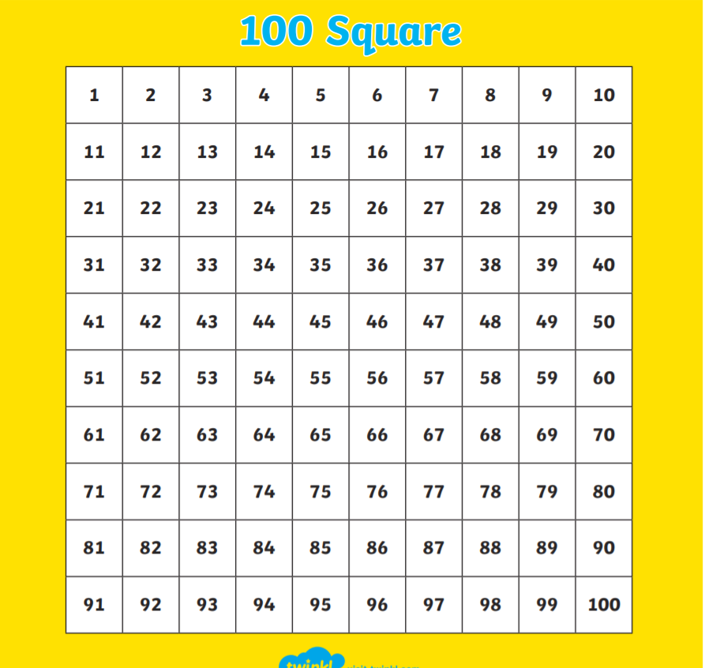

Maths: level 1
Can I write a repeated addition and a multiplication sum for each picture problem?
Example
5 + 5 + 5 + 5 = 20
4 x 5 = 20
Now your turn

Draw a picture to show this sum 8 x 5 = 40

English: handwriting
Continue the pattern

________________________________________________________

Trace over
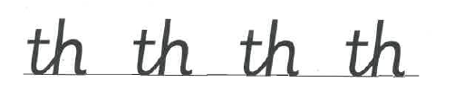
Now try on your own.

___________________________________________________________

Can you write these words?
_____________________________________________

