Thursday 4th February 2021 YEAR 1
Enjoy doing the activities listed.
The order to do them in is suggested below but you can change them to suit you. Please send me any work, photos or comments via Tapestry. Thank you.
MORNING  Let’s get started challenge | 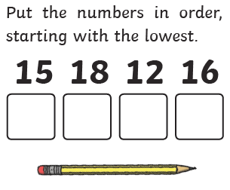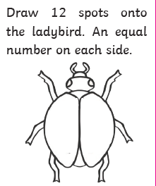  See enlarged versions below
Maths  Learning objective:  Can I count aloud in groups of 5 to at least 50?  Can I use what I know about counting in fives to solve problems? | This week we will be counting in groups of 2, 5 and 10. This will help you to learn your times tables in year 2.  For this lesson you may find it useful to have somethings to count with e.g. buttons, counters  Introduction  - This week we have found it much quicker to count in groups of 2 and 10.  - Today we will be learning how to count in groups of 5  - First we will learn how to count in fives and the numbers you land on and then you can use what you have learnt.  - Use the number line to count in fives.  - Start at 0 and each time make a jump of 5.  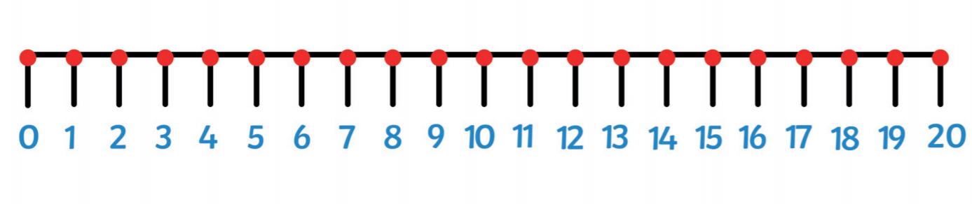  - Can you continue counting in jumps of 5 on the number line below?  - What numbers do you land on? Say them lots of times until they are fixed in your head.  - Now turn the number line over. Can you still say the numbers you would land on if you counted in fives?  Go to activity 1  OR  - If you would like another challenge try the same thing on a 100 square. This time colour the squares that you land on.  - What do you notice?  Top tip: when you count in fives the last digit will always be  0 or 5  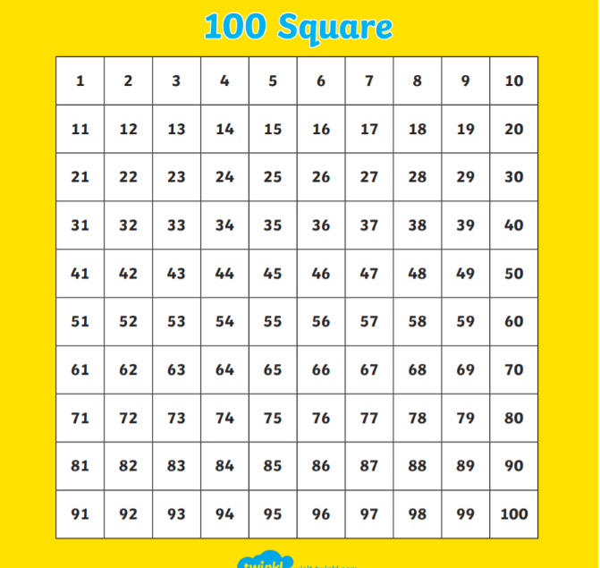  Activities  ALLCHILDREN  Watch https://www.bbc.co.uk/bitesize/articles/zhfjqp3. part a  - Then try one of the activities in activity 1 part of the webpage.  - Say the pattern of fives aloud 0 5 10 etc. until you  know it off by heart.  SOME CHILDREN-  - You may like to extend your learning further by watching the second video – part b  - Try the activities in activity 2 on the webpage.  (the sheet is also copied below)
English  Learning objective:  Can I write a list of the mini-beasts I have found? | Introduction  - So far we have read a story, a song/poem and a letter about a spider.  - Today we will read some facts or information. We call this no-fiction.  - Do you know any facts about spiders?  - Read page 13 of your ‘Sidney Spider’ pack with a grown up.  - Talk about what you have found out.  Activity :  Go on a spider hunt. I have lots in my house! But you might also be able to find some outside hiding in cracks in buildings and trees. They also love corners.  Maybe you will spot as cobweb. If it is a frosty day they show up really well.  As you go on your spider hunt you may find other mini-beasts as well.  Write down what you see in the order you see them on paper or on the sheet below.  Remember: if you pick any creature up be very careful not to harm them. If you can, look but don’t pick up. Always put them back where you found them.  KEEP YOUR LIST FOR FRIDAY
Handwriting/ spellings or phonics  Learning objective:  Can I learn the tricky words for this half term? | Introduction:  - You have learnt in the last 4 weeks the tricky words for this term :  here come one  where some they  there your  - Today we will be concentrating on learning the ones we are not sure of.  - Which ones do you find tricky? They are the ones you need to practise using the ways you have been taught e.g. saying aloud, writing over and over again, building as a pyramid, making up a funny sentence, words within words.  Activity  - Practise those tricky words you are not confident in.  Remember learning spellings can be done in different ways.  It could be inside with paper and pens or magnetic letters  Or it could be outside with chalk or sticks in the mud.  Choose your own way!
 | Lunchtime!
AFTERNOON  Reading | Read at least 3 pages of a book.
RE  (Mrs Watson)  Learning objective:  See power point | See PowerPoint
Story/ yoga/ mindfulness activity | Cosmic yoga
Additional notes for parents.

.
Let’s get started challenge

Cut the strips out and stick together to make a number line 0-50.
Then jump in groups of 5

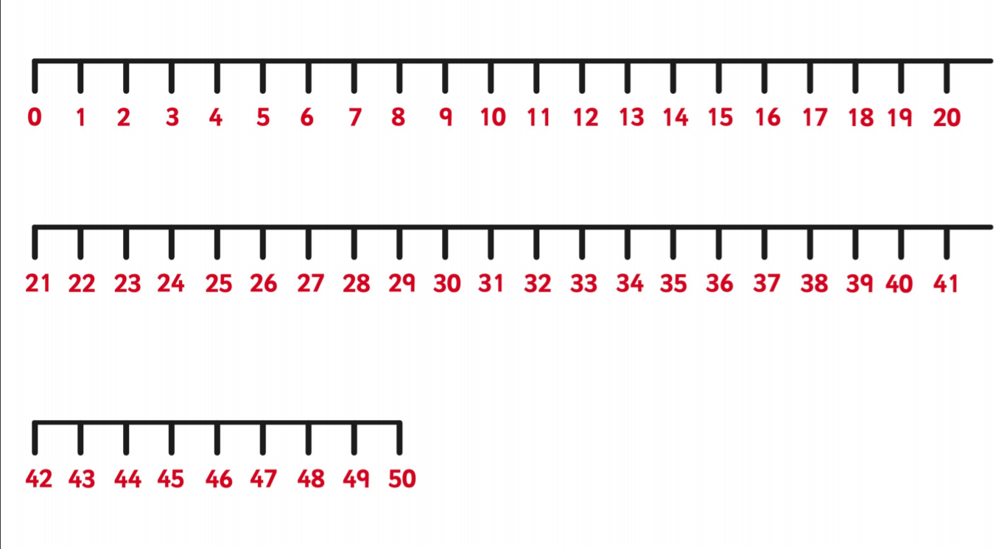
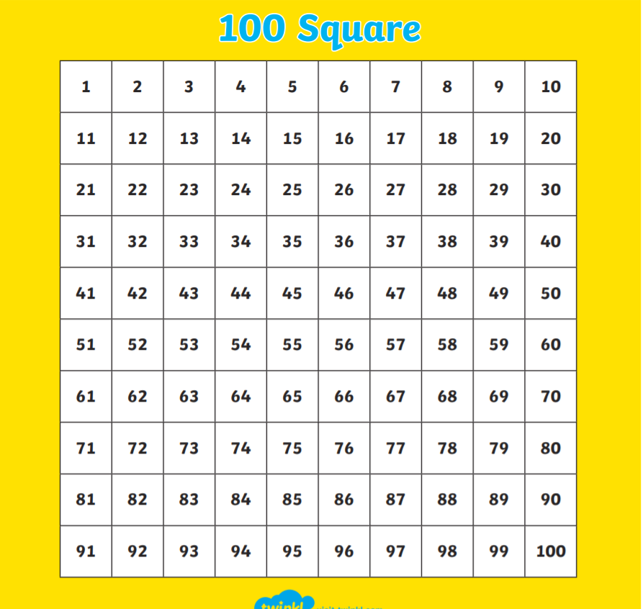

Extra Maths: (only if you are confident in counting in fives)
Can I count in groups of 5 to at least 50?
Can I use what I know about counting in groups of 5 to solve problems?

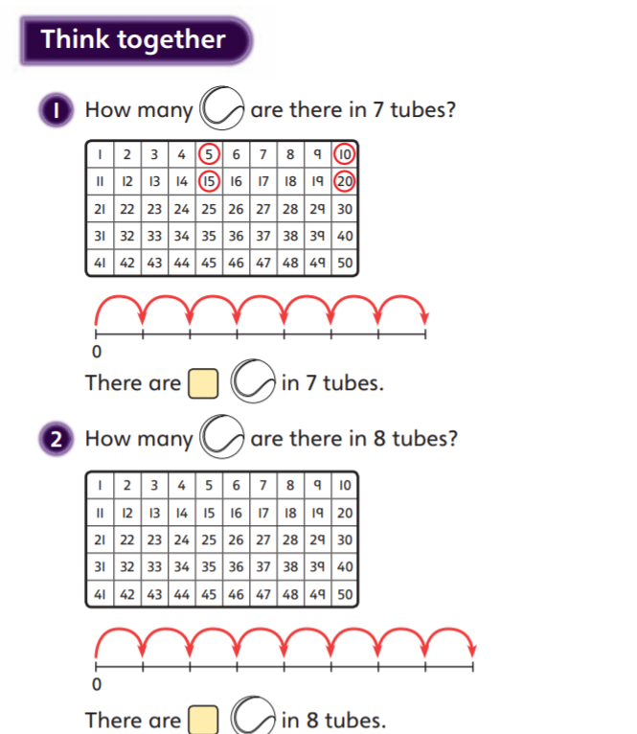

English
Can I write a list of the mini-beasts I have found?

- ___________________________________

- ___________________________________

- ___________________________________

- ___________________________________

- ___________________________________

