Thursday 25th February 2021 YEAR 2
Enjoy doing the activities listed.
The order to do them in is suggested below but you can change them to suit you. Please send me any work, photos or comments via Tapestry. Thank you.
MORNING  Let’s get started challenge | 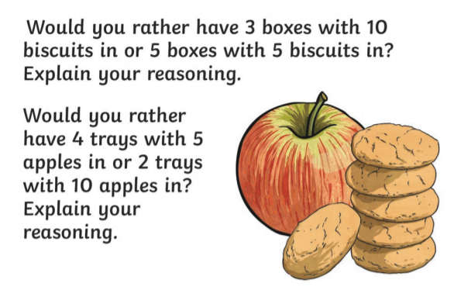  See enlarged versions below
Maths  Learning objective:  Can I read and set the time to o’clock and half past? | This week you have learnt the days of the week and the months of the year.  Today you will be learning how to tell the time using o’ clock and half past.  You need to begin by making a clock with moving hands- see template on school website to cut out and make below  Or follow link https://www.twinkl.co.uk/resource/T-N-062-Clocks-blank  Keep this for tomorrow too.  Introduction  - Look at this clock  The minute hand (the longest one) is pointing to the 12.  This means it is o clock.  The hour hand (the shortest hand) is pointing to the 1.  It is 1 o clock  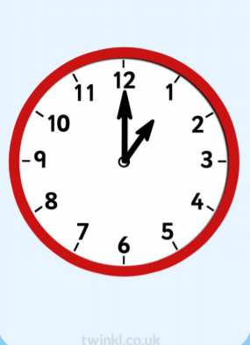  - Look at this clock.  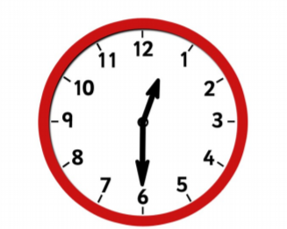  The minute hand (the longest one) is pointing to the 6.  This means it is half past.  The hour hand (the shortest hand) is pointing just past the 1.  It is half past one.  - Follow the lesson here if you can. Start with the quiz to test your knowledge so far.  https://classroom.thenational.academy/lessons/reading-and-writing-the-time-to-oclock-and-half-past-part-1-6wwpat  - If you can’t access Oak Academy then use these power points to help you. They can be printed off or accessed via  https://www.twinkl.co.uk/resource/t-n-7132-telling-the-time-powerpoint o clock  https://www.twinkl.co.uk/resource/t-n-4546-new-telling-the-time-half-past half past  Activities  Take part in the activities on the Oak Academy website.  The activity sheet is copied below.  Or if you can’t access the Oak academy complete the sheet below
English  Learning objective:  Can I express my thoughts about the story?  Extension: Can I give reasons for my answers? | Introduction  - This week you have been exploring the story of Pandora and her box.  - Did you like the story?  - What did you especially like about the story and why?  - Were there any parts you didn’t like? Why?  - Did any parts surprise you?  Activity :  Fill in the sheet below.
Handwriting/ spellings or phonics  Learning objective:  Can I spell the tricky words child, wild and children? | Introduction:  - On Tuesday you learnt 3 new spellings, using one word to help you learn 2 more.  - Can you remember how to spell child, wild children?  Activity  1. Practise the spellings of child, wild children  - If you are confident in them embed your understanding of them by playing a game.  Activity  Tricky word dominoes! Cut out the tricky words below and match them up.  (worksheet below)
 | Lunchtime!
AFTERNOON  Reading | Read at least 3 pages of a book.
RE  (Mrs Watson)  See Power Point | See Power Point
Story/ yoga/ mindfulness activity | Cosmic yoga
Additional notes for parents. | Watch out for additional notes tomorrow as preparation for next week.

.
Let’s get started challenge

Maths
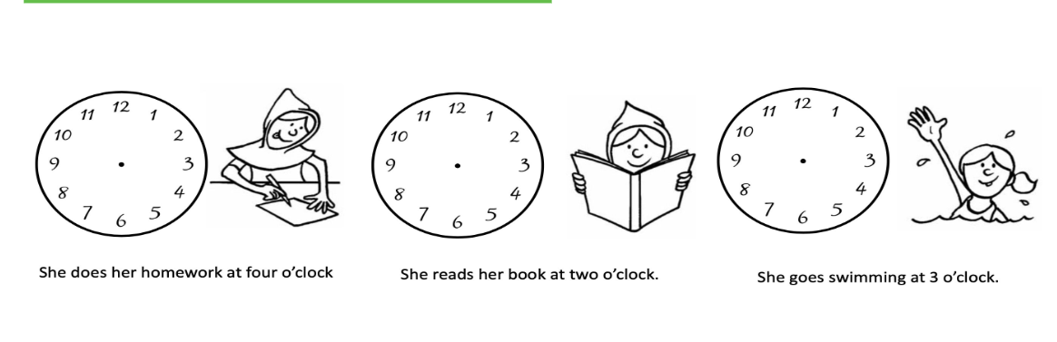
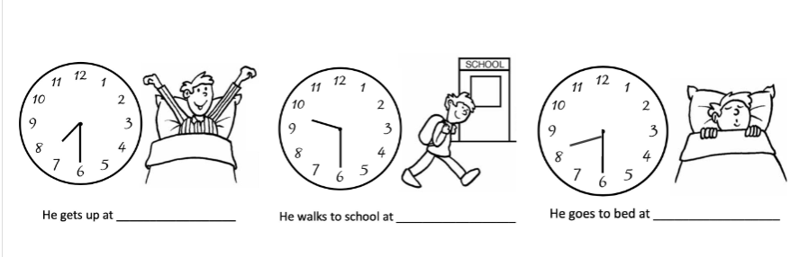
English
Can I express my thoughts about the story?
Extension: Can I give reasons for my answers?

The part of the story I liked most was…..

________________________________________________
_________________________________________________

Because
_________________________________________________
_________________________________________________

The part of the story I didn’t like so much was…………….
________________________________________________
_________________________________________________

Because
_________________________________________________
_________________________________________________

Spellings
Cut out the dominoes and match them up.

child | wild

children | child

wild | children

child | wild

