Thursday 25th February 2021 YEAR 1
Enjoy doing the activities listed.
The order to do them in is suggested below but you can change them to suit you. Please send me any work, photos or comments via Tapestry. Thank you.
MORNING  Let’s get started challenge | 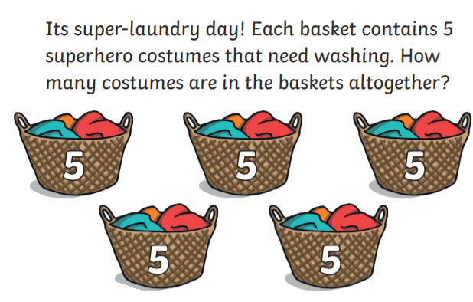  See enlarged versions below
Maths  Learning objective:  Can I read and set the time to o’clock? | This week you have learnt the days of the week and the months of the year.  Today you will be learning how to tell the time using o’ clock  You need to begin by making a clock with moving hands- see template on school website to cut out and make below  Or follow link https://www.twinkl.co.uk/resource/T-N-062-Clocks-blank  Keep this for tomorrow too.  Introduction  - Look at this clock.  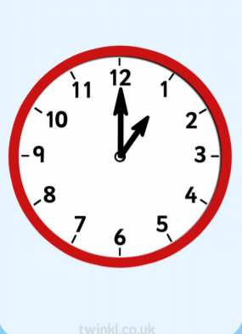  The minute hand (the longest one) is pointing to the 12.  This means it is o clock.  The hour hand (the shortest hand) is pointing to the 1.  It is 1 o clock  Now use the lesson and activities for Oak Academy to teach you about how to read and set the time to o’clock.  - Follow the lesson here if you can. Start with the quiz to test your knowledge so far.  https://classroom.thenational.academy/lessons/reading-and-writing-the-time-to-oclock-part-1-69jk6t?activity=video&step=2&view=1  If you can’t access Oak Academy then use this power point to help you. It can be printed off or accessed via  https://www.twinkl.co.uk/resource/t-n-7132-telling-the-time-powerpoint  Activities  Take part in the activities on the Oak Academy website.  The sheet to write the times on is copied below.  Or completer the sheet below even if you haven’t been following the oak academy lesson
English  Learning objective:  Can I understand the meanings of new words? | Introduction  - So far this week you have read the story ‘Brian Bear’s Picnic’ and shown that you understand it by answering questions.  - Read the story again today and look out for any words you may not have heard before or don’t understand what they mean.  - Can you find the words ‘scrumptious’ and ‘succulent’?  - Discuss what they mean.  - Can you think of any food you like which is scrumptious and succulent?  Activity :  Complete page 8 of the pack.
Handwriting/ spellings or phonics  Learning objective:  Can I learn the tricky words pull full? | Introduction:  - This week you learnt some new tricky words. They were pull full  - Did you find them tricky? If you did write them out again.  Activity  Play dominoes using the cards below (some are your spellings from last term as well).
 | Lunchtime!
AFTERNOON  Reading | Read at least 3 pages of a book.
RE  (Mrs Watson)  See Power Point | See Power Point.
Story/ yoga/ mindfulness activity | Cosmic yoga
Additional notes for parents. | Watch out for additional notes tomorrow as preparation for next week.

.

Let’s get started challenge

Maths
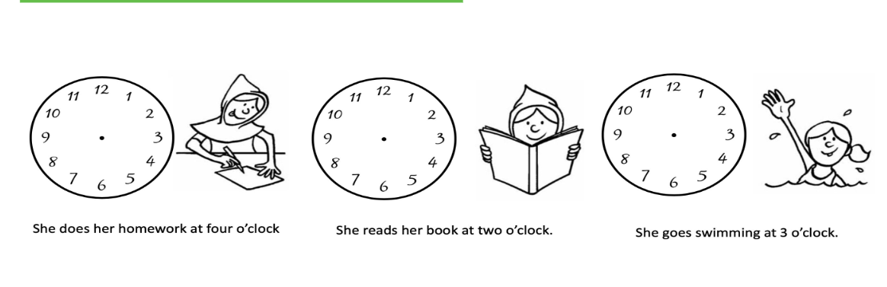
Phonics
Cut out the dominoes and match up the same words
pull | full

here | there

where | full

full | pull

there | where

here | here

