Thursday 11th February 2021 YEAR 2
Enjoy doing the activities listed.
The order to do them in is suggested below but you can change them to suit you. Please send me any work, photos or comments via Tapestry. Thank you.
MORNING  Let’s get started challenge | Have a change from Joe by trying out these! Make a choice to suit you and how you are feeling!  https://imoves.com/the-imovement
Maths  Learning objective:  All children  Can I write a repeated subtraction and a division sum for groups of 5?  Some children  Can I use multiplication facts to help me work out division? | This week we will be counting in groups of 2, 5 and 10 and seeing the link between repeated subtraction and division.  Introduction  - Today we will be looking at grouping into groups of 5 and start seeing the link with the x5 table.  - Look at this question: How many groups of 5 spots?  First count in groups of 5 to find the total.  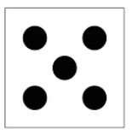 15  - We can work it out by splitting them into equal groups of 5  - So the answer is 3 groups  - We could count back to check as a repeated subtraction sum  15 - 5 - 5 - 5 = 0  - Or we can write is as 15 ÷ 5 = 3.  This can be read as ‘how many groups of 5 are there in 15?’  Here are some different ways to work out division:  - 15 ÷ 5 = 3 is the same as 15 – 5-5-5 =0 i.e. repeated subtraction  -5 -5 -5  0 5 10 15  - Arrays 15 divided into groups of 5 is 3 rows.  - Use the x5 table.  - Remember when you divide by 5 the answers will always end in 5 or 0.  - It can’t be done in any order.  - It can be checked by multiplying.  Now try this problem: How many groups of 5?  first count the total, then put into groups of 5  Does your answer look like this: 20  1 2 3 4  20 - 5 - 5 - 5 - 5 = 0  - Or 20 ÷ 5 = 4.  Now can you show it on a number line and as an array?  Activities  All children maths challenge 1  - Write sums for the pictures as you have been doing above (see worksheet below).  Some children maths challenge 2
English  Learning objective:  Can I join 2 letters? | Introduction  - Today you will be practising some joined letters. You will be joining from the bottom of a letter to the top of the next letter.  - First try making a pattern  - Now try doing the same pattern on a line.  _________________________  - Now try  TOP TIP: keep your pencil on until you have joined an a and a l and then go back and add the cross piece for the t  Activity :  Try the page below.
Handwriting/ spellings, grammar, punctuation or phonics  Learning objective:  Can I use the conjunctions because, if when to join 2 parts of a sentence together? | Introduction:  - This week you have learnt about coordinating conjunctions. Today is the last activity when you will use  because, if, when.  - If you need to watch again the video on the oceans https://www.bbc.co.uk/bitesize/articles/z6rvbdm  Activity  Now try Activity 3 on the same webpage: Writing some sentences using 'because', 'if' and 'when'  Write six sentences about the ocean using because, if or when. You might want to watch the video again to get some ideas.  Try and write two sentences for each conjunction.  For example:  Whales swim to the surface because they need to breathe.  Top tip! Remember to use capital letters at the start of your sentences and punctuation at the end.
 | Lunchtime!
AFTERNOON  Reading | Read at least 3 pages of a book.
RE  (Mrs. Watson) | see attached Power Point.
Story/ yoga/ mindfulness activity | If you haven’t already tried this have a look at  http://www.robbiddulph.com/draw-with-rob  and learn how to draw some characters  or go out for a walk.
Additional notes for parents. | One more day to go!

Maths: level 1
Can I write a repeated subtraction and a division sum for each picture problem?
20 - 5 - 5 - 5 - 5 = 0
20 ÷ 5 = 4
Now your turn

Draw a picture to show this sum 40 ÷ 5 = 8

Maths challenge 2

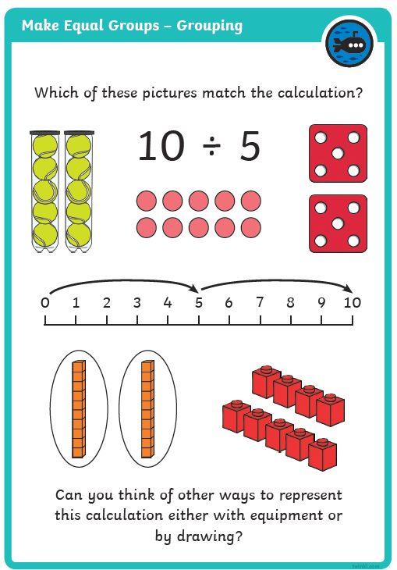

English: handwriting
Continue the pattern

________________________________________________________

Trace over
Now try on your own.

___________________________________________________________

Can you write these words?

-------------------------------------------------------------------------------------------------

--------------------------------------------------------------------------------------------------

-------------------------------------------------------------------------------------------------
