Thursday 11th February 2021 YEAR 1
Enjoy doing the activities listed.
The order to do them in is suggested below but you can change them to suit you. Please send me any work, photos or comments via Tapestry. Thank you.
MORNING  Let’s get started challenge | Have a change from Joe by trying out these! Make a choice to suit you and how you are feeling!  https://imoves.com/the-imovement
Learning objective:  All children  Can I put objects into groups of 5?  Can I count BACKWARDS in groups of 5 from 50? | Last week you learnt how to count forwards in groups of 2, 5 and 10. This week we will be counting backwards in the same groups.  We will also be learning how to share which will help you with division in year 2.  For this lesson you may find it useful to have somethings to count with e.g. buttons, counters .  Introduction  - First a quick quiz!  Finish the pattern:  0 5 10 15 ___ ____ ____ _____ ___  What’s missing?  0 5 10 15 _____ 25 30  What’s my mistake? Can you explain what I have done wrong?  10 15 20 30 35  - Use the number line to count BACK in fives.  - Start at 20 and each time make a jump of 5.  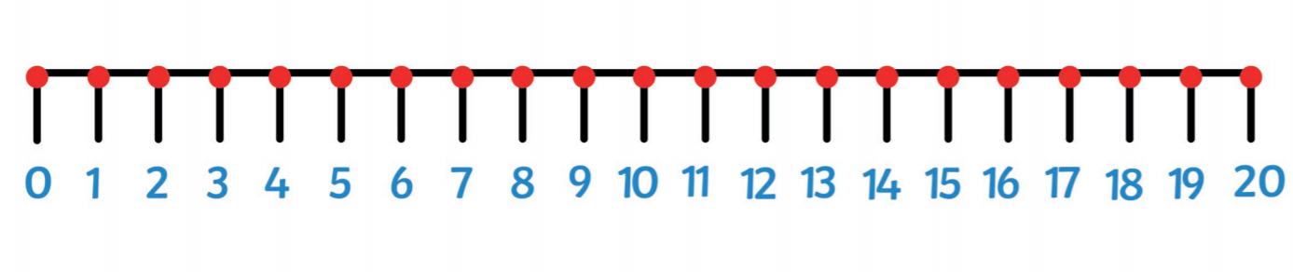  - Can you continue counting BACK in jumps of 5 on the number line from 50 below?  Top tip: when you count in fives the last digit will always be 5 or 0  - What numbers do you land on? Say them lots of times until they are fixed in your head.  - Now turn the number line over. Can you still say the numbers you would land on if you counted BACK in fives?  Go to activity 1 OR  - If you would like another challenge try the same thing on a 100 square. This time colour the squares that you land on.  - What do you notice?  What do you notice about the numbers? Are they the same as counting FORWARDS in fives?  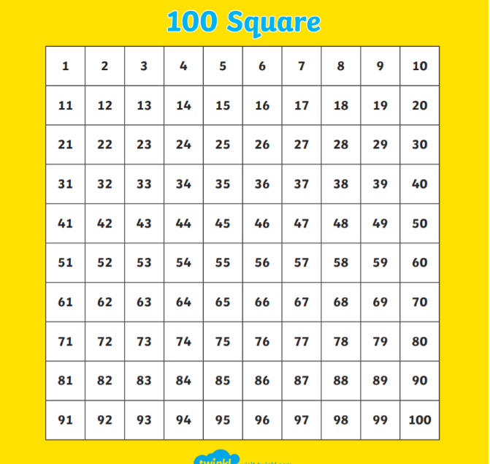  Activities  All children  - Get out 15 counters (or similar) and put them into groups of 5. You may find it easier to put them in dishes.  Start at 15 and count BACK in 5’ as you take away a group of five at a time until you end up at 0  15 10 5 0  - Repeat- but this time start with 20 objects. Put into groups of five and take way a group at a time. Count BACK in 5’s as you go until you have no objects left.  20 15 10 5 0  - Repeat and record your answers using the worksheet below.  Top tip: use the 100 square to help you if you find it tricky to remember how to count back in fives.
English | Introduction  - Over the last 2 weeks you have learnt a lot about spider and snails.  - Celebrate the end of this unit of work by choosing one of the activities below.  - Have fun!  Activity :  - Make spider biscuits – see page 16 of the pack (it is also copied below)  You may prefer to leave this until you have more time!  Or choose a different recipe.  - Do some mini beast art- draw a picture, make a spider or something else.  - Do some more research on a mini beast which fascinates you! Maybe caterpillars https://www.youtube.com/watch?v=QYbMScXPEV0&feature=emb_rel_end  Or earwigs  https://www.youtube.com/watch?v=95BgMEsYtdY  KEEP FOR FRIDAY
Handwriting/ spellings or phonics  Learning objective:  Can I use my knowledge of tricky words in a game? | Introduction:  - You have learnt in the last 4 weeks the tricky words for this term :  here come one  where some they  there your  - Today we will be sorting out correct from incorrect spellings.  NOTE TO PARENTS: THIS WILL TAKE A FEW MINUTES TO SET UP. IF YOU HAVEN’T GOT TIME CHOOSE A SOUND ACTIVITY TO DO INSTEAD  Activity  - Go to phonics play – buried treasure  https://www.phonicsplay.co.uk/resources/phase/5/buried-treasure  see instructions on next page:  click on start  then choose phase 5  then enter your own words  put in 5 tricky word spellings spelt correctly on  the real words side and 5 with same words misspelt  on the fake words side.  If you don’t have time choose a sound/s that your child is less sure of and practise those.
 | Lunchtime!
AFTERNOON  Reading | Read at least 3 pages of a book.
RE  (Mrs. Watson) | see attached Power Point.
Story/ yoga/ mindfulness activity | If you haven’t already tried this have a look at  http://www.robbiddulph.com/draw-with-rob  and learn how to draw some characters  or go out for a walk.
Additional notes for parents. | One more day to go!

maths
Cut the strips out and stick together to make a number line 0-50.
Then jump BACK in groups of 5

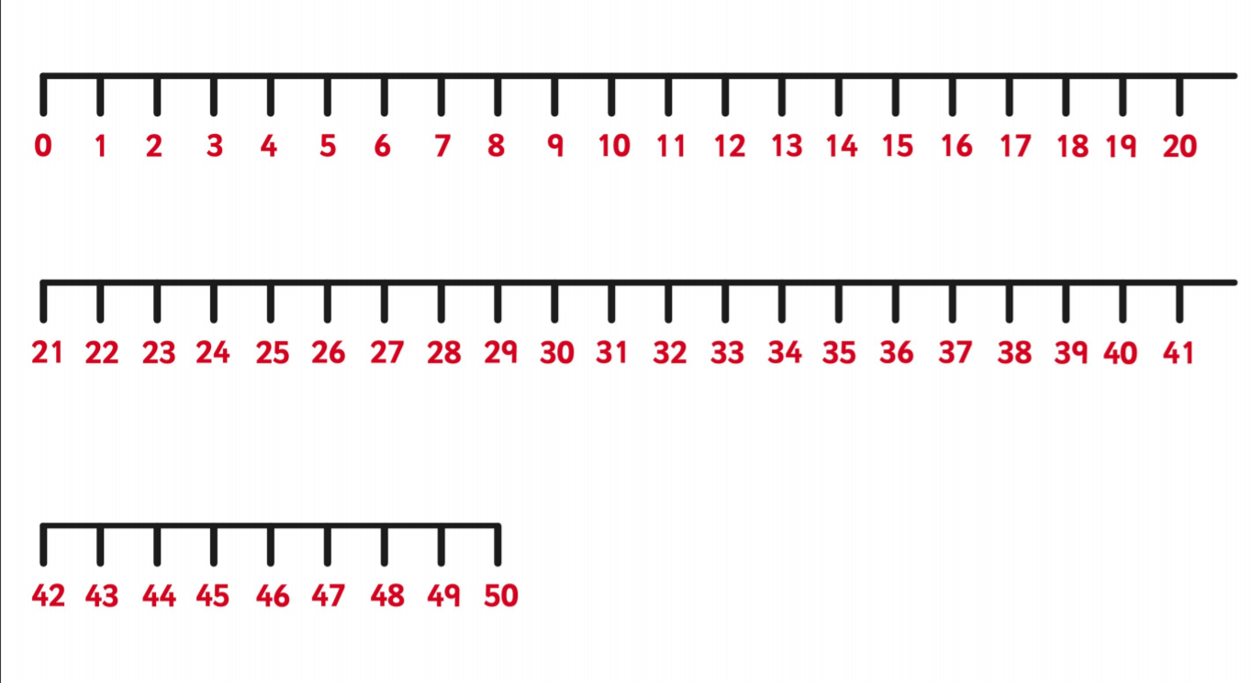
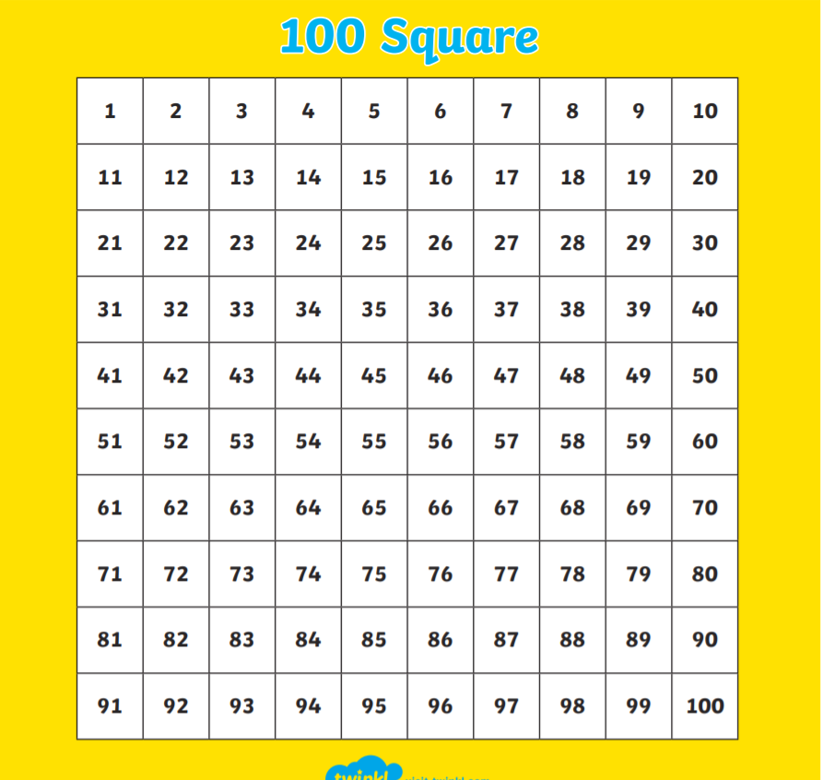

Maths

Can I put objects into groups of 5?
Can I count BACKWARDS in groups of 5 from 50?
Find 20 objects e.g. counters or similar.
Put them into groups of 5 (you may find it easier to put them into dishes). Draw your groups of objects here.

Now take away a group at a time until you have no objects left. As you do write the number pattern:

20 15 _____ ______

Can you count back in 5’s from 50? Write down the pattern here.

English

