Monday 8th February 2021 YEAR 2
Enjoy doing the activities listed.
The order to do them in is suggested below but you can change them to suit you. Please send me any work, photos or comments via Tapestry. Thank you.
MORNING  Let’s get started challenge | Have a change from Joe by trying out these! Make a choice to suit you and how you are feeling!  https://imoves.com/the-imovement
Maths  Learning objective:  All children  Can I write a repeated subtraction and a division sum for groups of 2?  Some children  Can I use multiplication facts to help me with division? | This week we will be grouping objects and exploring the link between repeated subtraction and division.  To get an idea of this watch this FIRST teaching video:  https://www.bbc.co.uk/bitesize/articles/zhwmhg8  Introduction  - Division can be done by sharing or grouping. We usually use grouping.  - Look at this question: How many pairs? This means how many groups of 2.  First count the total number of socks i.e. 6  - We can work it out by splitting them into equal groups of two  1 2 3  - So the answer is 3 pairs  - We could count back to check as a repeated subtraction sum  6 - 2 - 2 - 2 = 0 you counted back 3 times  - Or we can write is as 6 ÷ 2 = 3.  This can be read as ‘how many groups of 2 are there in 6?’  - division can also be worked out like this:  -2 -2 -2  0 2 4 6 repeated subtraction  - Arrays 6 divided into groups of 2 is 3 rows.  - It helps to know your x2 table by heart!  - ÷ 2 is the same as halving  - Remember when ÷ by 2 the answers will always end in 0, 2, 4, 6,8 (remainders come into year 3)  - It can’t be done in any order – biggest number has to be first.  - It can be checked by multiplying e.g. 6 ÷ 2 = 3 3 x 2 = 6  Now try sharing these socks into pairs or groups of 2  Top tip: get some real socks to help you  Here is an example.  How many pairs? First count the total number of socks.  8  Then put into pairs or groupa of 2.  Does your answer look like this:  1 2 3 4  - So the answer is 4 pairs  - We could count back to check as a repeated subtraction sum  8 - 2 - 2 - 2 - 2 = 0 you counted back 4 times  - Or we can write is as 8 ÷ 2 = 4.  This can be read as ‘how many groups of 2 are there in 8?’  Now can you show it on a number line and as an array?  Activities  All children  - Write sums for the pictures as modelled above (see work below).  Most children  - Work sheet below  Optional  Play the game (see below)
English  Learning objective:  Can I find out about Louis Braille and begin to create a mind map? | Introduction  - Last week in topic work we discovered a pair of glasses in the box and found out that SIGHT is one of our five senses.  - This week you will find out more about LOUIS BRAILLE who developed a way of reading and writing for people who couldn’t see. It is called the Braille alphabet and is still used today.  - First travel back in time to find out more about Louis Braille by watching Magic Grandad.  https://www.youtube.com/watch?v=b6cVVTMioPc  Activity:  Think about all the facts you have found out and start to make a mind map.  Can you write at least 6 facts – one in each circle?  KEEP FOR TOMORROW
Handwriting/ spellings, grammar, punctuation or phonics  Learning objective:  Can I use the words because, if or when in a sentence? | Introduction  - There were some great stories written by Year 2 in week 4 based on ‘The Elves and the Shoemaker’. Stories were even more successful when sentences were joined together with words like ‘because’.  - This week you will find out about other words you can use to join two parts of a sentence together. These can be called co-ordinating conjunctions.  Conjunctions join together two different, but related, parts of a sentence.  They can be words like: and, but, if, when, because  For example: I like swimming and she likes dancing.  Activities  - Watch the short video below to see some more examples of conjunctions in action!  https://www.bbc.co.uk/bitesize/articles/z6rvbdm  - Next watch the ‘teacher talk video’ on the same webpage  Top tip!  You can use because, if and when at the beginning or the middle of a sentence.  For example:  - I was late because I missed the bus.  - Because I missed the bus, I was late.  - Try finishing this sentence using the word because  My kite flew into a tree because………………………………………  Now change the order of the sentence by starting with  Because …………………………………………………my kite flew into a tree.
 | Lunchtime!
AFTERNOON  Reading | Read at least 3 pages of a book or go online to find a story (see reading notes on school website).  You can also borrow reading packs from school.
Topic  Learning objective:  Can I explore different sounds?  Can I sort them into how they were made? | Introduction:  - The owner of the box is still a mystery!  We know:  - that they were part of a big family  - they had an x ray of their hand  - they had lost a tooth  - they wore glasses  - let’s look at Clue 5:  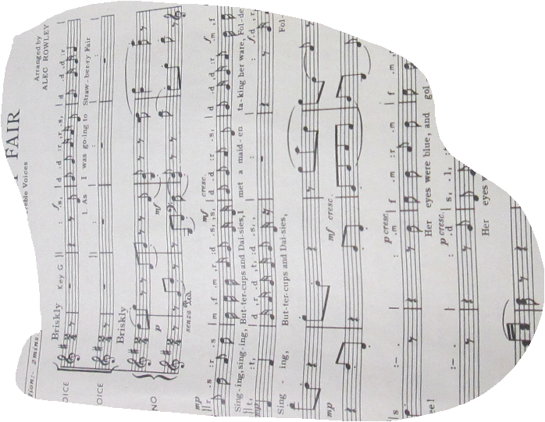  - Can you guess what it is?  - Yes, it is a piece of music. Maybe the owner of the box liked to listen to music or maybe played an instrument.  - To be able to hear any sound you need to use another of your five senses ; HEARING  Activity.  - Find out more about your sense of hearing with this short clip:  https://www.bbc.co.uk/bitesize/clips/zqf9wxs  - Test your knowledge of sounds  http://www.lancsngfl.ac.uk/curriculum/computing/index.php?category_id=13  - Walk round your house and garden and see how many different sounds you can make.  You may need to tap, or blow, or pluck.  BE CAREFUL!  - Make a list of the sounds you made.  As an extension can you sort them into the way in which the sounds were made (see sheet below).
Story/ yoga/ mindfulness activity/ songs
Additional notes for parents. | Be kind to yourselves! Do what you can!  Don’t forget to join the Willow Class Google meeting tomorrow.

Maths: level 1 challenge
Can I write a repeated subtraction and a division sum for each picture problem?

How many pairs of socks? First count the total number of socks. 8
Then put into pairs.

8 - 2 - 2 - 2 - 2 = 0

8 ÷ 2 = 4

Now your turn.

Draw the socks to match this sum: 16 ÷2 = 8

Maths: Level 2 challenge
Can I use multiplication facts to help me with division?

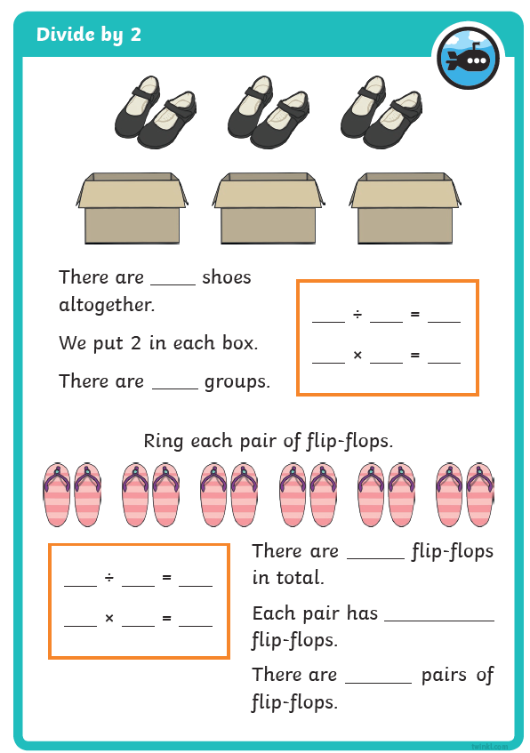

Maths: optional game

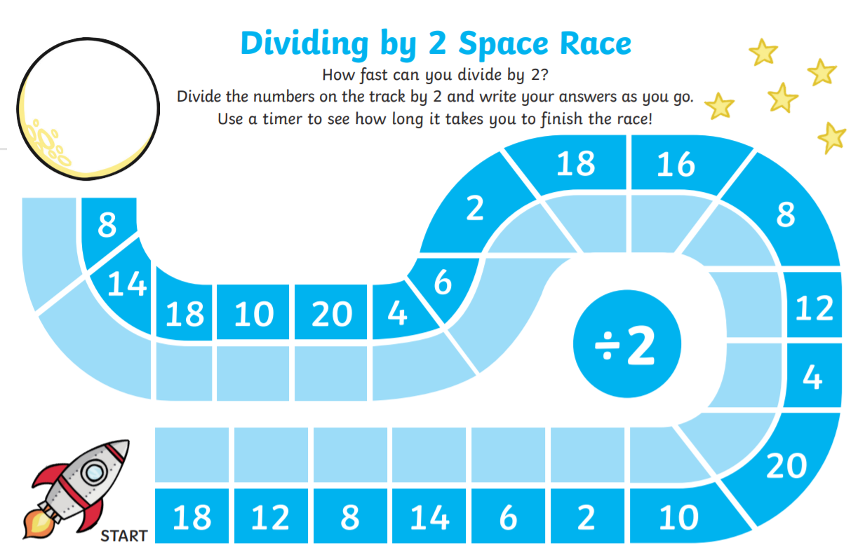

English

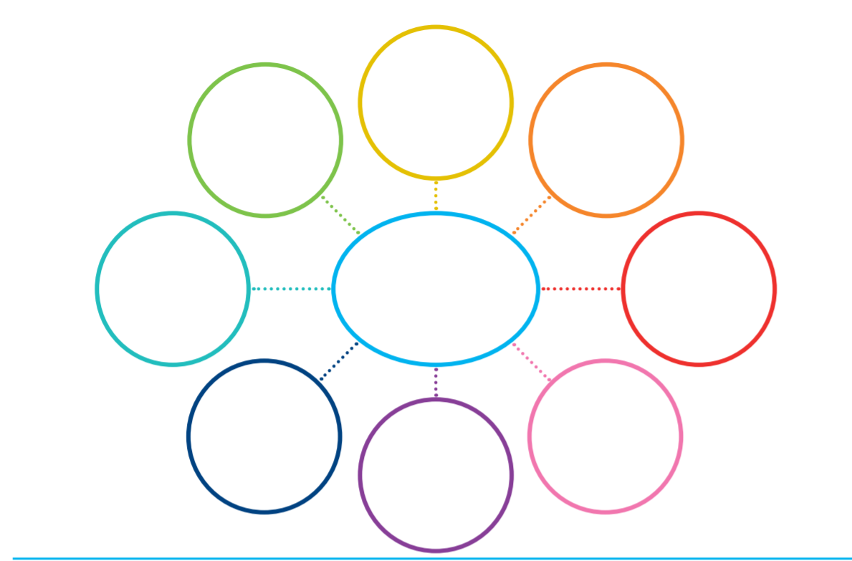
Can I write at least 6 facts about Louis Braille?

topic
Can I explore different sounds?
Can I sort them into how they were made?
Draw or write the things you found which could make a sound.

Things which made a sound by  tapping. | Things which made a sound by scraping.
Things which made a sound by  blowing. | Things which made a sound by  ………………………………………….

