Monday 8th February 2021 YEAR 1
Enjoy doing the activities listed.
The order to do them in is suggested below but you can change them to suit you. Please send me any work, photos or comments via Tapestry. Thank you.
MORNING  Let’s get started challenge | Have a change from Joe by trying out these! Make a choice to suit you and how you are feeling!  https://imoves.com/the-imovement
Learning objective:  Can I put objects into groups of 2?  Can I count BACK in groups of 2 from 20? | Last week you learnt how to count forwards in groups of 2, 5 and 10. This week we will be counting backwards in the same groups.  We will also be learning how to share into groups which will help you with division in year 2.  For this lesson you may find it useful to have somethings to count with e.g. buttons, counters or even pairs of socks!  Introduction  - First a quick quiz!  Finish the pattern:  0 2 4 6 ___ ____ ____ _____ ___  What’s missing?  0 2 4 6 8 _____ 12 14  What’s my mistake?  12 14 17 18 20  NOW  - Use the number line to count BACK in twos.  - Start at 20 and each time make a jump of 2.  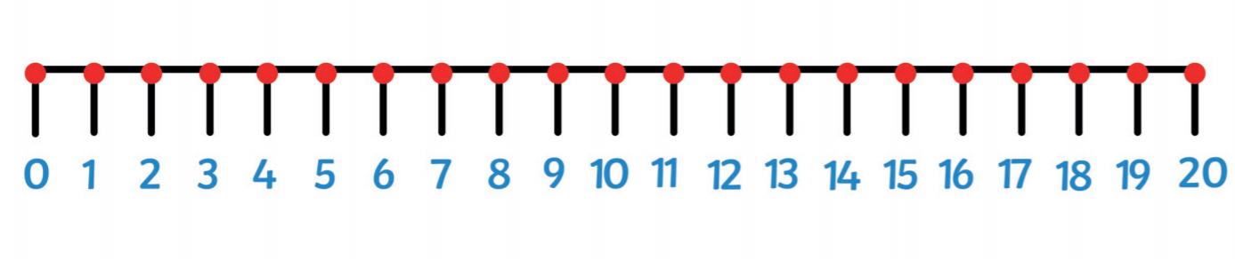  - Can you continue counting BACK in jumps of 2 on the number line below?  Top tip: make sure you miss a number out each time.  - What numbers do you land on? Say them lots of times until they are fixed in your head.  - Now turn the number line over. Can you still say the numbers you would land on if you counted BACK in twos?  Go to activity 1 OR  - If you would like another challenge try the same thing on a 100 square. This time colour the squares that you land on.  - What do you notice?  What do you notice about the numbers? Are they the same as counting FORWARDS in twos?  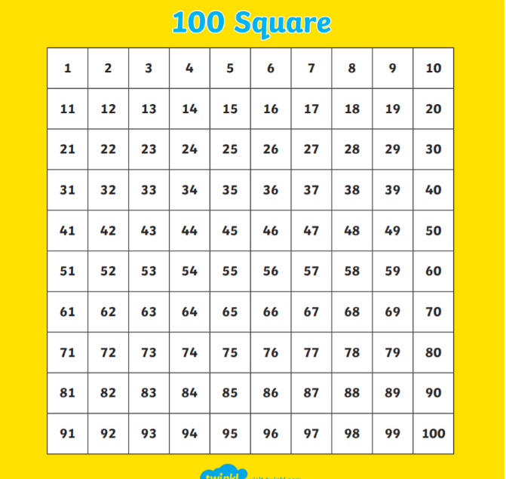  Activities  - Get out 8 socks and put them into pairs. Start at 8 and count BACK in 2’s as you take away a pair at a time until you end up at 0  8 6 4 2 0  - Repeat but this time start with 10 socks. Put into pairs and take away a pair at a time. Count BACK in 2’s as you go until you have no socks left.  10 8 6 4 2 0  - Repeat and record your answers using the worksheet below.  Top tip: use the 100 square to help you if you find it tricky to remember how to count back in twos.
English  Learning objective:  Can I write at least 3 facts about snails on the mind map? | Introduction  - Last week you started a pack ‘Sidney Spider’.  - Last Friday you went on a mini-beast hunt and wrote down a list of creatures you found. It’s not easy in the winter as lots like to hide away to keep warm.  - One creature that does this is a snail.  - What do you know already about snails? Share your facts with a grown up.  - Today we will write these down. Then during the week we will find out more and finally you can write you own fact file.  Activity:  Use the mind map below to write down the 3 facts you know about snails.  KEEP THE MIND MAP FOR TOMORROW
Handwriting/ spellings or phonics  Learning objective:  Can I read and write words containing the oi sound? | Introduction  - Today you will recap this sound oi  - Practise reading these words  soil foil quoit coin  OR test your reading on the oi power point  Activities  - Watch Mr Thorne does phonics oi  https://www.youtube.com/watch?v=IRTITdRL_cU  - Now complete the sheet below to write the oi  words.  - Finally check that you can read oi words by sorting the real from the nonsense words (see sheet below)
 | Lunchtime!
AFTERNOON  Reading | Read at least 3 pages of a book or go online to find a story (see reading notes on school website).  You can also borrow reading packs from school.
Topic  Learning objective:  Can I explore different sounds?  Can I sort them into how they were made? | Introduction:  - The owner of the box is still a mystery!  We know:  - that they were part of a big family  - they had an x ray of their hand  - they had lost a tooth  - they wore glasses  - let’s look at Clue 5:  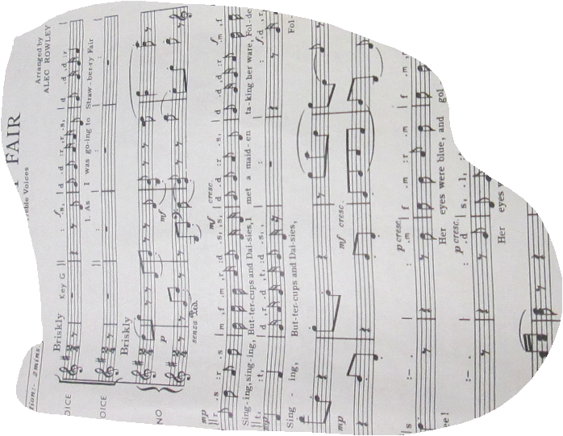  - Can you guess what it is?  - Yes, it is a piece of music. Maybe the owner of the box liked to listen to music or maybe played an instrument.  - To be able to hear any sound you need to use another of your five senses ; HEARING  Activity.  - Find out more about your sense of hearing with this short clip:  https://www.bbc.co.uk/bitesize/clips/zqf9wxs  - Test your knowledge of sounds  http://www.lancsngfl.ac.uk/curriculum/computing/index.php?category_id=13  - Walk round your house and garden and see how many different sounds you can make.  You may need to tap, or blow, or pluck.  BE CAREFUL!  - Make a list of the sounds you made.  As an extension, can you sort them into the way in which the sounds were made (see sheet below)?
Story/ yoga/ mindfulness activity/ songs
Additional notes for parents. | Be kind to yourselves! Do what you can!  Don’t forget to join the Willow Class Google meeting tomorrow.

Maths:

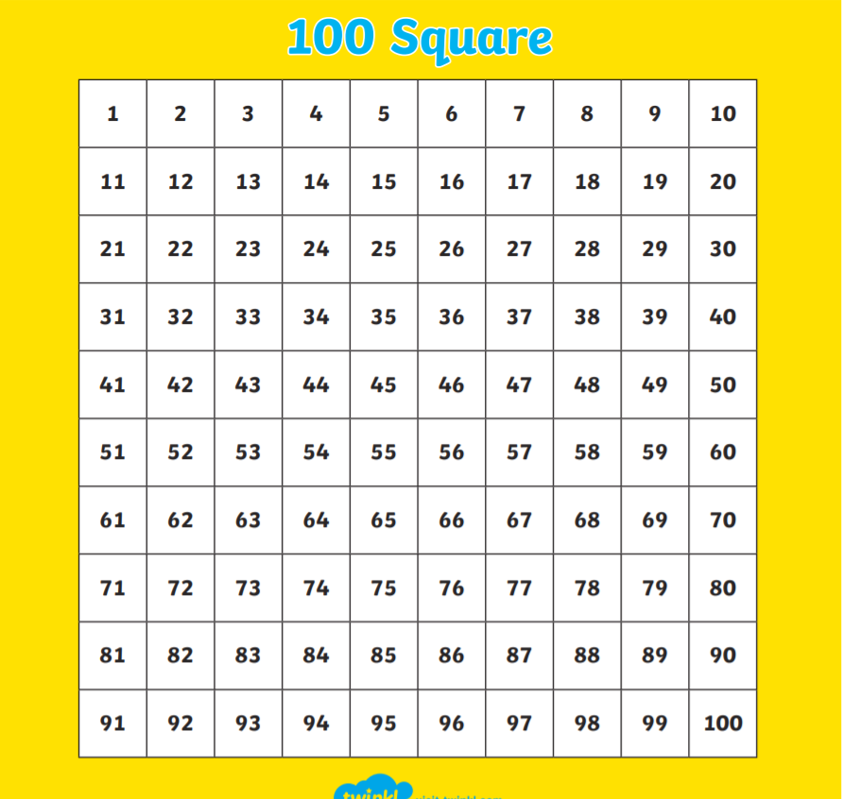

Maths

Can I put objects into groups of 2?
Can I count BACKWARDS in groups of 2 from at least 20?
Find 12 socks.
Put them into pairs. Draw your pairs of socks here:

Now take away a pair at a time until you have no sooks left. As you do write the number pattern:

12 10 _____ _____ _____ _____ ______

Can you count back in 2’s from 20? Write down the pattern here.

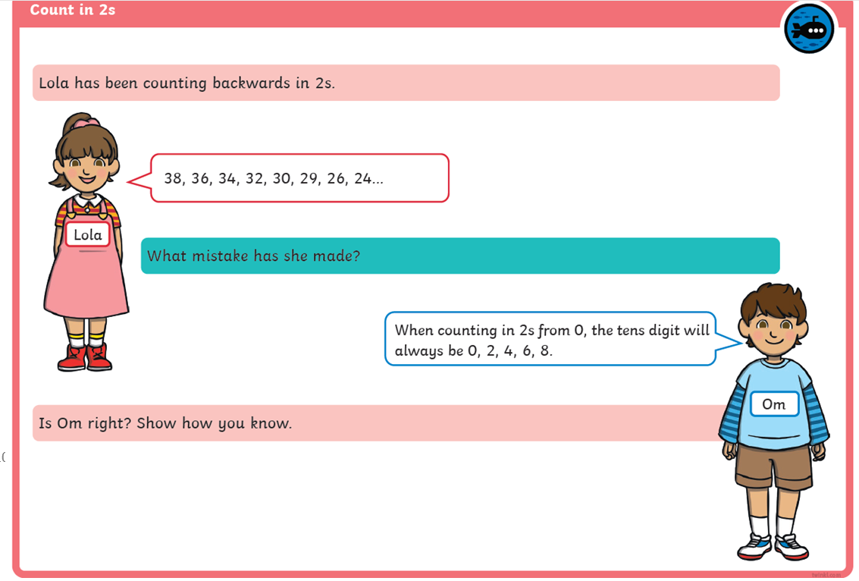

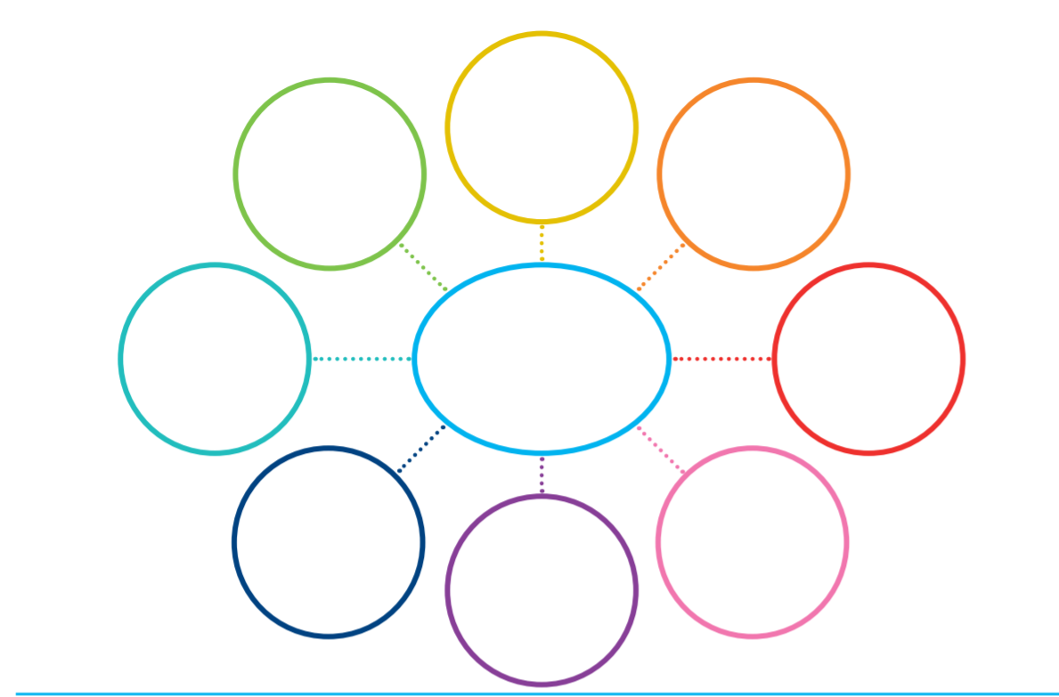

Snails
Can I write at least 3 facts about snails?

Phonics
Can I read and write words containing oi?

Practise writing on the line.

oi……………………………………………………………………………………………………………………………………

Write the words to match the pictures.
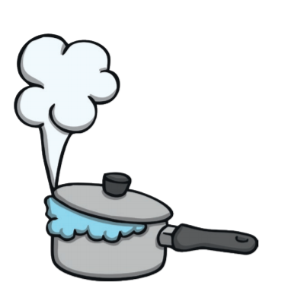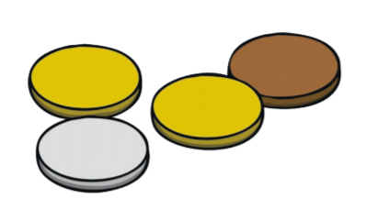

_______________ __________________

__________________ ____________________

Now write a sentence for 2 of the words.

_____________________________________________________

______________________________________________________

Now practise your reading
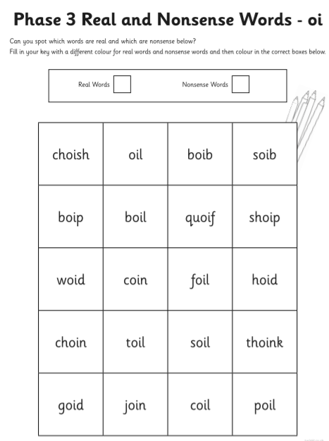

topic
Can I explore different sounds?
Can I sort them into how they were made?
Draw or write the things you found which could make a sound.

Things which made a sound by  tapping. | Things which made a sound by scraping.
Things which made a sound by  blowing. | Things which made a sound by  ………………………………………….

