Monday 22nd February 2021 YEAR 2 WECOME BACK!
Enjoy doing the activities listed.
The order to do them in is suggested below but you can change them to suit you. Please send me any work, photos or comments via Tapestry. Thank you.
MORNING  Let’s get started challenge | Get your body moving with Joe Wicks or  https://imoves.com/the-imovement
Maths  Learning objective:  Can I say all the days of the week in the right order?  Can I spell the days of the week? | This week we will be exploring time. By the end of the week you will be able to say the days of the week, months of the year (including knowing your birthday) and be able to read and set the time to o’clock and half past.  Today we are looking at days of the week.  Introduction  - What day of the week is it today?  - Listen to this song to help you  - https://www.youtube.com/watch?v=zJLiJIf8c_c  - Can you remember our days of the week song?  - Try this new one and move along with it!  https://www.bbc.co.uk/teach/supermovers/ks1-english-days-of-the-week/zd8njhv  - Can you answer these questions?  If it is Monday today what day will it be tomorrow?  What was the day yesterday?  What day comes after Tuesday?  Does Wednesday come after Thursday?  Activities  - Read through the power point on days of the week – see school website – classes- or follow the link  https://www.twinkl.co.uk/resource/days-of-the-week-powerpoint-us-cm-37  - Talk to your grown up about what you do on different days of the week e.g. Monday is topic work, Tuesdays are computing etc.  (See timetable below to remind you)!  - Now show your knowledge of days of the week with this quiz:  https://www.twinkl.co.uk/go/resource/days-of-the-week-ordering-multiple-choice-quick-quiz-tg-t-93  - Look at how the days of the week are spelt  Monday  Tuesday  Wednesday  Thursday  Friday  Saturday  Sunday  What patterns do you notice?  Some days e.g. Sunday can be sounded out.  Other days e.g. Wednesday can be split into  chunks wed nes day.  The rest just have to be learnt off by heart.  Activities  ALL: Use the sheets below to learn how to spell the days of the week.  Look at the word, think about how to spell it, then  cover it over and write. Open it up and check whether  you are right.  Some: If you would like to, test your knowledge of the spellings of the days of the week with the word search below.
English  Learning objective:  Can I read the story and show my understanding by designing a box?  Extension: can I give reasons for the design I have made? | This week we will be starting a new unit called ‘The Magical Teaching Box’. It can be downloaded from the school website or found here https://www.talk4writing.com/wp-content/uploads/2020/04/Y2-Unit.pdf  Introduction  - Read the story ‘The Magical teaching Box’ on pages 4 and 5 of the pack.  - Stop at the end of page 5 and think about what you have read. Answer these questions?  What did Zeus give Pandora?  What words tell you that Pandora really wanted to open the box?  What do you think is in the box?  - Think about what the box might look like. Is it plain or colourful? Does it have patterns? What is it decorated in? Does it have a key?  Activity:  Complete the activity at the bottom of page 5 of your pack – draw your idea of what the box looked like. See sheet below
Handwriting/ spellings, grammar, punctuation or phonics  Learning objective.  Can I merge 2 words into one using an apostrophe? | Introduction:  - Last half term you learnt that there are different sorts of punctuation.  Capital letters  Full stops  Commas  Exclamation marks  Questions marks  Inverted commas (speech marks)  - For the next 2 weeks you will be learning about APOSTOPHES.  - Apostrophes can be used in different ways. This week we will find out how they are used to merge 2 words into one e.g. do not can become  don’t. Can you see the o in not is taken away and replaced with an apostrophe ‘  - Can you contract these words into one?  Take out one letter.  he is ₌ he’s  we are = we’re  Activities –  - Have a go at turning these 2 words into a shorter word using an apostophe. (see sheet below).
 | Lunchtime!
AFTERNOON  Reading | Read at least 3 pages of a book.
Topic  Learning objective:  Y1: Can I say which part of the body I use to touch with?  Can I describe an object through feeling it? | Introduction:  - Our last clues helped us to find out that the owner of the box needed help to read but we still don’t know who it belongs to.  - Maybe another clue will help!  - Clue 6: an old badge.  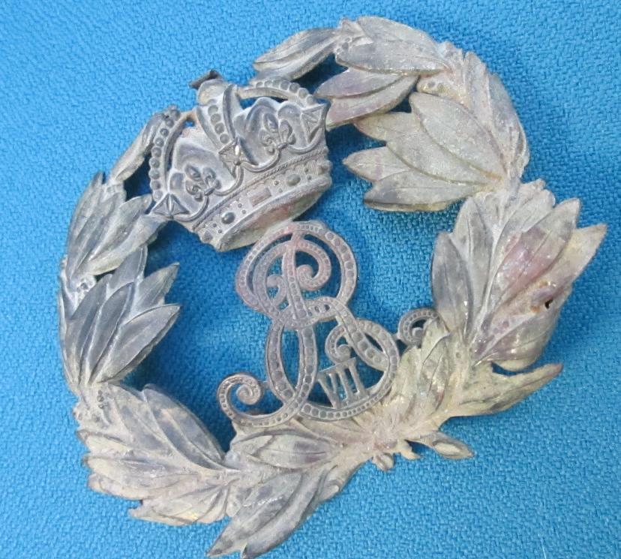  - It is so old that we need to use our sense of sight to look more carefully at it.  - Would our sense of hearing help? When we hit it, the badge makes a tinny sound as if it is made of metal.  - What other sense could we use? Yes TOUCH would be a good one.  - When I feel it, it does feel hard like metal.  - This week let’s find out more about our sense of TOUCH.  - When we touch things they can be:  hard, soft, squidgy, rough, smooth  - This afternoon you will create a feely bag full of things you can find around the house or garden which you can then share with a member of your family and talk about how they feel.  Think carefully about what you choose- you don’t want anyone to feel in the bag and hurt themselves.  Activity.  Choose at least 6 things that feel different and put them in a bag or box.  Ask someone in your family to guess what they are just by feeling? Remember to tell them not to peek.  What words would you use to describe them?  Can someone make a feely bag for you now?
Story/ yoga/ mindfulness activity/ songs | Be kind to yourselves! Do what you can!
Additional notes for parents. | on Wednesday you will need a calendar

Monday  WT in school | Maths | English | Letters and sounds (L&S) | Reading | Topic
Tuesday  WT in school | Music | English | L&S | Reading | Topic | Computing
Wednesday  AP in school | Maths | English | L&S | Reading | PE
Thursday  AP in school | Maths | English | L&S | Reading | RE | PSHCE
Friday  AP in school | Maths | English | L&S | Reading | Forest Schools

Maths: level 1 challenge
Can I spell the days of the week?
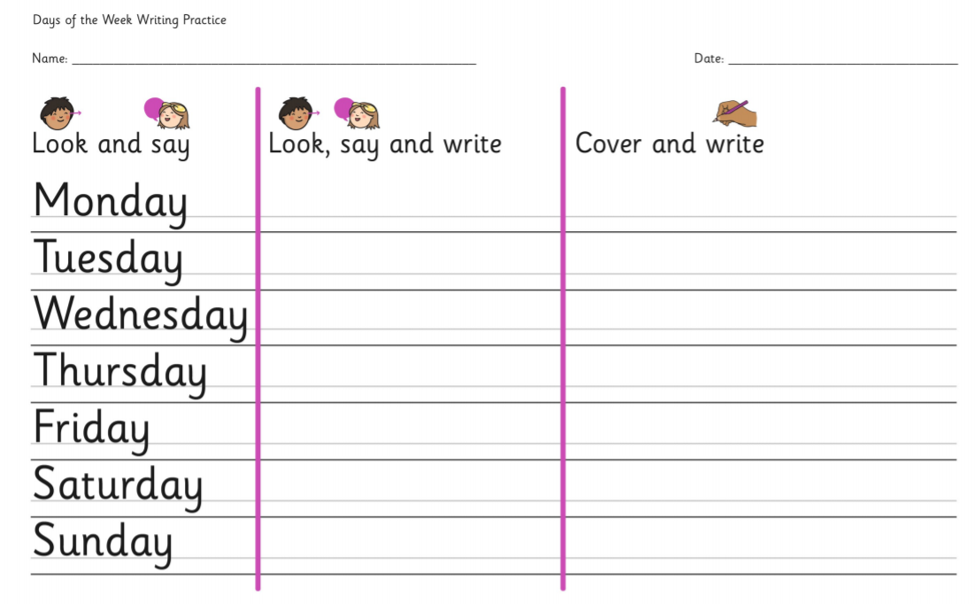

Maths: Level 2 challenge
Can I use the spellings of the days of the week to complete the word search?

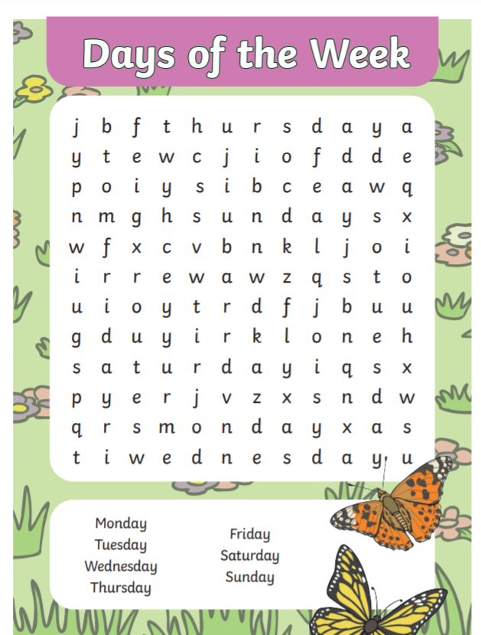
English
Can I read the story and show my understanding by designing a box?
Extension: can I give reasons for the design I have made?

My box looks like this because

________________________________________________________________________

_____________________________________________________________________________

_____________________________________________________________________________

______________________________________________________________________________

Punctuation
Can I merge 2 words into one using an apostrophe?

Example
he is he’s

she is …………………………………

we are ………………………………….

they are …………………………………

could not …………………………………

should not ………………………………….

is not …………………………………

