Monday 22nd February 2021 YEAR 1 WECOME BACK!
Enjoy doing the activities listed.
The order to do them in is suggested below but you can change them to suit you. Please send me any work, photos or comments via Tapestry. Thank you.
MORNING  Let’s get started challenge | Get your body moving with Joe Wicks or  https://imoves.com/the-imovement
Maths  Learning objective:  Can I put the days of the week in order?  Can I use the words: today, tomorrow, before and after to answer questions? | This week we will be exploring time. By the end of the week you will be able to say the days of the week, months of the year (including knowing your birthday) and be able to read and set the time to o’clock and half past.  Today we are looking at days of the week.  Introduction  - What day of the week is it today?  - Can you remember our days of the week song?  - Try this new one and move along with it!  https://www.bbc.co.uk/teach/supermovers/ks1-english-days-of-the-week/zd8njhv  - Can you answer these questions?  If it is Monday today what day will it be tomorrow?  What was the day yesterday?  What day comes after Tuesday?  Does Wednesday come after Thursday?  How many days in one week?  How many days in 2 weeks?  Activities  - Read through the power point on days of the week – see school website - or follow the link  https://www.twinkl.co.uk/resource/days-of-the-week-powerpoint-us-cm-37  - Think about what you do on different days of the week e.g. Monday is topic work, Tuesdays are computing etc.  (See timetable below to remind you)!  - Now try cutting and sticking the days of the week in order (see worksheet below)  - If you want an additional challenge – complete the second level challenge.  Parents – on Wednesday you will need a calendar
English  Learning objective:  Can I share the story of ‘Brian Bear’s Picnic’ with an adult and talk about the story? | This week we are starting a new unit of work called  Brian Bear’s Picnic. It can be downloaded from the school website or found online https://www.talk4writing.com/wp-content/uploads/2020/06/Y1-Brian-Bear.pdf  Introduction  - Read the story on pages 3 and 4 with a grown up  - Discuss the story.  What did you like best about the story?  Do you think Curtis, Bertha and Gertie should have given away their party food?  How do you think Brian felt at the end of the story?  Activity:  Fill in the sheet on page 5 of the pack.
Handwriting/ spellings or phonics  Learning objective:  Can I use the wh sound to read and spell? | Introduction:  - Recap these sounds that you learnt last half term  ai ee igh oa oo  ay ea ie ow ue  a-e e-e i-e o-e u-e  oi oy or au aw  - Today you will learn that the w sound can also be made by wh  - Read these words  wheel when whisk  Activities –  - Watch Mr Thorne does phonics – wh  https://www.youtube.com/watch?v=mppiO8xtYoA  - Cut and stick the sounds for the words (see sheet below).
 | Lunchtime!
AFTERNOON  Reading | Read at least 3 pages of a book.
Topic  Learning objective:  Y1: Can I say which part of the body I use to touch with?  Can I describe an object through feeling it? | Introduction:  - Our last clues helped us to find out that the owner of the box needed help to read but we still don’t know who it belongs to.  - Maybe another clue will help!  - Clue 6: an old badge.  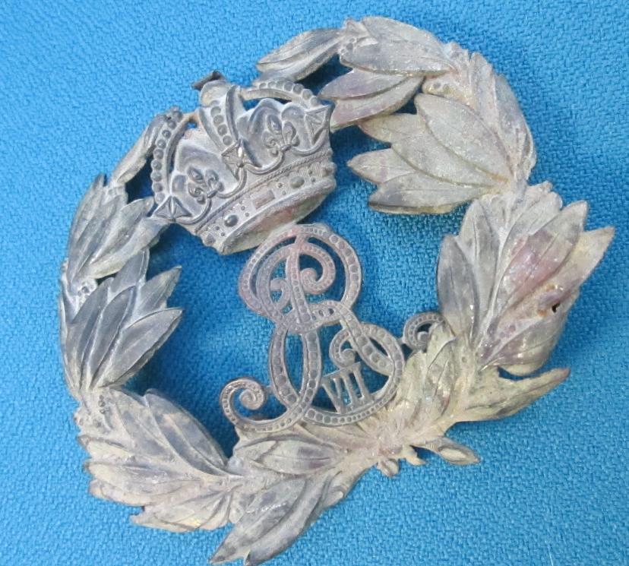  - It is so old that we need to use our sense of sight to look more carefully at it.  - Would our sense of hearing help? When we hit it, the badge makes a tinny sound as if it is made of metal.  - What other sense could we use? Yes TOUCH would be a good one.  - When I feel it, it does feel hard like metal.  - This week let’s find out more about our sense of TOUCH.  - When we touch things they can be:  hard, soft, squidgy, rough, smooth  - This afternoon you will create a feely bag full of things you can find around the house or garden which you can then share with a member of your family and talk about how they feel.  Think carefully about what you choose- you don’t want anyone to feel in the bag and hurt themselves.  Activity.  Choose at least 6 things that feel different and put them in a bag or box.  Ask someone in your family to guess what they are just by feeling? Remember to tell them not to peek!  What words would you use to describe them?  Can someone make a feely bag for you now?
Story/ yoga/ mindfulness activity/ songs | Be kind to yourselves! Do what you can!
Additional notes for parents. | on Wednesday you will need a calendar

Monday  WT in school | Maths | English | Letters and sounds (L&S) | Reading | Topic
Tuesday  WT in school | Music | English | L&S | Reading | Topic | Computing
Wednesday  AP in school | Maths | English | L&S | Reading | PE
Thursday  AP in school | Maths | English | L&S | Reading | RE
Friday  AP in school | Maths | English | L&S | Reading | Forest Schools

Maths: level 1 challenge
Can I put all the days of the week in the right order?
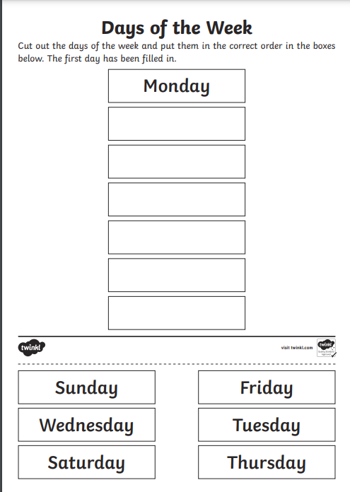
Maths: Level 2 challenge
Can I use the words: today, tomorrow, before and after to answer questions?

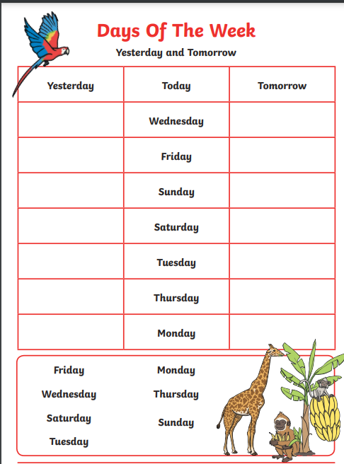
Phonics
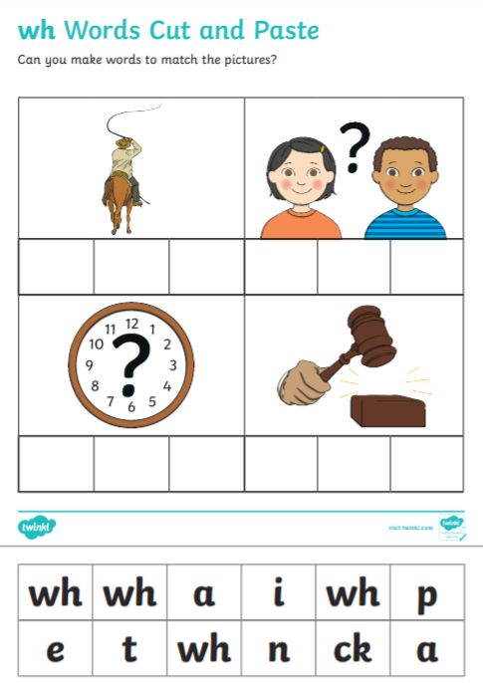

Answers below

