**Monday 1st March 2021** **YEAR 1**

Enjoy doing the activities listed.

The order to do them in is suggested below but you can change them to suit you. Please send me any work, photos or comments via Tapestry. Thank you.

|  |  |
| --- | --- |
| MORNING  Let’s get started challenge | Get your body moving and practise counting at the same time!  <https://www.bbc.co.uk/teach/supermovers/ks1-maths-counting-with-john-farnworth/zbct8xs> |
| Maths  *Learning objective:*  Can I recognise coins to £1?  Can I talk about what is the same and what is different between the coins? | This week we will be exploring MONEY. By the end of the week you will be able to say recognise the coins to one pound and be able to use coins to pay for things.  You will need some real coins to help you.  **Introduction**   * What is this coin?     Can you find a real coin to match? It is a 1 pence coin. We write this as 1p.   * What is this coin?     Can you find a real coin to match? It is a 2 pence coin. We write this as 2p.   * What is the same and different between the 2 coins? Look carefully at both sides. * What is this coin?     Can you find a real coin to match? It is a 5 pence coin. We write this as 5p.   * What is this coin?     Can you find a real coin to match? It is a 10 pence coin. We write this as 10p   * What is the same and different between the 5p and 10p coins? * What is this coin?      * Can you find a real coin to match? It is a 20 pemce coin. We write this as 20p.      * Can you find a real coin to match? It is a 50 pence coin. We write this as 50p.   What is the same and what is different between the 20p and 50p coins?   * What is this coin?     Can you find a real coin to match? It is one pound. Sometimes it is written like this this £1.  It is worth 100 pennies.  Activities    **Either** Watch this video on coins and what they look like from the Oak Academy.  <https://classroom.thenational.academy/lessons/to-identify-the-physical-properties-of-coins-ccrp2c>  **Or** If you can’t see it, line up the coins you have and talk about what is the same and what is different between them.  Can you sort them in different ways? |
| English  *Learning objective:*    Can I write a list of things to take on a picnic?  Can I write in sentences? | Last week we started a new unit of work called  ‘Brian Bear’s Picnic’. It can be downloaded from the school website or found online <https://www.talk4writing.com/wp-content/uploads/2020/06/Y1-Brian-Bear.pdf>  Introduction   * Last week you read a story. * Today you will read or sing a song – ‘The teddy bear’s picnic’ * Read it on page 10 of your pack or listen to it   <https://www.youtube.com/watch?v=kqd2ePU9sZY>   * If I was going on a picnic I would take **sandwiches**. * I could write this in a sentence.   I would take egg sandwiches.  Remember what you have learnt about writing sentences:   * Start with a capital letter * End with a full stop. * Check it makes sense. * Now think about what you would take on a picnic.   Activity:  Complete the sheet on page 11. |
| Handwriting/ spellings or phonics  *Learning objective:*  Can I use the **er** sound to read and spell? | Introduction:   * Recap these sounds that you have learnt.   ai ee igh oa oo  ay ea ie ow ue  a-e e-e i-e o-e u-e  oi oy or au aw oi oy  wh ph th   * Today you will recap the **er** sound        * Read these words   farmer player teacher herbs  Activities –   1. Watch Mr Thorne does phonics – er   <https://www.youtube.com/watch?v=WaxZN4BZjgc>     1. Highlight or circle all the **er** sounds in the mermaid story below. |
|  | Lunchtime! |
| AFTERNOON  Reading | It is World Book Day on March 4th.  The World Book Day website has some great resources.  <https://www.worldbookday.com/2020/09/world-book-day-2021-announcements/>  Listen to a story every day this week:  <https://www.worldbookday.com/share-a-story-corner/> |
| Topic  *Learning objective:*  Y1: Can I guess some smells and give reasons?  Can I talk about which were the easiest and the hardest smells to name?  Can I link the correct part of the body to the sense of smell?  *Extension: Can I explain one fact that I have learnt about smelling?* | Introduction:   * We are still looking for the owner of the box! * Last week by using our senses of seeing and touch we discovered that the metal object was a badge from a soldier’s hat over 100 years ago. * So far we know * it belongs to someone in a family of 6 * they had hurt their hand and lost a tooth * they wore glasses * they liked music and may have played an instrument * they could have been a soldier * Maybe another clue will help! * Clue 7: Can you guess what it is?      * It is an old perfume bottle and it still smells faintly of perfume. * Maybe if we found out more about another of our senses – SMELL this may help us. * We use our nose to smell. * Watch <https://www.bbc.co.uk/bitesize/clips/zy8hycw> * Today we are going to see how good our sense of smell is. To do this we need to set up a scientific experiment. * Share your ideas about how you could test your sense of smell. * Ask your grown up to find at least 4 things for you to smell. You will need a pencil to record your answers and something to cover your eyes e.g. a scarf.   Activity.  Put your blind fold on and smell number one. What do you think it is? Ask your grown up to hide it while you write down what you think it is. Were you right?  Repeat for the other smells.  Did you like some smells more than others? |
| Story/ yoga/ mindfulness activity/ songs | **Learn and move teddy bear teddy bear turn around**  [**https://www.youtube.com/watch?v=Tu\_n94Wp3rg**](https://www.youtube.com/watch?v=Tu_n94Wp3rg) |
| Additional notes for parents. |  |

**Phonics**

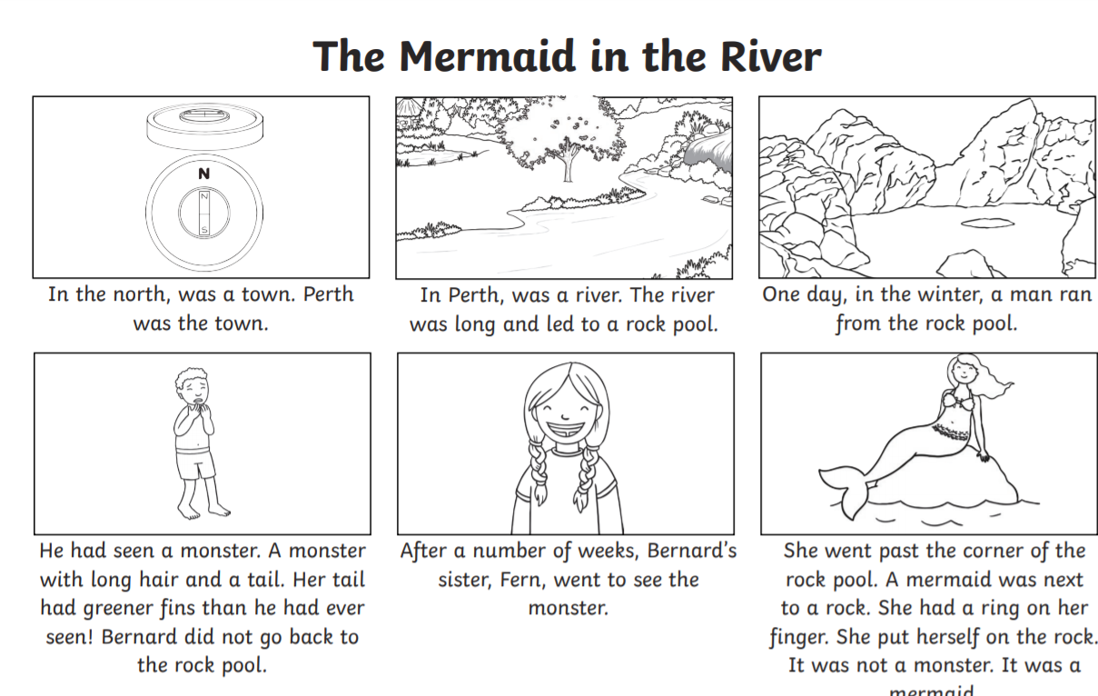

Topic 1.3.21

Y1: Can I guess some smells and give reasons?

Can I talk about which were the easiest and the hardest to name?

Can I link the correct part of the body to the sense of smell?

*Extension: Can I explain one fact that I have learnt about smelling?*

Smells Experiment

Do you think you have a good sense of smell? This experiment will test how good it is.

Instructions

1. Put a blindfold on or shut your eyes. No peeking!
2. Sniff smell, number 1.
3. What do you think it is?
4. Take your blindfold off whilst the adult hides it.
5. Write what you think it is in the ‘My Guess’ column.
6. Check – were you right?
7. Repeat for the other smells.

|  |  |  |
| --- | --- | --- |
| Smell Number | My Guess | Correct Answer |
| 1 |  |  |
| 2 |  |  |
| 3 |  |  |
| 4 |  |  |
| 5 |  |  |
| 6 |  |  |

hm00324_

I found was the easiest smell to recognise.

I found was the most difficult to recognise.