Friday 5th February 2021 YEAR 2
Enjoy doing the activities listed.
The order to do them in is suggested below but you can change them to suit you. Please send me any work, photos or comments via Tapestry. Thank you.
MORNING  Let’s get started challenge | 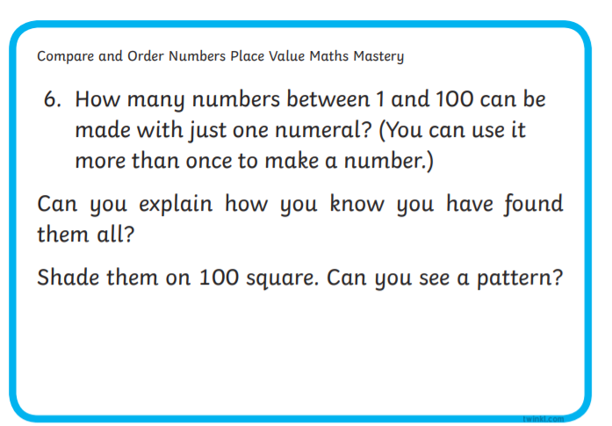  e.g. 1 11 2 22  See below for enlarged versions
Maths  Learning objective:  Can I show my understanding of x 2, 5 and 10 through activities? | To remind yourself of what you learnt this week watch this SECOND teaching video  https://www.bbc.co.uk/bitesize/articles/zv48cmn  Introduction:  - What have you learnt so far about multiplying by 2, 5 or 10? Answer these questions:  When you multiply a number by 2 what will the last digits be?  If you saw a 0 in the answer which tables may you be using?  When you multiply by 5 what do the numbers always end in?  - Challenge day! Now put your knowledge into action.  TOP TIP: Remember to use a 100 square, number line or array to help you if you need it.  Activities choose one  Go to Mathletics and try some of the activities for multiplication or arrays  or try the quizzes on Bitesize https://www.bbc.co.uk/bitesize/topics/zqbg87h  the 2, 5 and 10 times tables
English  Learning objective:  Can I show what I have learnt about punctuation by playing a game? | Introduction  - You have worked so hard  - Today you are going to test your knowledge by playing a game.  Activity :  Go to  https://www.bbc.co.uk/games/embed/crystal-explorers  then select story  then punctuation
Handwriting/ spellings, grammar, punctuation or phonics  Learning objective:  Can I add inverted commas to a sentence? | Introduction  - This week we have learnt how to use INVERTED COMMAS (sometimes called speech marks)  - “ ” They look like 66 and 99.  - Today you are going to try and write a few sentences and include inverted commas.  Remember: inverted commas are put in to show what a person is saying.  They go above the word. “Help”  Activities  - Write a short conversation between you and a family member about going for a walk.  Here is an example:  “Hi mum shall we go for a walk?” said Sam.  “That would be a good idea” answered mum.  So they went out for a walk with Pip the dog.
 | Lunchtime!
AFTERNOON  Reading | Choose one of your own books to read or read a book online.
FOREST SCHOOLS | In the last few weeks you have been exploring the outside or taking part in some nature activities.  For the next 2 weeks choose one of the activities below or choose something different. Have fun!  Stick activities  - Read ‘The Stickman’ by Julia Donaldson or watch  https://www.bbc.co.uk/iplayer/episode/b06t09rk/stick-man  - Make a magic wand using a stick and ribbons etc.  - Make a mini stick tepee for a woodland elf.  - Make a track path for someone to follow with sticks – first collect some sticks, then put them down in the shape of arrows until you reach X marks the spot.  - Use a stick to draw in the mud.  Remember in school we carry sticks like a walking stick. Be careful not to hit or poke anyone with your sticks.
Additional notes for parents. | Enjoy your weekend! One more week to go before half term!

Let’s get started challenge

