Friday 5th February 2021 YEAR 1
Enjoy doing the activities listed.
The order to do them in is suggested below but you can change them to suit you. Please send me any work, photos or comments via Tapestry. Thank you.
MORNING  Let’s get started challenge | 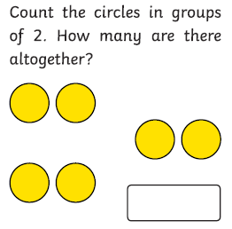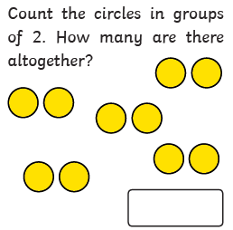  See below for enlarged versions
Maths  Learning objective:  Can I show my understanding of counting in groups of 2, 5 and 10 by completing some activities? | Introduction:  - What have you learnt so far about counting in groups of 2, 5 and 10? Answer these questions:  Finish this pattern of counting in twos: 0 2 4 6 __ __?  When you count in tens what is the last digit?  When you count in fives starting at 0, what do the numbers always end in?  - Challenge day! Now put your knowledge into action.  TOP TIP: Remember to use a number line, 100 square or objects to help you.  Activities  Go to Mathletics  Then multiply and divide  Next groups of two (try the activity)  After that try groups of 10 and groups of 5
English  Learning objective:  Can I write some sentences to explain which mini-beasts I found? | Introduction  - Can you remember any facts about spiders?  - Yesterday you went on a spider and mini-beast hunt and wrote a list.  - Get the list and look at it. What did you find first?  - Think of a sentence to explain this and say it aloud  E.g. First I went to the shed and found a spider.  Then look at the second thing you found and repeat thinking it and saying it then writing it  Activity :  Fill in page 14 using your list to help you.  Then check it
Handwriting/ spellings or phonics  Learning objective:  Can I use the au sound to read and spell? | Introduction:  - Use the sound cards which you made on Monday and sort into piles of sound families.  - Can you do this more confidently than on Wednesday?  If you have lost these cards they are printed again below  These are the sounds you need to sort.  ai ee igh oa oo  ay ea ie ow ue  a-e e-e i-e o-e u-e  - On Monday you were reminded that the or sound can be made by or. Then on Wednesday you learnt that it can also be made with aw.  - BUT! The or sound can also be made by au. Look carefully at the difference!  - Try reading these words:  August launch haunt  Activities –  - Watch Mr Thorne does phonics – au sound to recap  https://www.youtube.com/watch?v=RBPIvgL89jQ  - Finish the sheet by spelling words containing the au sound below.
 | Lunchtime!
AFTERNOON  Reading | Choose one of your own books to read or read a book online.
FOREST SCHOOLS | In the last few weeks you have been exploring the outside or taking part in some nature activities.  For the next 2 weeks choose one of the activities below or choose something different. Have fun!  Stick activities  - Read ‘The Stickman’ by Julia Donaldson or watch  https://www.bbc.co.uk/iplayer/episode/b06t09rk/stick-man  - Make a magic wand using a stick and ribbons etc.  - Make a mini stick tepee for a woodland elf.  - Make a track path for someone to follow with sticks – first collect some sticks, then put them down in the shape of arrows until you reach X marks the spot.  - Use a stick to draw in the mud.  Remember in school we carry sticks like a walking stick. Be careful not to hit or poke anyone with your sticks.
Additional notes for parents. | Enjoy your weekend! One more week to go before half term!

Let’s get started challenge

Phonics
