Friday 26th February 2021 YEAR 2
Enjoy doing the activities listed.
The order to do them in is suggested below but you can change them to suit you. Please send me any work, photos or comments via Tapestry. Thank you.
MORNING  Let’s get started challenge | 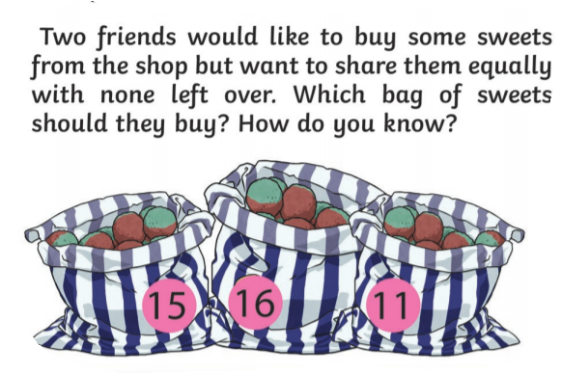  See below for enlarged versions
Maths  Learning objective:  Can I show my understanding of o clock and half past by reading and setting the time?  Extension:  Can I use my knowledge of o clock and half past to solve problems? | Introduction:  This week you have been learning the days of the week, months of the year and how to tell the time for o’clock and half past.  Today you will be recapping what you know and showing your understanding through activities.  Have your clock from yesterday ready.  - Test your knowledge so far. What are these times?  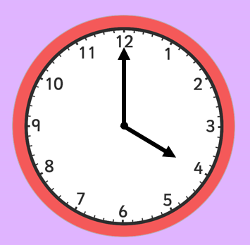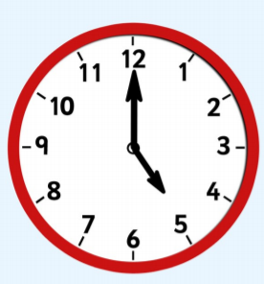  Explain how you know.  - Put the hands on the clock to show these times.  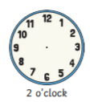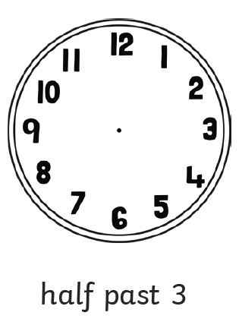  Activities  - Complete the sheets below.  - If you have time play this fun game  https://www.twinkl.co.uk/go/resource/whats-the-time-mr-wolf-half-past-version-game-tg2-m-86
English  Learning objective  Can I select the words which describe Zeus and use this to help me draw and label a picture? | Introduction  - This week you have been reading about Pandora’s Box.  - The story is from ancient Greece and included the God Zeus  - Today you will be reading about Zeus. Turn to page 8 of your pack and read about Zeus. It looks like this  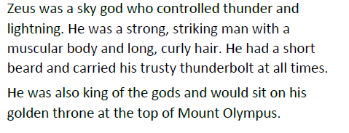  - Look through the text and highlight some words which describe what Zeus looked like e.g. long, curly hair and what sort of character he was e.g. strong.  - Remember these words are called adjectives.  Activity :  Complete the activity on page 8 – to draw and label Zeus.  If you prefer use the worksheet below.
Handwriting/ spellings, grammar, punctuation or phonics  Learning objective.  Can I show my understanding of contractions by completing an activity | Introduction:  - This week you have been learning how to shorten 2 words into one e.g. did not = didn’t by taking out one or two letters and replacing them with an apostrophe.  - Be careful! It is not always this simple. Sometimes 2 words merge and the rule can’t be applied e.g. will not = won’t  - Today have a go at practicing what you have learnt.  Activities – choose an activity (enlarged below)  - 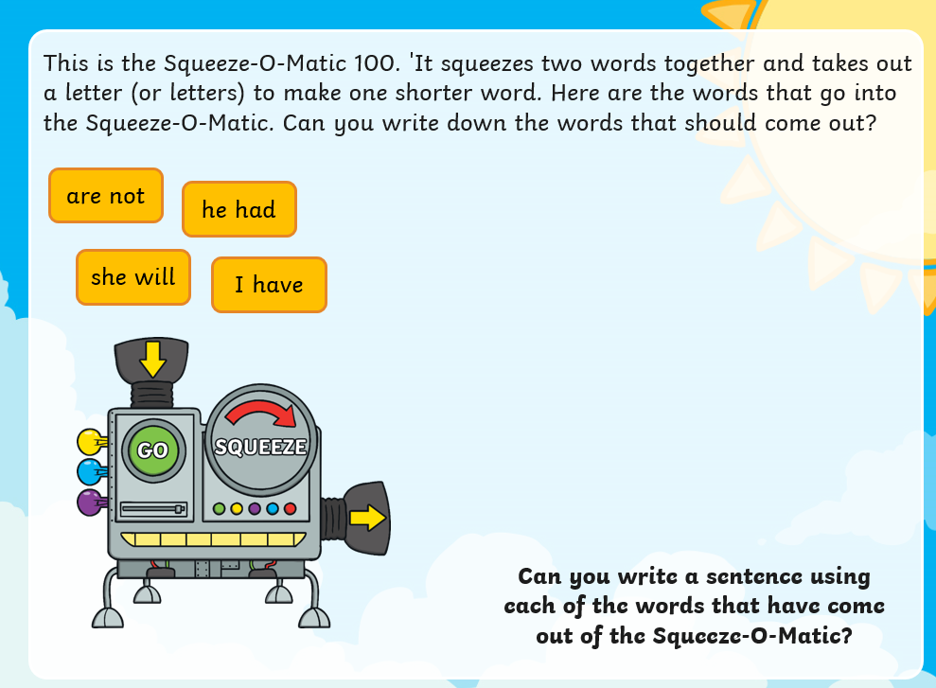  - 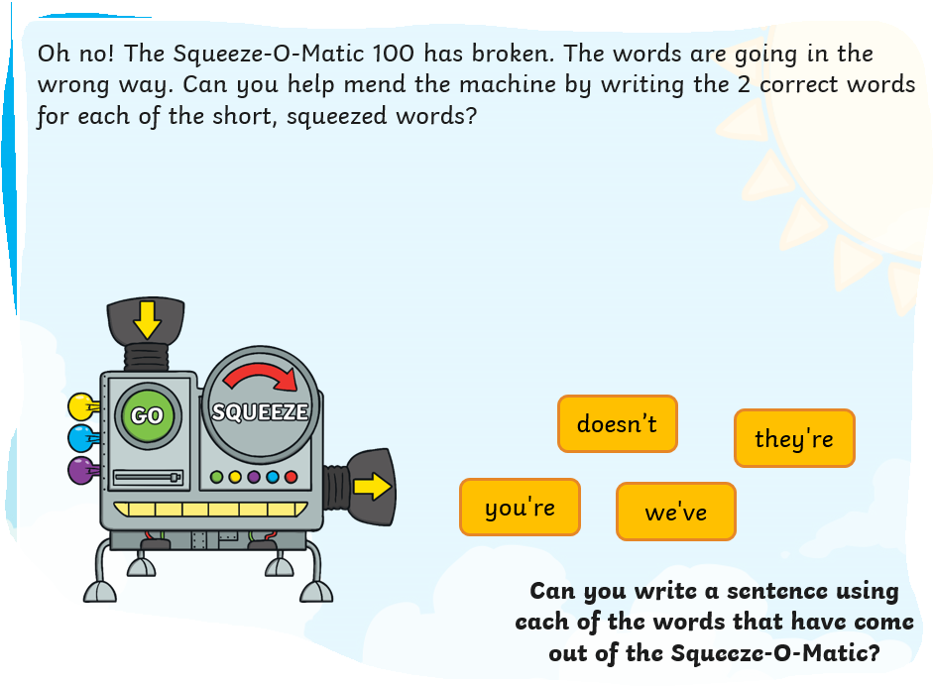  - Play a game 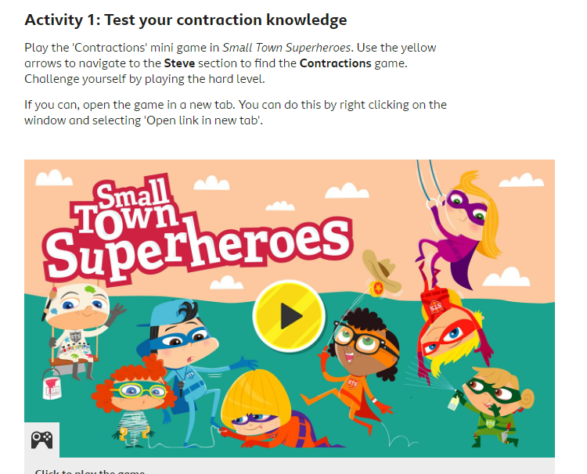  https://www.bbc.co.uk/games/embed/small-town-superheroes?exitGameUrl=https%3A%2F%2Fbbc.co.uk%2Fbitesize%2Farticles%2Fzncgvk7
 | Lunchtime!
AFTERNOON  Reading | Choose one of your own books to read or read a book online.
FOREST SCHOOLS | Forest schools  Introduction  - Spring is on its way!  - Watch this video- What signs of Spring can you see?  https://www.youtube.com/watch?v=vLAnt9__5Mg  - For the next few weeks we will be thinking about Spring.  - Choose one of the activities below over the next 2 weeks.  Activities  - Go for a walk and see what signs of spring you can see. (Sheet below if you would like to use it).  - Buy some cress seeds, plant them and watch them grow, (see sheet below)  - Make a grass head (see sheet below).  - Make a nest for a bird using only natural materials. Can you find a safe place to put it?  - Look out for patterns in the natural world e.g.  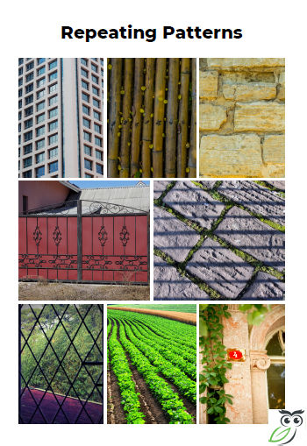  Then make your own pattern.
Additional notes for parents. | Enjoy your weekend!  Next week we will be learning about money. Please could you get a collection of change together?  One of each coin would be useful as well as a collection of 1p 2p 5p 10p 20p coins. Thank you.

Let’s get started challenge

Maths Level 1 challenge
Can I read and set the times to o clcok and half past?

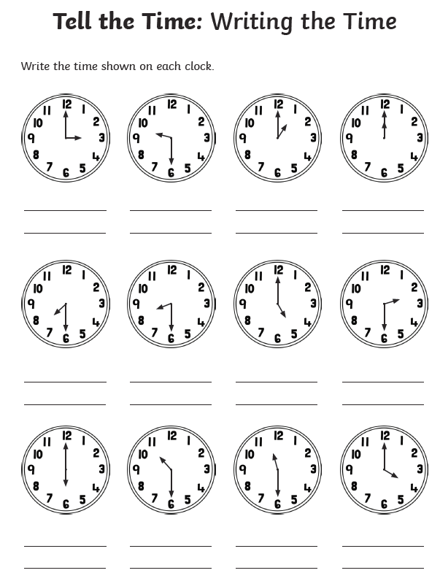
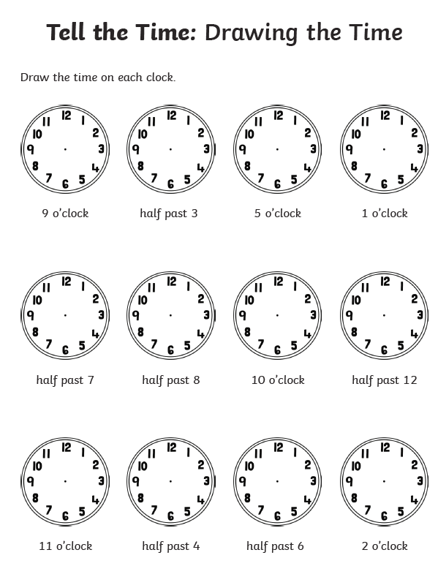

Maths level 2 challenge
Can I use what I know about o clock and half past to solve these problems?
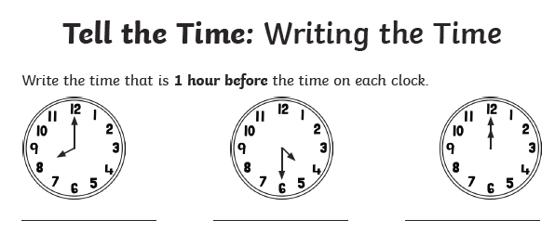
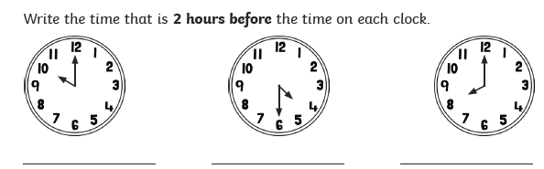
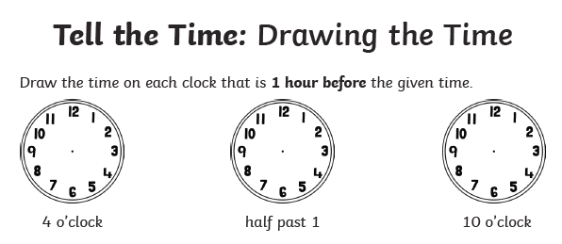
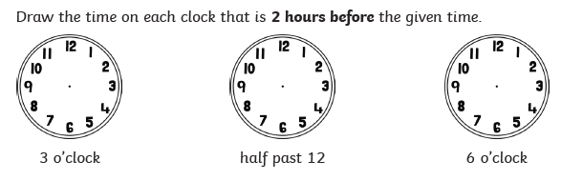

Punctuation
1.
2.

Forest schools
