Friday 26th February 2021 YEAR 1
Enjoy doing the activities listed.
The order to do them in is suggested below but you can change them to suit you. Please send me any work, photos or comments via Tapestry. Thank you.
MORNING  Let’s get started challenge | 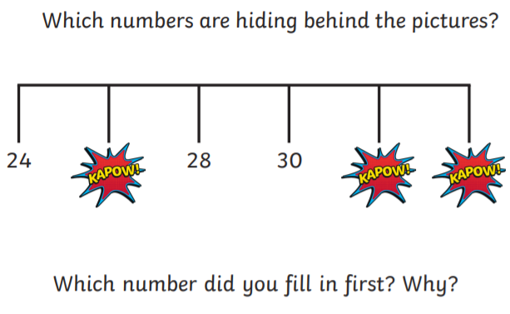  See below for enlarged versions
Maths  Learning objective:  Can I read and set the time to half past? | Introduction:  This week you have been learning the days of the week, months of the year and how to tell the time for o’clock. .  Today you will be finding out how to read and set the time for half past.  Then you will show your understanding through activities  Have your clock from yesterday ready.  Activities  - Test your knowledge so far. What are these times?  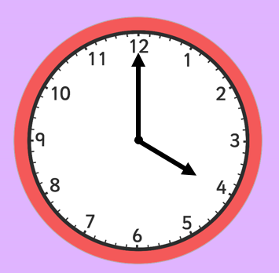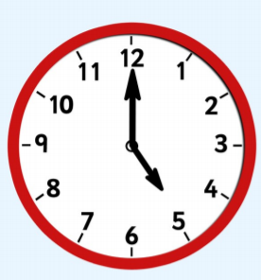  - When the long hand moves half way round the clock it becomes half past.  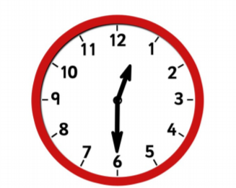  The minute hand (the longest one) is pointing to the 6.  This means it is half past.  The hour hand (the shortest hand) is pointing just past the 1.  It is half past one.  Activities  If you can follow the lesson provided by the Oak Academy.  https://classroom.thenational.academy/lessons/reading-and-writing-the-time-to-oclock-and-half-past-part-2-c4wkjr  - First start with the quiz to see how much you can remember about o’clock.  - Then watch the video.  - Next complete the independent activities (copied below)  - Finally finish with the quiz  If you can’t access this site ask your adult to say some o clock and half past times for you to put on the clock you made then do the sheet below.  If you have time play this fun game  https://www.twinkl.co.uk/go/resource/whats-the-time-mr-wolf-half-past-version-game-tg2-m-86
English  Learning objective:  Can I retell the story of Brian bear in the right order? | Introduction  - Today you will be retelling the story of Brian Bear and his picnic.  - To be successful you will need to:  - Put the story in the right order  - Use words such as ‘first’, ‘next’ to join the parts of the story together  - Make sure what you are saying makes sense.  - Use the pictures on page 9 of the pack to help you  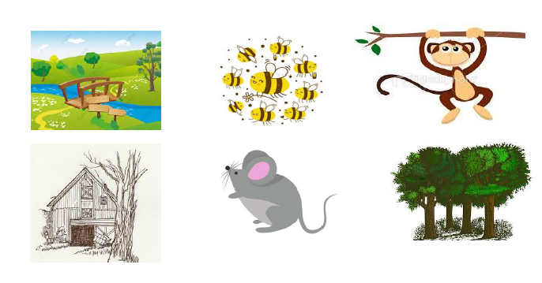  Activity : CHOOSE ONE  EITHER retell the story aloud to an adult  OR cut and stick the pictures on page 9 of the pack in order to make a story map.
Handwriting/ spellings or phonics  Learning objective:  Can I read and spell words containing th? | Introduction:  - This week you have learn that w can also be made with wh and f can also be made with ph  - I have noticed that sometimes children use f instead of th, so we will practise th again.  - Look at the sounds below and say them out loud clearly.  f th f f th th th th f th  Activities –  - Watch Mr Thorne does phonics – th sound to recap https://www.youtube.com/watch?v=6hZMjZGNq4g  - Complete the sheet below
 | Lunchtime!
AFTERNOON  Reading | Choose one of your own books to read or read a book online.
FOREST SCHOOLS | Forest schools  Introduction  - Spring is on its way!  - Watch this video- What signs of Spring can you see?  https://www.youtube.com/watch?v=vLAnt9__5Mg  - For the next few weeks we will be thinking about Spring.  - Choose one of the activities below over the next 2 weeks.  Activities  - Go for a walk and see what signs of spring you can see. (Sheet below if you would like to use it).  - Buy some cress seeds, plant them and watch them grow, (see sheet below)  - Make a grass head (see sheet below).  - Make a nest for a bird using only natural materials. Can you find a safe place to put it?  - Look out for patterns in the natural world e.g.  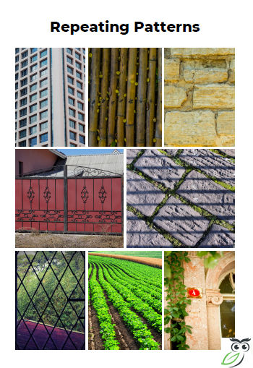  Then make your own pattern.
Additional notes for parents. | Enjoy your weekend!  Next week we will be learning about money. Please could you get a collection of change together?  One of each coin would be useful as well as a collection of 1p 2p 5p 10p 20p coins. Thank you.

Let’s get started challenge

Maths
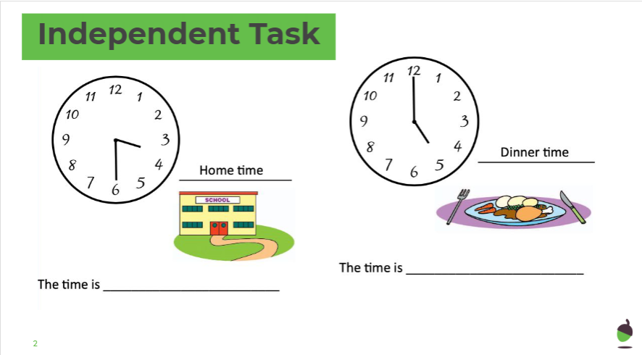

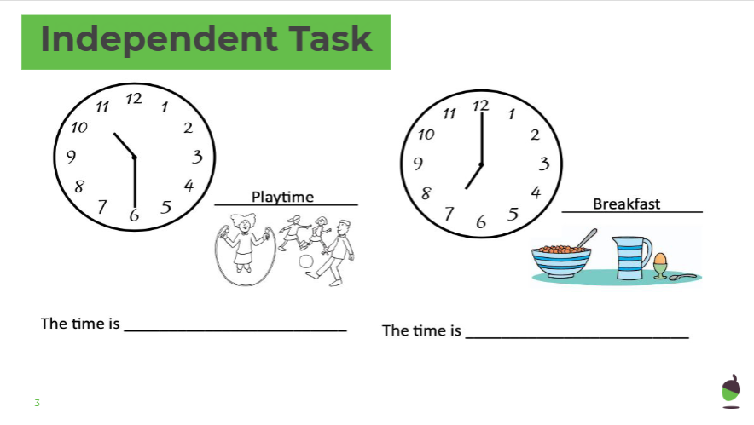

Phonics
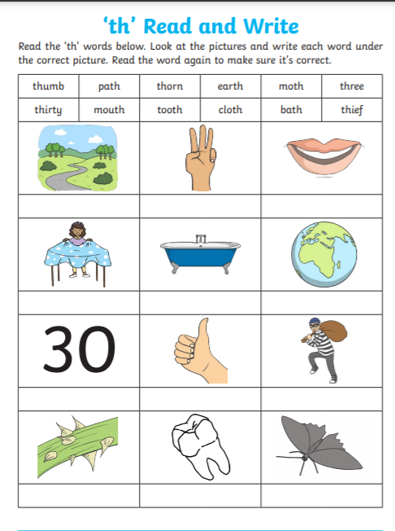

Forest schools

