Friday 29nd January 2021 YEAR 2
Enjoy doing the activities listed.
The order to do them in is suggested below but you can change them to suit you. Please e mail me any work, notes, photos or comment. Thank you.
MORNING  Let’s get started challenge | 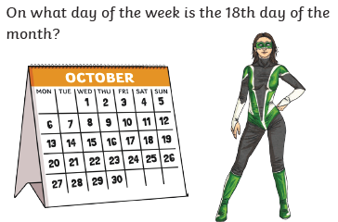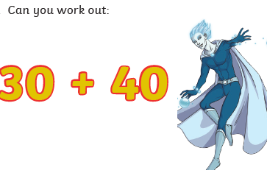  See below
Maths  Learning objective:  Can I work out a missing number subtraction problem?  Additional challenge: Can I check my answer by adding? | Introduction:  - Today we will be using what we know about subtraction to work out missing number problems.  - When we see a sum e.g. 20 - = 16  We have to work out what the number is by counting back or using what we know about number bonds to 20 to help us.  - Use a 100 square. Start at 20. Count back until you get to 16 and then stop. How many did you count back?  - 4 so the missing number is 4? Use your hundred square to help you or work out mentally by adding back the ones and then the tens.  Additional challenge: Can you check your answer by adding?  - If 20 – 4 = 16 then 16 + 4 = 20
English  Can I read and follow instructions carefully to make some superhero cuffs?  Extension: Can I say how the instructions could be improved? | Introduction  - Today you are going to make some superhero cuffs and decorate them. To be successful you will need to read and follow the instructions carefully.  - Read pages 12 and 13 before you start. If you don’t have a toilet roll use some paper or card instead.  Activity  - Follow the instructions to make your cuffs.  - Think about whether the instructions were clear enough.  - What would you have done to make them even clearer?
Handwriting/ spellings/ grammar/ punctuation or phonics  Learning objective:  Can I use what I have learnt about punctuation? | Introduction:  - So far you have been investigating capital letters, full stops, commas, question marks and exclamation marks.  - Today you will be showing what you have learnt  Activity  Play a game  https://www.bbc.co.uk/bitesize/topics/zd63xyc/articles/zncgvk7  Go to the first page and select ‘punctuation’.  Then try the different activities for  Capital letters  Full stops  Commas  Question marks  Exclamation marks
 | Lunchtime!
AFTERNOON  Reading | Read at least 3 pages of a book.
FOREST SCHOOLS | It is good to be outside for many reasons. It helps us to keep our minds and bodies healthy.  Being outside can also present challenges we may not get inside so it is good to help us with building confidence, perseverance and solving problems.  Can you think what you like most about being outside with nature?  You may have some ideas of things you would like to do, such as build a den.  Here are some suggestions for the next 3 weeks which you can pick and choose from depending on the weather.  - Create a hanging ice sculpture.  Choose a container e.g. an old ice cream container and put some water in it.  Now add a piece of string so that the string is partly in the water and partly hanging over the side.  Collect some pieces from your garden eg delicate leaves, interesting sticks and put them in your water.  Put it outside to freeze overnight. (If the temperature doesn’t go low enough you may have to put it in the freezer).  Then carefully take it out and hang in a tree.  - Make a bird cake.  Don’t worry, no baking is required. This quick and easy treat is packed full of energy to keep birds going, especially important in cold weather. Design your own recipe or use whatever’s to hand.  Ideal ingredients  - sunflower hearts  - peanut pieces and other bird seed mixes  - dried fruits softened with water  - crumbled or grated cheese  - cooked rice and other leftovers  - breadcrumbs.  Don’t use  - uncooked rice  - nuts .  Method  - Combine your chosen ingredients in a bowl and add softened lard or dripping  - Mix together into a firm paste. For best results you’ll need to get your hands in there – a great activity for kids, if a bit messy!  - Pierce the bottom of a clean yoghurt pot and poke a length of string through  - Knot securely on the inside of the pot so that it hangs upside down like a bell  - Fill with the fat mixture and hang outside  - Pretend to be an nature pirate  How much hidden loot can you fit in your miniature treasure chest? Search for tiny natural items in your garden and see who can fit the most inside a matchbox or other small container. Look out for mini discarded snail shells, tiny twigs, small shiny pebbles and little petals and leaves. Set a time limit and see who will be the winner!  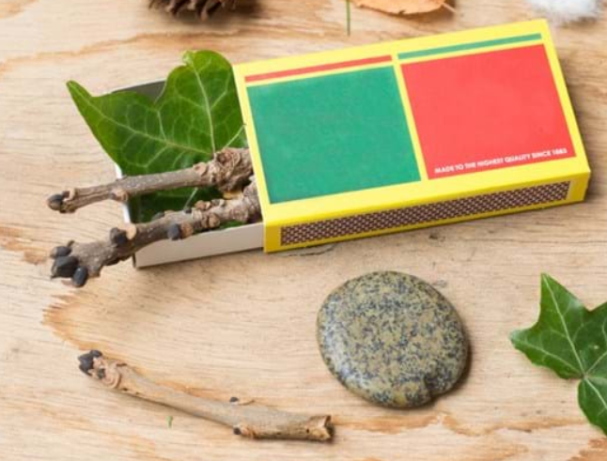  https://www.woodlandtrust.org.uk/blog/2020/03/nature-detectives/  or take part in the RSPB Big Garden Birdwatch  https://www.rspb.org.uk/get-involved/activities/birdwatch/
Additional notes for parents. | Enjoy your weekend. Another week completed!  This weekend is the Big Garden Birdwatch organised by the RSPB  You may like to take part https://www.rspb.org.uk/get-involved/activities/birdwatch/  Check on the egg experiment!

Please send your completed work to me at willow@lyng.norfolk.sch.uk so I can enjoy seeing what has been done and give top tips and feedback as necessary.

Let’s get started challenge

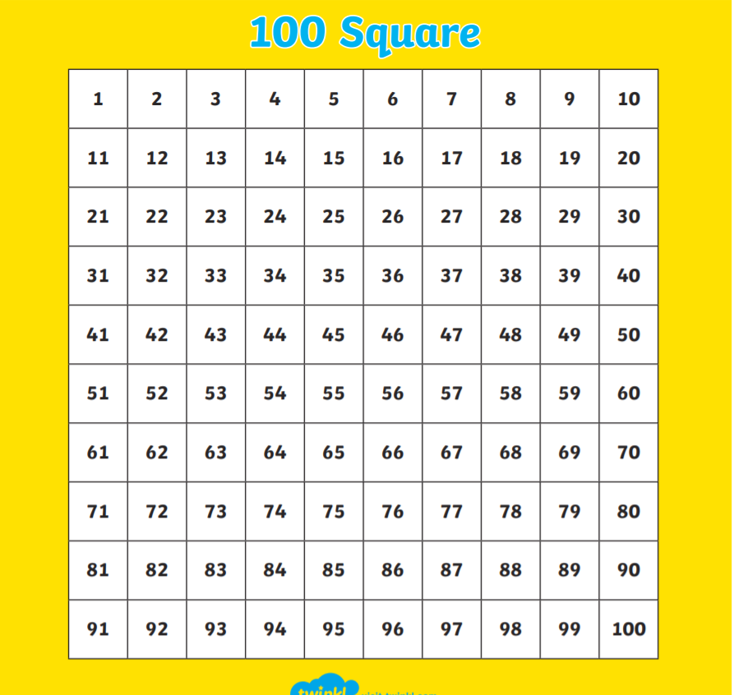

Maths: level 1
Can I work out a missing number subtraction problem?

Additional challenge: Can I check my answer by adding?
Example 20 - 3 = 17 17 + 3 = 20

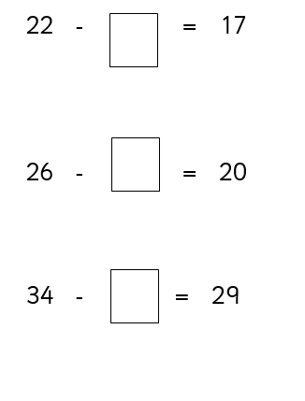

Level 2
Can I work out a missing number subtraction problem?

Additional challenge: Can I check my answer by adding?

