Morning  Challenge | 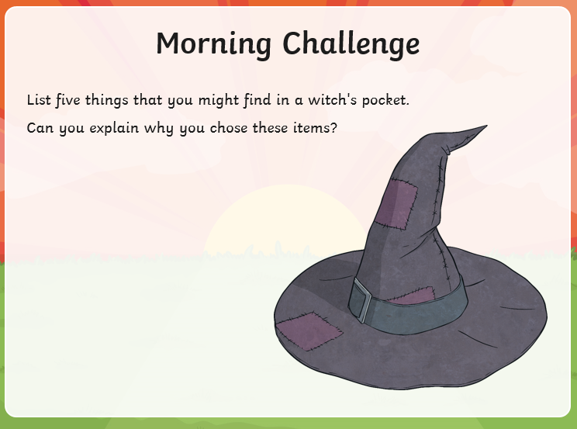
Maths | Morning Year 6,  We are going to embed our learning from yesterday, if you need a reminder, here is the link from yesterday’s lesson.  https://classroom.thenational.academy/lessons/compare-and-classify-triangles-6mu6at  Please complete the sheet below:  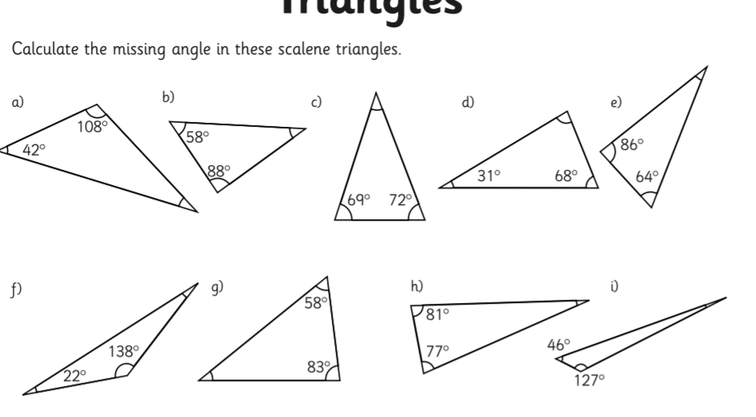  Remember the sheet below, says estimate, it’s not asking you to measure the angles.  If you have a protractor at home and would like too, that’s fine.  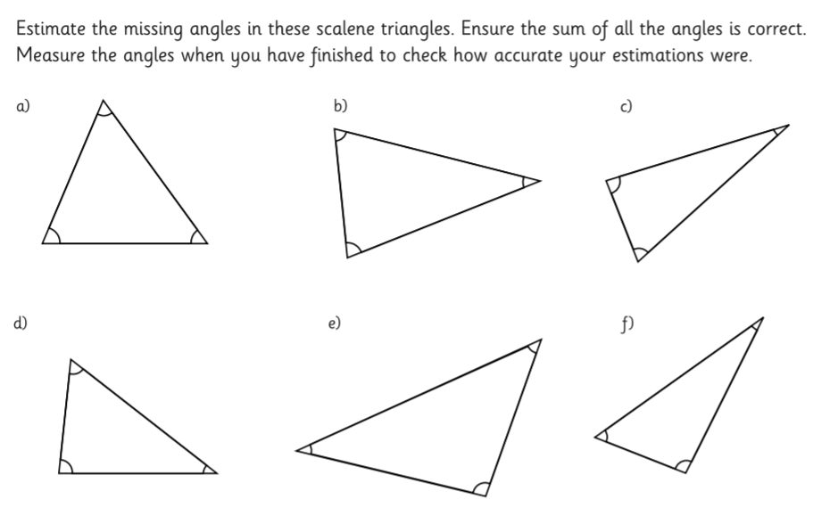
Guided Reading | 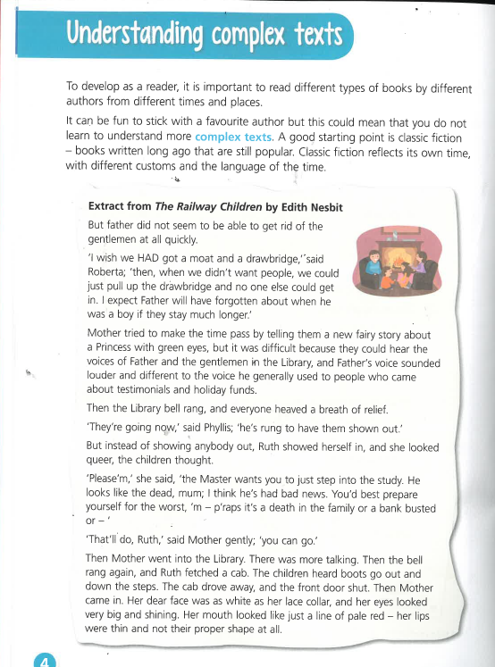  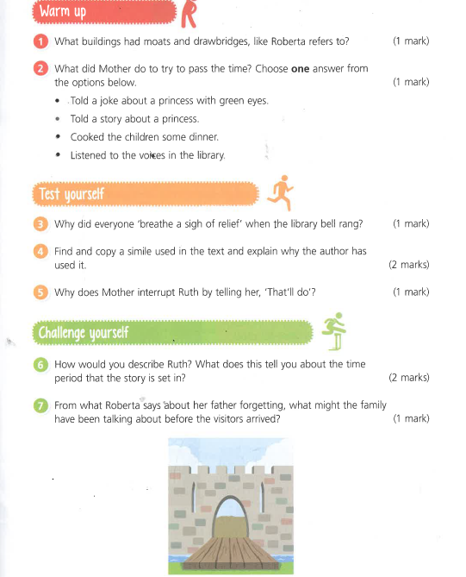
P.E. | I’m sure you are all getting out and about for your daily exercise, if you need other ideas, you could complete a Joe Wicks work out (you tube) or a Cosmic yoga one (you tube).
Afternoon lessons:  Topic | Last week we looked at the basics of how the digestive system works. Today Miss Hummel from Oak Academy will explain:  What are the key parts of a healthy diet?  In this lesson, you will learn about what is important in a healthy diet.  You will discuss the seven nutrients we need to know as well as their role in the body.  There is a lesson to watch and tasks to complete.  LO: Can I learn about what is important in a healthy diet?  Here is the link:  https://classroom.thenational.academy/lessons/what-are-the-key-parts-of-a-healthy-diet-60wkgr  If you would like to spend more time on a certain part of this session, I would love to see your menus:  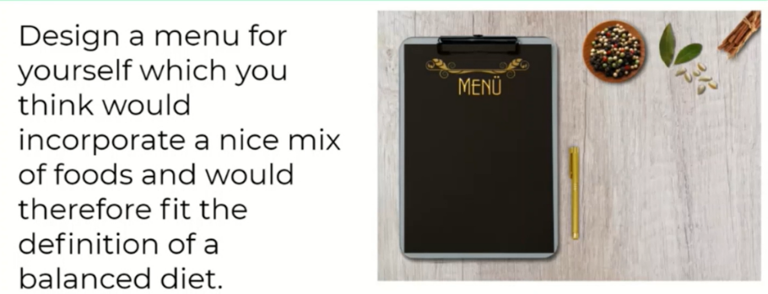
Thanks Oak, I’ll hear from you via the class email.
Remember Miss Wharton has her laptop on all day during the week, like when we are at school, so you can send your work or a message when you like (I can share these with Mrs Wylie), We love hearing from you.

Please ensure that you email completed work to oak@lyng.norfolk.sch.uk so I can provide feedback on certain pieces to ensure progression.

