Morning Challenge | 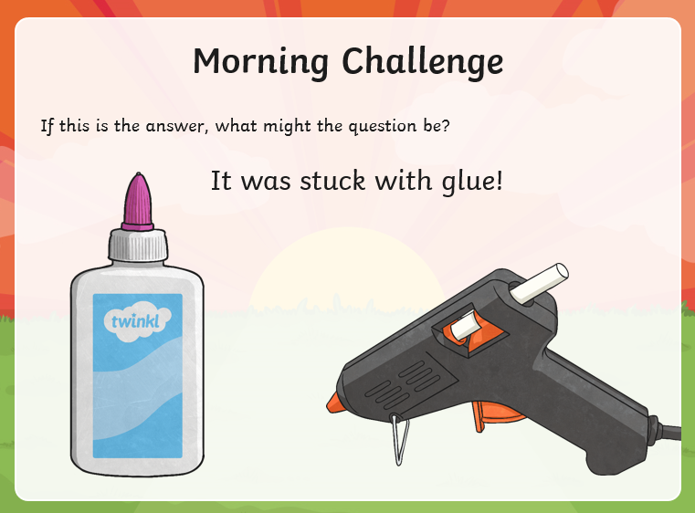
Maths | Morning Year 6,  Today we are continuing the series of taught sessions, today our LO: Can I compare and classify triangles?  Click on this link:  https://classroom.thenational.academy/lessons/compare-and-classify-triangles-6mu6at  - Watch the video. Complete the activity.  Then, take the quiz.
English | We are continuing to work through the ‘talk for writing’ English books.  https://www.talk4writing.com/wp-content/uploads/2020/06/Y6-Treasure-F.pdf  Treasure by James Walker.  Each day I will ask you to complete certain pages.  As we come to the end of this unit, you story should now be finished. Today you have the fun of acting out/telling your story to someone in your household.  Have a look at activity 15: performing your writing. It has lots of tips.  Let me know, via class email, how it goes please.  This is the sheet, below. Remember to click on the link for the larger versions.  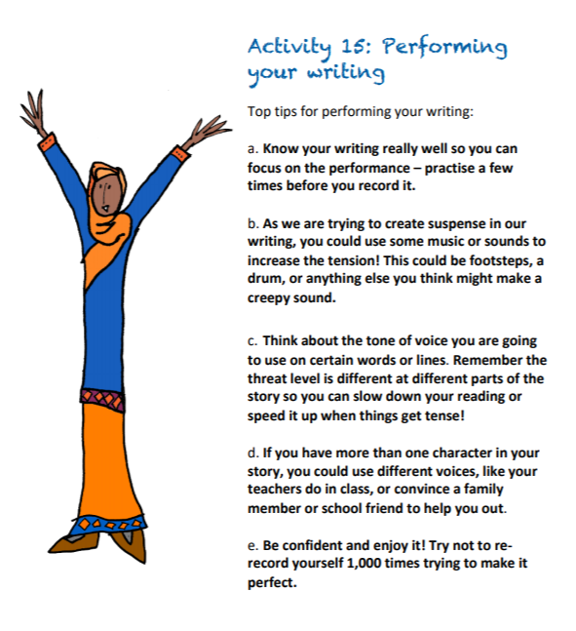
Spelling | Today year 6 for we are building on yesterday’s lesson. We are going to recap what a homophone is, revisit the 10 spelling words set and learn a spelling practice strategy. The 10 spelling words will also be tested at the end.  LO: Can I score 10/10 0n the test?  Watch:  https://classroom.thenational.academy/lessons/to-practise-and-apply-knowledge-of-homophones-including-test-69hk0d  Have a go at the test at the end.
Afternoon lessons:  French | 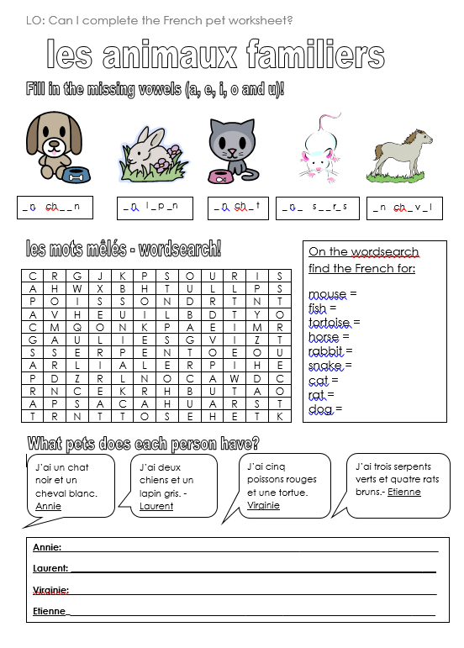
Music | A music crossword from Ms Burners:  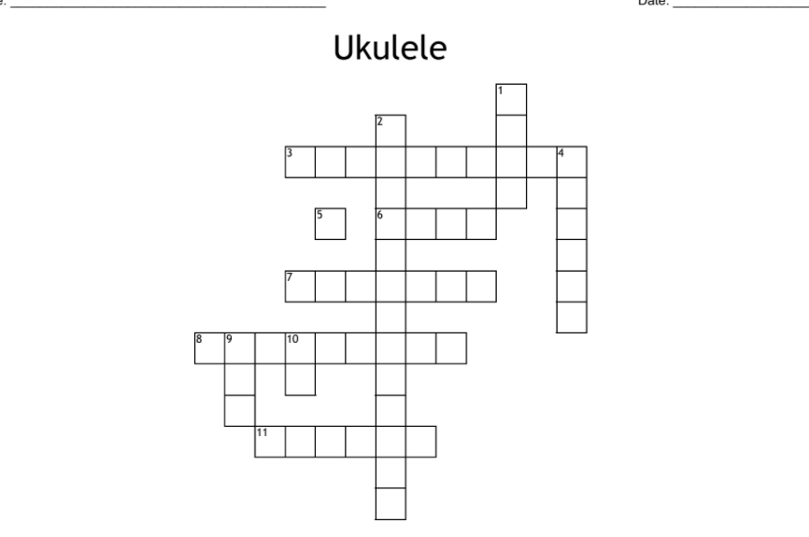  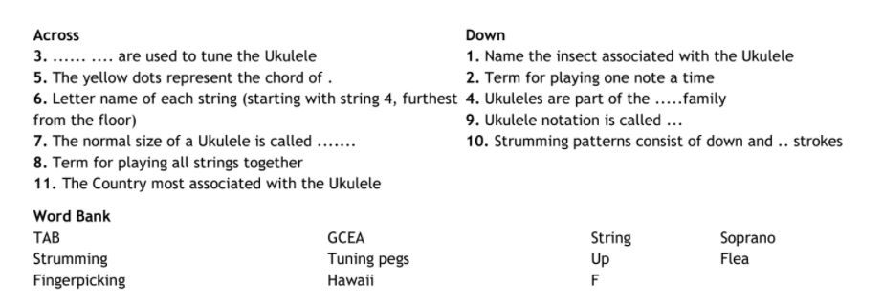
Thanks Oak, I’ll hear from you via the class email.
Remember Miss Wharton has her laptop on all day during the week, like when we are at school, so you can send your work or a message when you like (I can share these with Mrs Wylie), We love hearing from you.

Please ensure that you email completed work to oak@lyng.norfolk.sch.uk so I can provide feedback on certain pieces to ensure progression.

