Morning  Challenge | 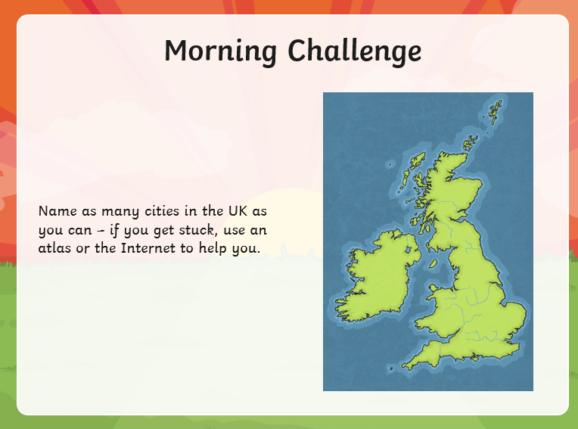
Maths | Morning Year 6,  Today our LO is: Can I classify different types of quadrilateral and learn about the sum of their internal angles?  Please watch:  https://classroom.thenational.academy/lessons/compare-and-classify-quadrilaterals-71h38c  - Watch the video. Complete the activity.  Then, take the quiz.
English | We are starting a new ‘talk for writing’ English book.  https://www.talk4writing.com/wp-content/uploads/2020/04/Y6-Unit.pdf  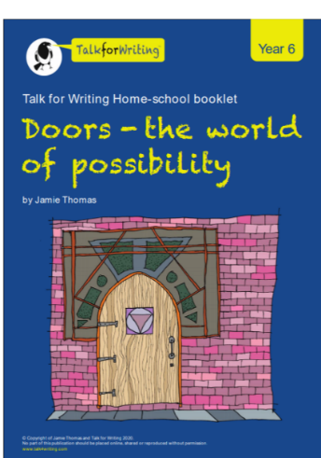  Each day I will ask you to complete certain pages.  Today, please read the introduction on page 2.  Complete activity 1 on page 3: The world we live in.  Complete activity 2, pages 3, 4 and 5: I opened a magical door and saw…  These are the pages, below. Remember to click on the link for the larger versions.  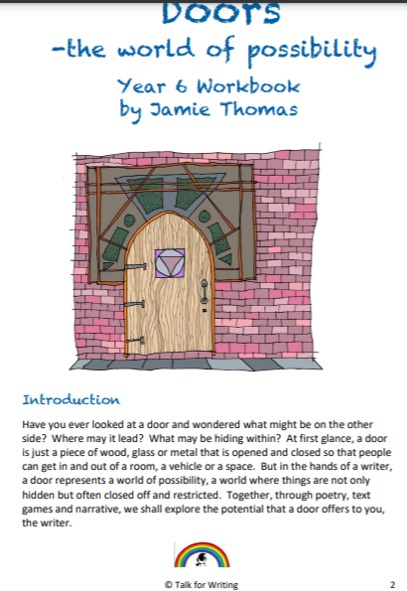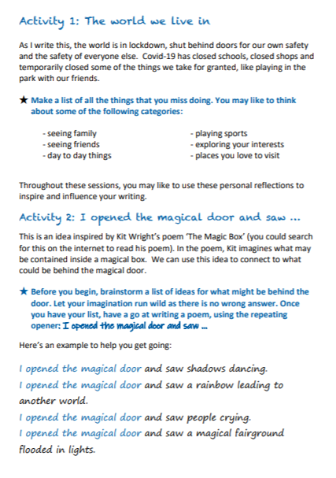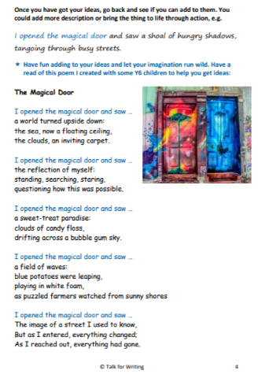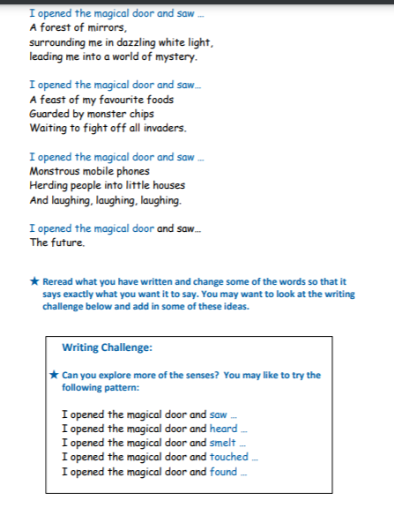
PSHCE | It was lovely to see the friendship cards that you made last week Oak-thank you.  This week we are going to think about all our good qualities.  Once you have completed your own, you could also complete one for a friend or family member, if you want to.  LO: Can I consider my good qualities?  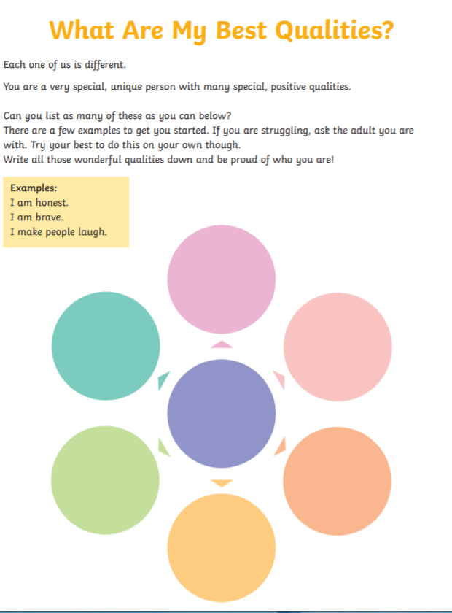
Afternoon lessons:  Science | Oak today we are going to embed our digestive system learning from last week.  Here is the system explained in a session from The Oak academy, I think this should be the session where we embed the scientific vocabulary. There is a task which is part of this session which will help do this.  You can either explain it verbally to an adult using the scientific vocab or you could write it down, again using the scientific vocab.  LO: Can I use scientific vocabulary (listed in the video) to explain how humans digest food?  Here is the link:  https://classroom.thenational.academy/lessons/how-do-humans-digest-food-60rp4c  I think you will enjoy the demonstration!
Thanks Oak, I’ll hear from you via the class email.
Remember Miss Wharton has her laptop on all day during the week, like when we are at school, so you can send your work or a message when you like (I can share these with Mrs Wylie), We love hearing from you.

Please ensure that you email completed work to oak@lyng.norfolk.sch.uk so I can provide feedback on certain pieces to ensure progression.

