Morning  Challenge | 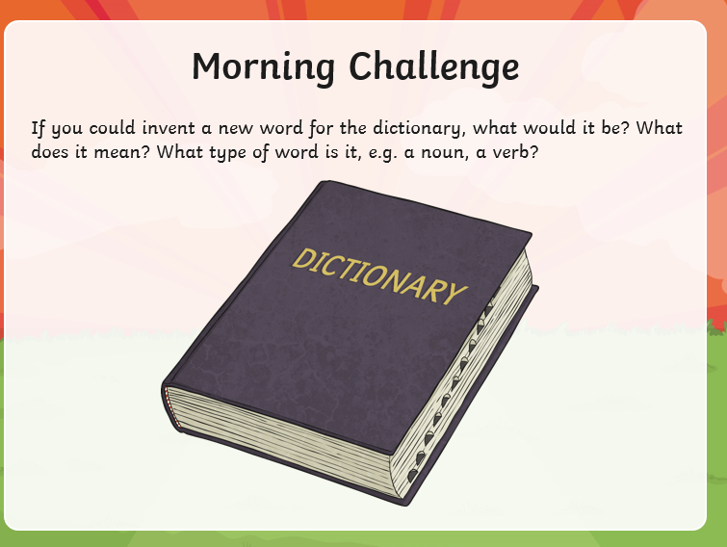
Maths | Morning Year 6,  This week we are going to be developing your understanding of coordinates in all four quadrants, including developing skills using negative numbers, using this understanding to draw, translate and reflect shapes on a coordinate grid. You will use this knowledge to find missing coordinates in a range of 2-D shapes in problems both with and without gridlines and deepen your understanding of 3-D shape through exploring nets.  You will also learn to define the parts of a circle before applying this to solve problems.  In today’s lesson, you will learn to describe the position of coordinates on a full coordinate grid.  LO: Can I describe the position of coordinates on a full coordinate grid?  Watch the session from Oak academy, linked below:  https://classroom.thenational.academy/lessons/describing-coordinate-positions-on-a-grid-6hgpat  The worksheets are below, remember to watch the lesson first.  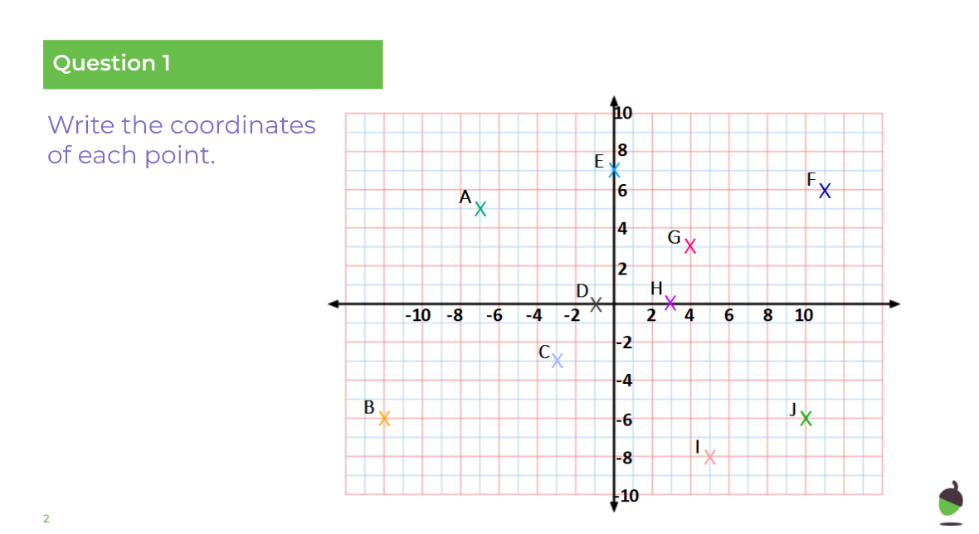  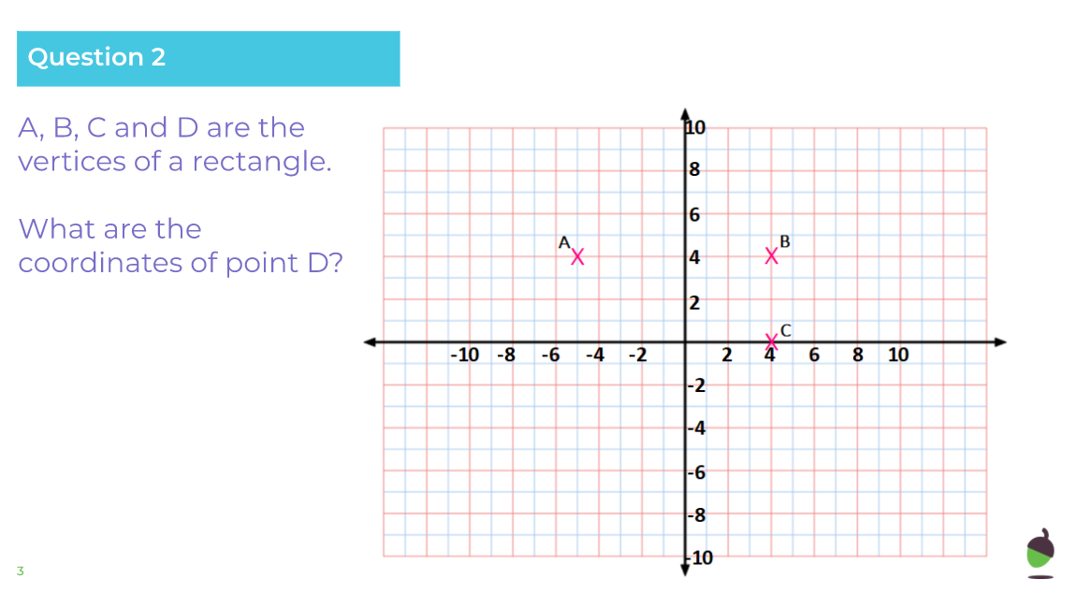  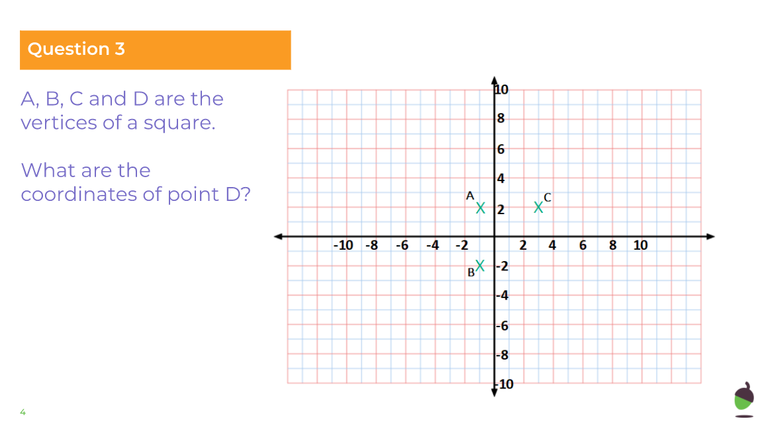  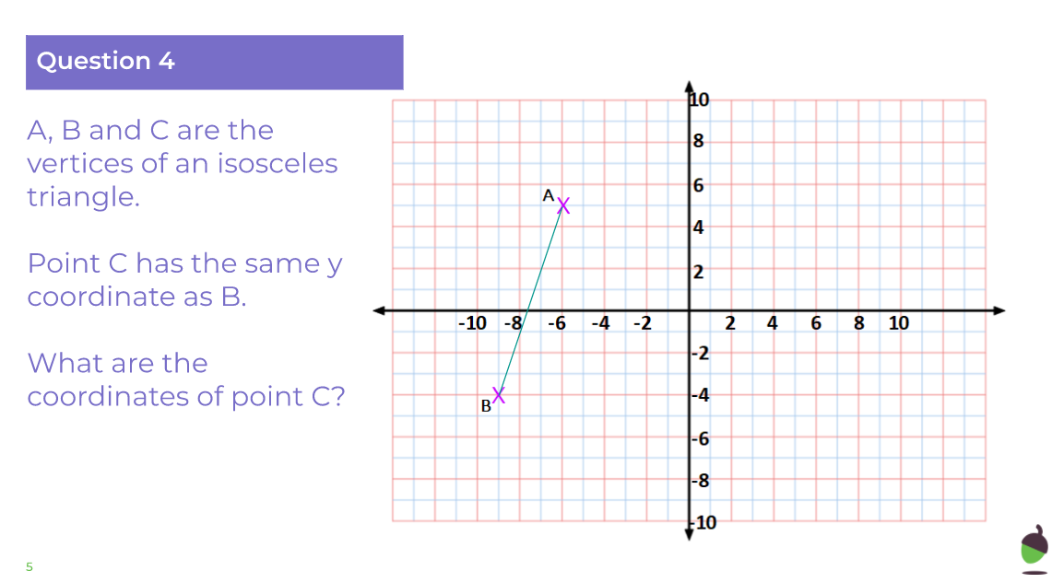  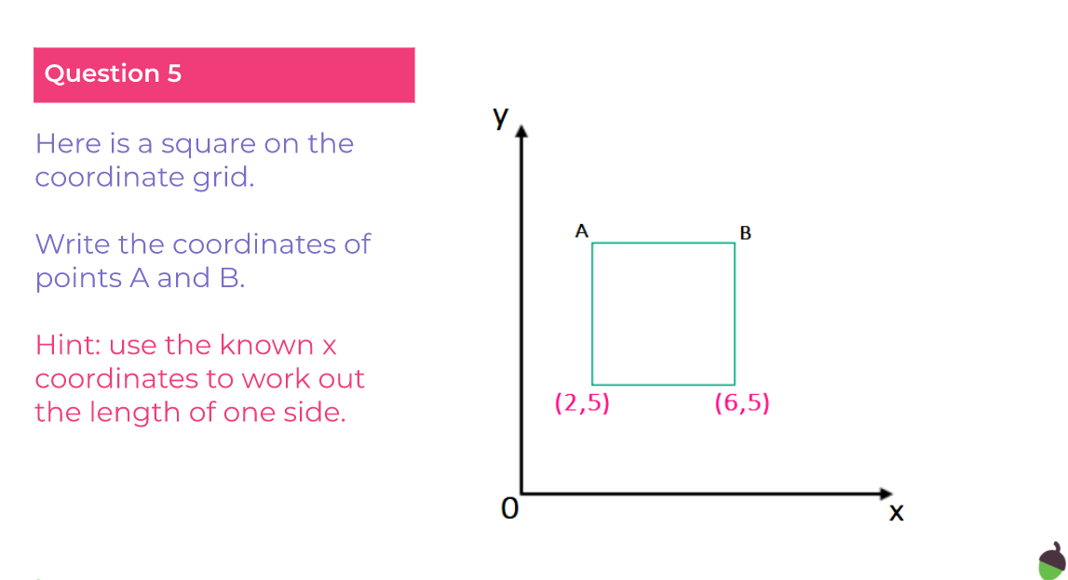  - Watch the video. Complete the activities.  - Then, take the quiz.
English | We are continuing to work through the ‘talk for writing’ English books.  https://www.talk4writing.com/wp-content/uploads/2020/04/Y6-Unit.pdf  Doors-the world of possibility. By Jamie Thomas.  Each day I will ask you to complete certain pages.  Today, please complete page 8, activity 4: Idioms  Have a go at the answers, then research any that you are unsure about.  This is the page, below. Remember to click on the link for the larger versions.  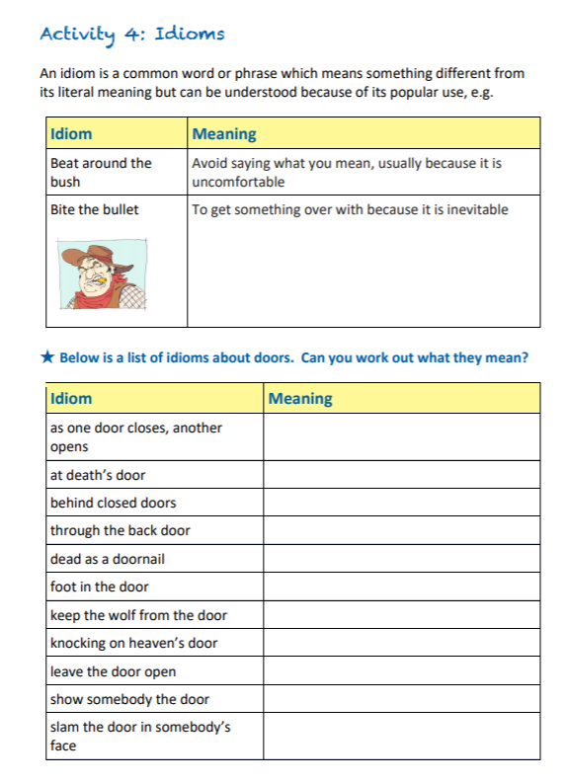
Spelling | In this lesson, we will explore the rules associated with adding the suffixes -ed and -ing. 10 spelling words will be explained and set to learn.  LO: Can I spell the 10 words correctly at the end of the session?  Here is the link:  https://classroom.thenational.academy/lessons/to-investigate-suffixes-past-and-present-60rkcc  Work through the activities.  10 spelling words will be explained and set to learn.
Afternoon lessons:  R.E | We are starting a new unit in R.E.  - In this unit we will encounter people who followed the example of Jesus both in the past and as contemporary followers world-wide.  - We will consider the impact of Christian belief on peoples’ lives in terms of their jobs and daily life.  Today we are going to learn about Edith Cavell.  Watch this clip:  https://www.bbc.co.uk/bitesize/clips/zx6pfg8  Your task is to make a poster about Edith Cavell showing her Christian beliefs and actions, during her life?  LO: Can I show how Edith Cavell demonstrated Christianity?  This may be helpful too:  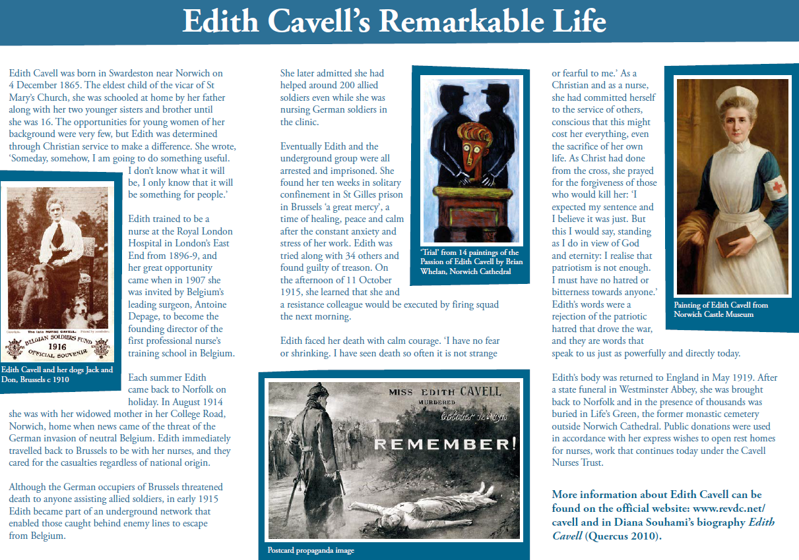
P.E | I’m sure you are all getting out and about for your daily exercise, if you need other ideas, you could complete a Joe Wicks work out (you tube) or a Cosmic yoga one (you tube).
Thanks Oak, I’ll hear from you via the class email.
Remember Miss Wharton has her laptop on all day during the week, like when we are at school, so you can send your work or a message when you like (I can share these with Mrs Wylie), We love hearing from you.

Weekly Art Challenge. | Some of Oak, have requested that we continue our weekly art challenge, that we work on during the week.  Please feel free to join in and send me your finished pieces.  This week our challenge is: Can you draw your favourite season?

Please ensure that you email completed work to oak@lyng.norfolk.sch.uk so I can provide feedback on certain pieces to ensure progression.

