Morning Challenge | 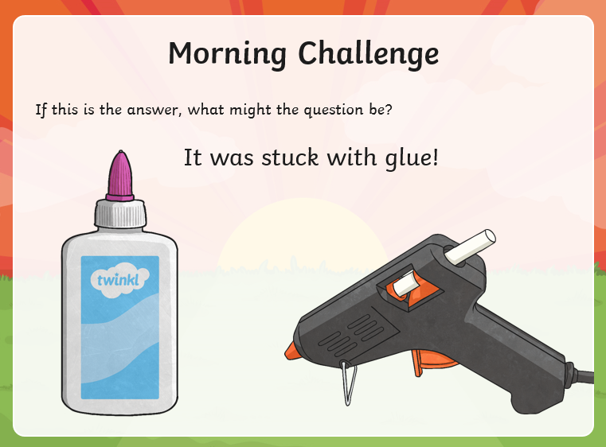
Maths | Morning Year 5 ,  Today we are continuing the series of taught sessions, today our LO is: Can I learn how to make a right angle measure (90), then use this to identify right angles within angles, shapes and daily objects?  Click on this link  https://classroom.thenational.academy/lessons/recognise-right-angles-6hj3jr  - Watch the video. Complete the activity.  - Then, take the quiz.
English | We are continuing to work through the ‘talk for writing’ English books.  The link to the year 5 book is below:  https://www.talk4writing.com/wp-content\\\\\\/uploads/2020/06/Y5-Elves-F.pdf  The ultimate guide to elves and sprites by Pie Corbett.  Each day I will ask you to complete certain pages.  Today please read p15, and complete p16, activity 10: Create a passport.  These are the pages below, remember to click on the link above for the bigger version.  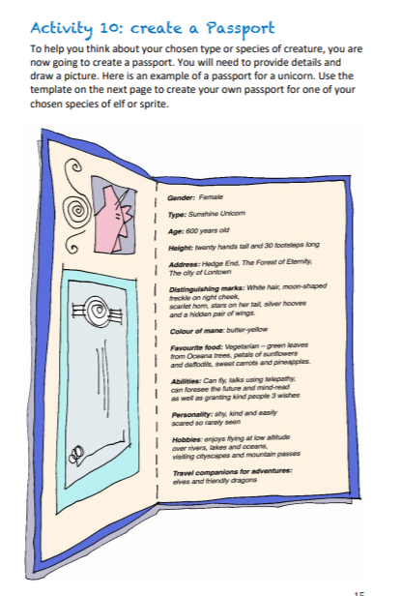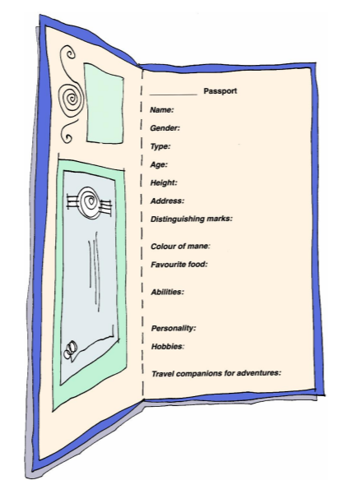
Spelling | Today year 5 for we are building on yesterday’s lesson. We are going to look at the application of spelling rules for plural suffixes, use several spelling strategies, and take a spelling test.  LO: Can I look at the application of spelling rules for plural suffixes and take a spelling test?  Watch:  https://classroom.thenational.academy/lessons/to-practise-and-apply-knowledge-of-suffixes-plurals-including-test-cgwket  Have a go at the test at the end.
Afternoon lessons:  French | 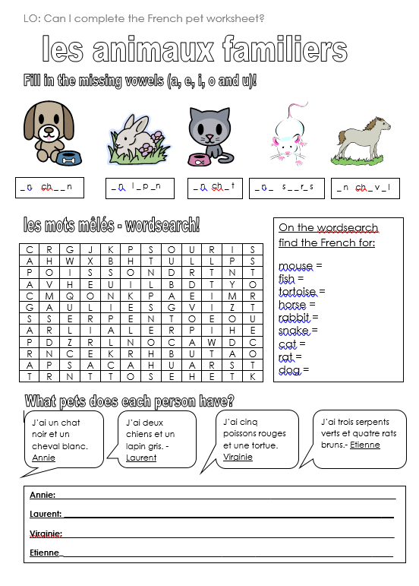
Music | A music crossword from Ms Burners:  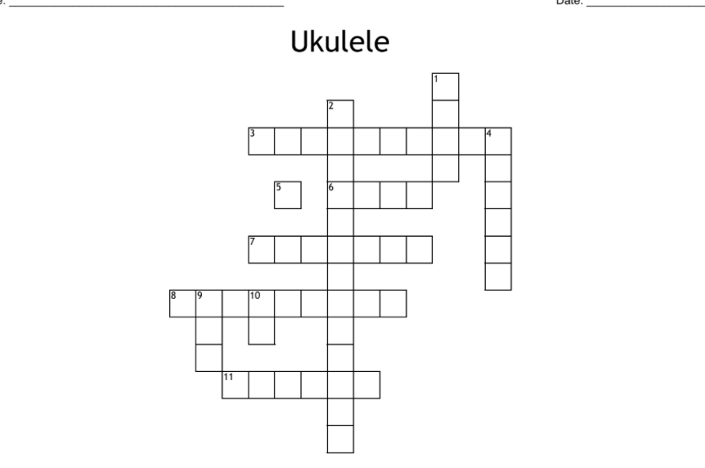  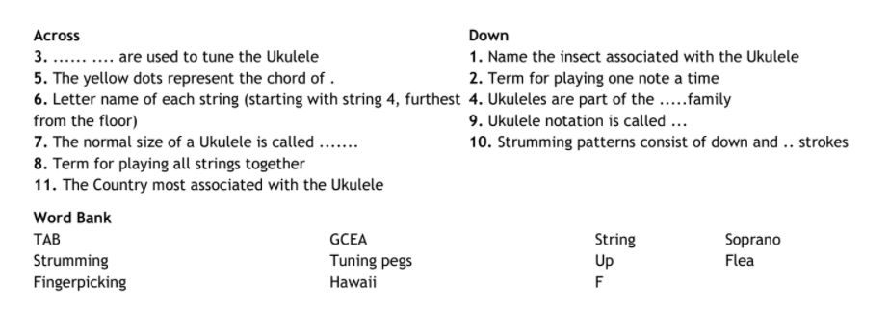
Thanks Oak, I’ll hear from you via the class email.
Remember Miss Wharton has her laptop on all day during the week, like when we are at school, so you can send your work or a message when you like (I can share these with Mrs Wylie), We love hearing from you.

Please ensure that you email completed work to oak@lyng.norfolk.sch.uk so I can provide feedback on certain pieces to ensure progression.

