Morning  Challenge | 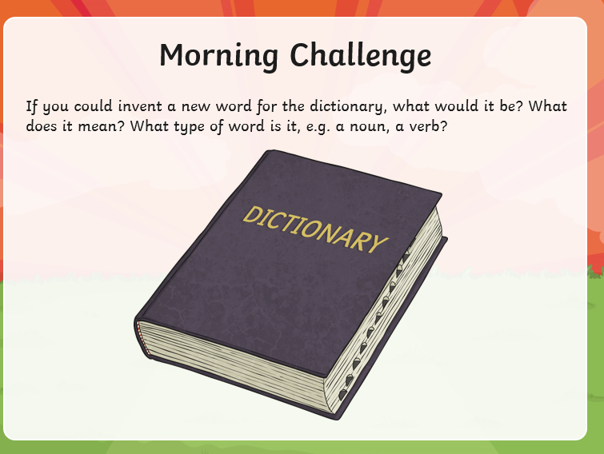
Maths | Morning Year 5,  This week we are going to be embedding our knowledge of 2D and 3D shapes.  Watch the session from Oak academy, linked below:  https://classroom.thenational.academy/lessons/2d-and-3d-shape-to-identify-describe-and-classify-shapes-based-on-the-properties-part-1-6dhpac  LO: Can I identify, describe and classify shapes based on the properties?  Here is one of the tasks, to save you drawing it, below:  The worksheets are below, remember to watch the lesson first. 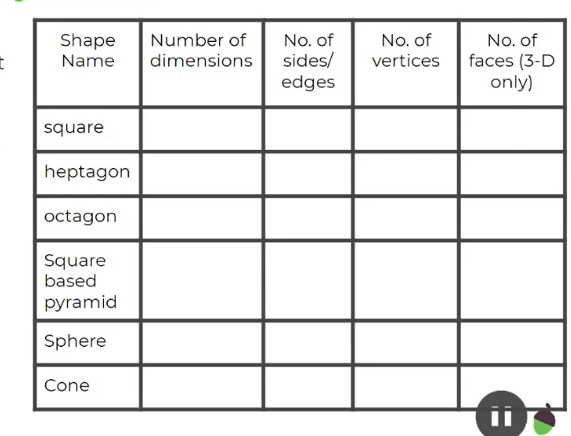  Here are the tasks, remember to watch the video first.  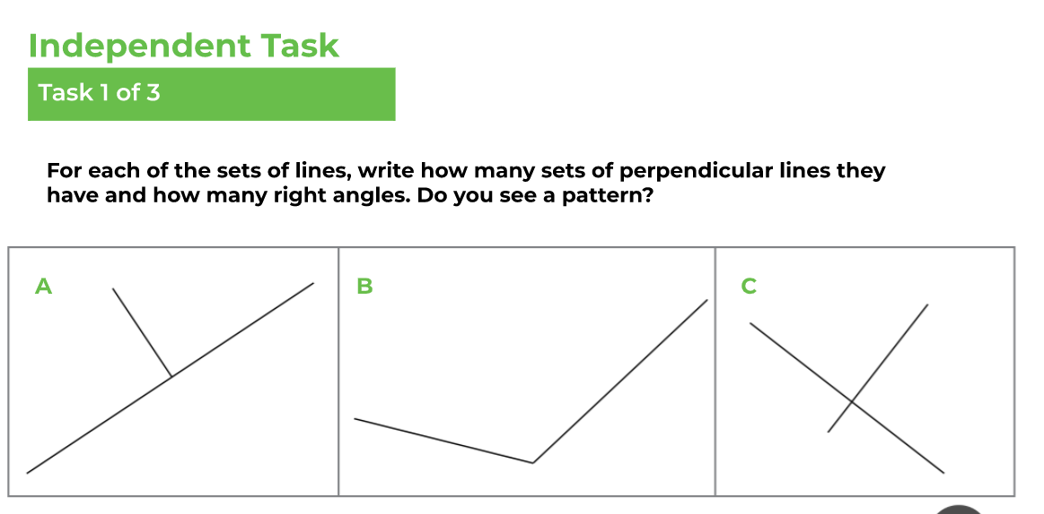  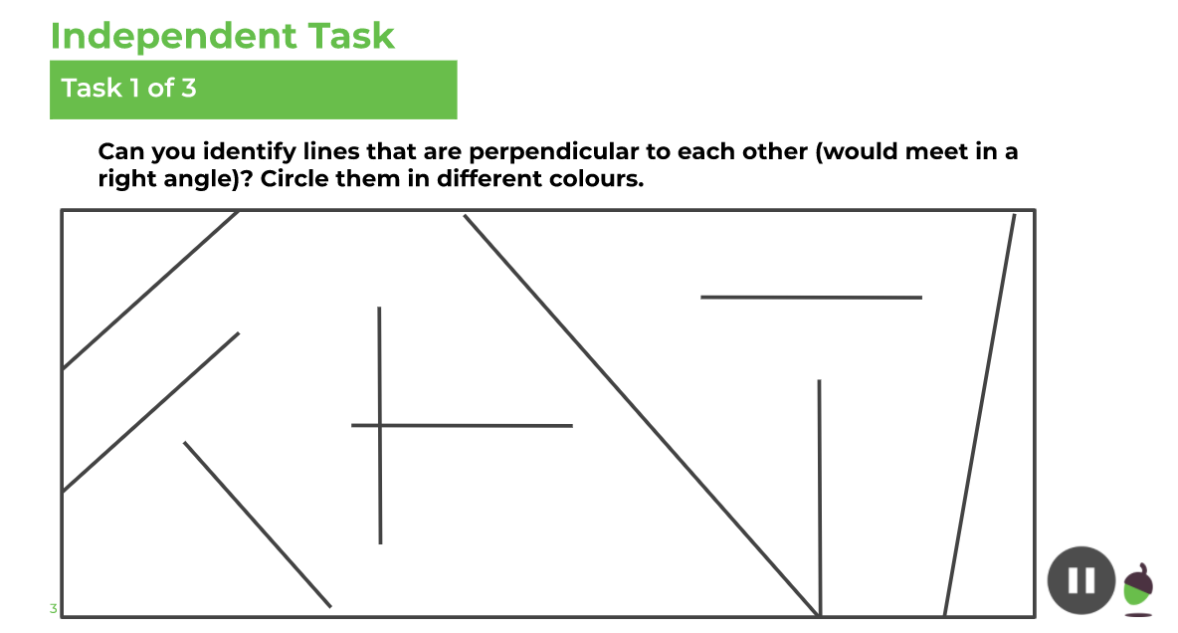  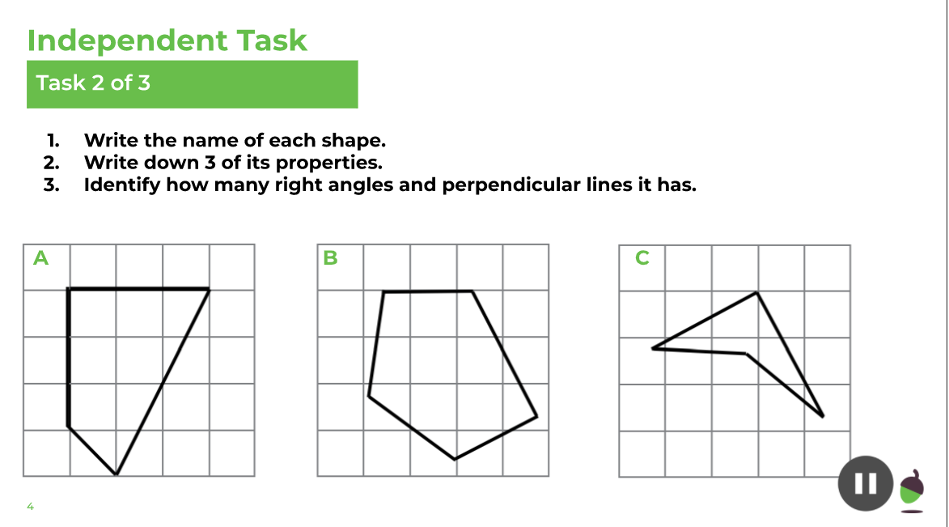  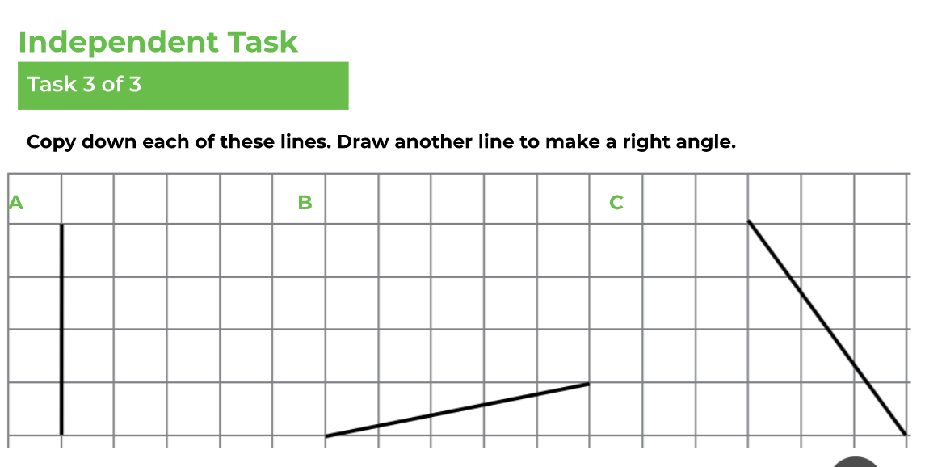  - Watch the video. Complete the activities.  - Then, take the quiz.
English | We are continuing to work through the ‘talk for writing’ English books.  The link to the year 5 book is below:  https://www.talk4writing.com/wp-content\\\\\\/uploads/2020/06/Y5-Elves-F.pdf  The ultimate guide to elves and sprites by Pie Corbett.  Each day I will ask you to complete certain pages.  Find your plan from Friday, ready to complete activity 14 and to start activity 15.  Talk through your plan to yourself, or and adult or sibling, ready to start your final draft.  You now have a choice, today you can make a rough version of your ‘ultimate guide’ page, ready to make the final version on Tuesday or you can start your guide today and have tomorrow’s lesson to finish it.  The page we are using is shown below:  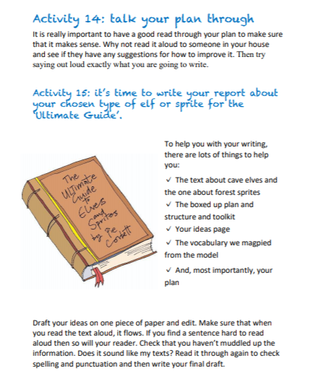
Spelling | In this lesson, we will investigate suffixes that change the word class of a word from a noun/ adjective to a verb and explore appropriate spelling rules associated with the addition of -ate -en -ify - ise.  LO: Can I show how suffixes that change the word class of a word from a noun/ adjective to a verb and explore appropriate spelling rules associated with the addition of -ate -en -ify - ise.?  Here is the link:  https://classroom.thenational.academy/lessons/to-investigate-suffixes-ate-en-ify-ise-6xj62t
Afternoon lessons:  R.E | We are starting a new unit in R.E.  - In this unit we will encounter people who followed the example of Jesus both in the past and as contemporary followers world-wide.  - We will consider the impact of Christian belief on peoples’ lives in terms of their jobs and daily life.  Today we are going to learn about Edith Cavell.  Watch this clip:  https://www.bbc.co.uk/bitesize/clips/zx6pfg8  Your task is to make a poster about Edith Cavell showing her Christian beliefs and actions, during her life?  LO: Can I show how Edith Cavell demonstrated Christianity?  This may be helpful too:  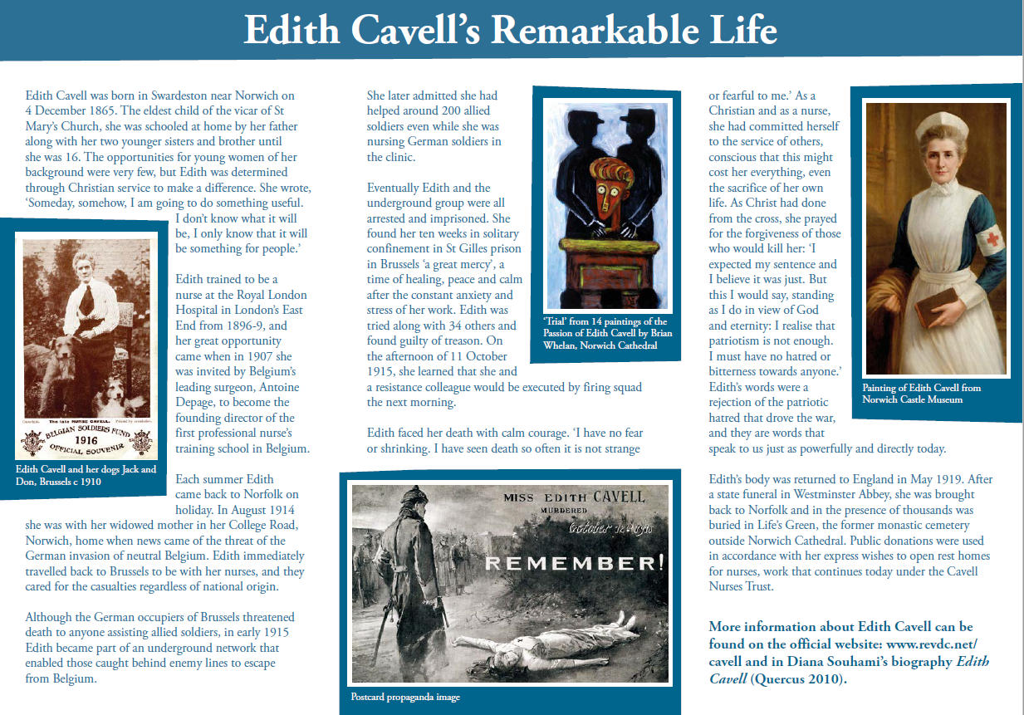
P.E | I’m sure you are all getting out and about for your daily exercise, if you need other ideas, you could complete a Joe Wicks work out (you tube) or a Cosmic yoga one (you tube).
Thanks Oak, I’ll hear from you via the class email.
Remember Miss Wharton has her laptop on all day during the week, like when we are at school, so you can send your work or a message when you like (I can share these with Mrs Wylie), We love hearing from you.

Weekly Art Challenge. | Some of Oak, have requested that we continue our weekly art challenge, that we work on during the week.  Please feel free to join in and send me your finished pieces.  This week our challenge is: Can you draw your favourite season?

Please ensure that you email completed work to oak@lyng.norfolk.sch.uk so I can provide feedback on certain pieces to ensure progression.

