Maths  LO: Can I use column subtraction? | Today we will be looking at column subtraction.  Like column addition, remember to present your work neatly and line up your work correctly.  ‘knock next door’ if you need to borrow a ten or hundred from the next number along, if you cannot subtract the two numbers you have been given.  Choose your challenge and complete the problems below.  Video to show method: https://www.bbc.co.uk/bitesize/topics/zy2mn39/articles/zc78srd  Same options as Monday –  Option 1 – Complete the first two boxes.  Option 2 – Complete boxes 2, 3 and 4.  - Access Mathletics and complete a subtraction task.  - Daily practise of the 7 times tables.
English  LO: Can I substitute the author’s ideas for my own? | Continue to remind yourself of the key points of the story.  Write down all the things you need to include in order to make your writing exciting. In particular, think about what you need to include in your sentences.  Complete the grammar sheet attached. Use the example from the text and have a go at substituting the author’s ideas for some of your own.  - Daily reading.  - Complete a task in your reading record.
Handwriting  LO: Can I practise my handwriting? | Word list – gu  Complete over the week; focussed practise of writing the words out every day, aiming to improve each day.  Remember to have clearly defined ascenders and descenders. Ensure joins are clear and your writing not too big or too small!
Spellings  LO: Can I include my spelling words within sentences? | Word list – gu.  Try to use your gu words in a sentence.  E.g., The guard stood outside the castle, so she could protect the king.  Send me what you have learnt on the class email.
Afternoon lessons:  LO: Can I identify ways of living a healthy lifestyle?  LO: Can I complete a series of PE activities? | PSCHE  What does it mean to be healthy? Make a mind map of ideas.  How can you maintain a healthy lifestyle? Make a list of ways you can remain healthy.  Create a poster/PowerPoint/leaflet with your top-tips of maintaining a healthy lifestyle.  PE  Joe Wicks  Cosmic Kids Yoga OR try to make up your own yoga sequence with your own poses.  We often do this in PE, our favourites are:  Roald Dahl yoga poses  Animal Crossing poses  Pokémon poses  Animal poses  Dinosaur poses.  I’d love to see what you come up with. Send me some pictures of your poses on the class email!

Please ensure that you email completed work to rowan@lyng.norfolk.sch.uk so I can provide feedback on certain pieces to ensure progression.
I will provide feedback via the class email.

Word list:
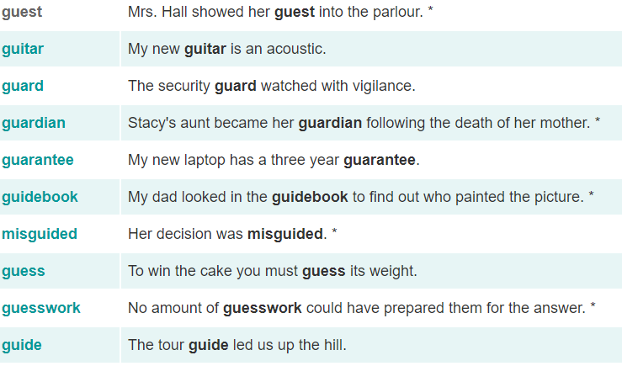

Maths 1 2
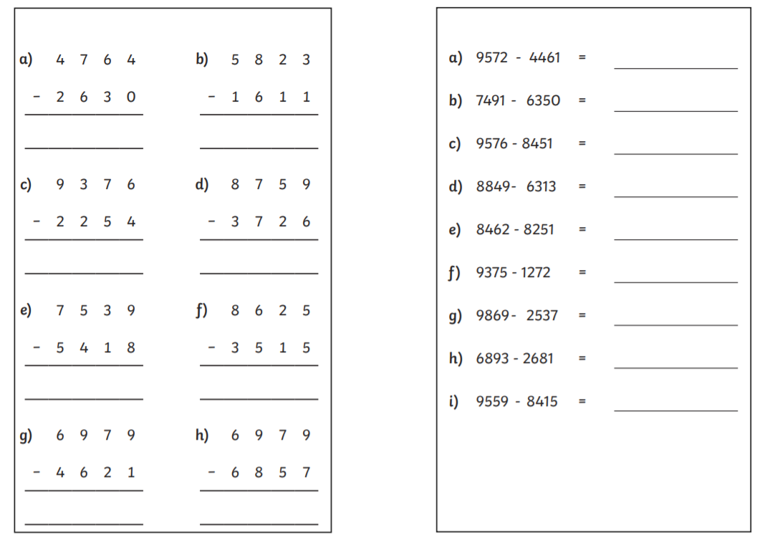

3 4
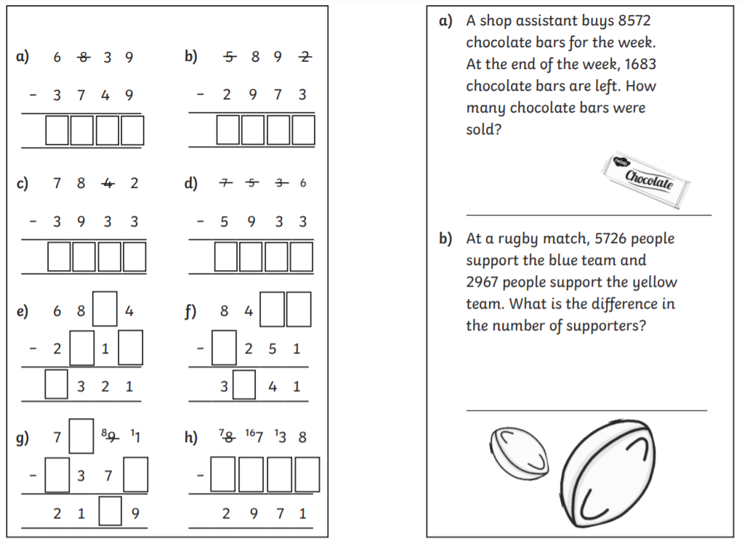

English
