Hi Y4,
Today in maths, you are going to be trying out a new method of division called the bus stop method. If you watch the video and follow the teacher’s instructions, you’ll be fine. The key is to take your time.
Have a good day of learning,
Miss Cartwright, Miss Dorr and Mrs. Warnes.
Maths | Morning maths problem:  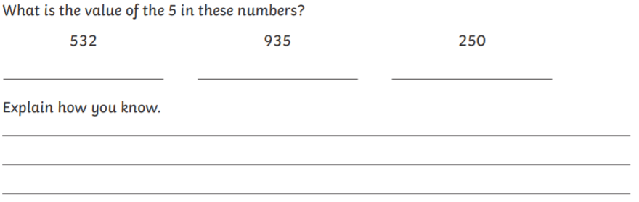  Today we are going to be trying a new method of division, which is called the ‘bus stop method’.  Please watch the video, which explains how we can solve division problems using the bus stop method.  https://www.youtube.com/watch?v=trjepeOy2rc&t=11s  Complete these problems using the bus stop method:  96÷3 84÷4 63÷3 55÷5 66÷3  68÷2 88 ÷ 4 42÷2 93÷3 48÷4
Additional maths (if the above maths work is completed). | Please use Mathletics daily and complete tasks related to what you have been learning in maths that day.  If you need your log-in, please email Miss Cartwright and she will get it to you ASAP.  If Mathletics is being slow (which it can sometimes due to traffic on the website), please use one of these websites for other KS2-friendly maths games:  https://www.topmarks.co.uk/maths-games/hit-the-button  https://mathsframe.co.uk/en/resources/category/22/most-popular  https://www.bbc.co.uk/bitesize/topics/zd2f7nb/articles/zn2y7nb  Y4: Please also keep completing the times table checker on MathsFrame:  https://mathsframe.co.uk/en/resources/resource/477/Multiplication-Tables-Check
English | Please continue to write your wishing story.  Y4 writing checklist:  - Full stops and capital letters  - Fronted adverbials – this will help https://www.bbc.co.uk/bitesize/topics/zwwp8mn/articles/zp937p3  - Up-leveled vocab – use an online thesaurus to help  - Complex sentences – this will help https://www.bbc.co.uk/bitesize/articles/zbvqkty  - Clear beginning, middle and end.
Spellings | Word list – ture/Miss Dorr’s list.  Play some word games with the gu words. You could make word pyramids, mnemonic poems, word petals. I’ve attached some suggested ideas below.  Send me what you have learnt on the class email.
Reading | Spend some time reading your book. You can read in your head, but please also read to an adult.  Grown-ups – I will upload the list of questions we use in class so you can assess your child’s comprehension.  You can download the Libby app, which allows you to borrow books and e-books from your local library.  Those children who are reading banded books – use the Oxford Owl website to find eBooks to read. https://www.oxfordowl.co.uk/for-home/find-a-book/library-page/  Continue to fill in your reading records and completing the activities in your reading records.
Afternoon lessons: | Computing –  We are going to be completing projects from the Scratch from CodeClub this half term.  Please follow the link to the CodeClub website: https://projects.raspberrypi.org/en/projects/stress-ball  Or follow these steps:  - Search for CodeClub on Google or your preferred search engine.  - Click the link for CodeClub.org  - Follow the page ‘Explore Projects’  - If you scroll to the bottom, there is a section called ‘Look after yourself’. Click on this.  - Then, you can start the ‘Stress Ball’ project!  Parents – all the instructions the children need are included in the guide I have just sign posted you to. Encourage your child to try and complete the project as independently as they can.  PE – Choose your own challenge:  Complete a Joe Wicks workout.  Go outside for a bicycle ride or a run.  Complete a Cosmic Kids Yoga sequence.  Choose one of the videos from This is PE and complete the tasks they set out.  https://www.youtube.com/playlist?list=PLYGRaluWWTojV3An2WEgsQ4qGFy_91jDL Link to playlist of videos.

Please ensure that you email completed work to rowan@lyng.norfolk.sch.uk so I can provide feedback on certain pieces to ensure progression.
I will provide feedback via the class email.

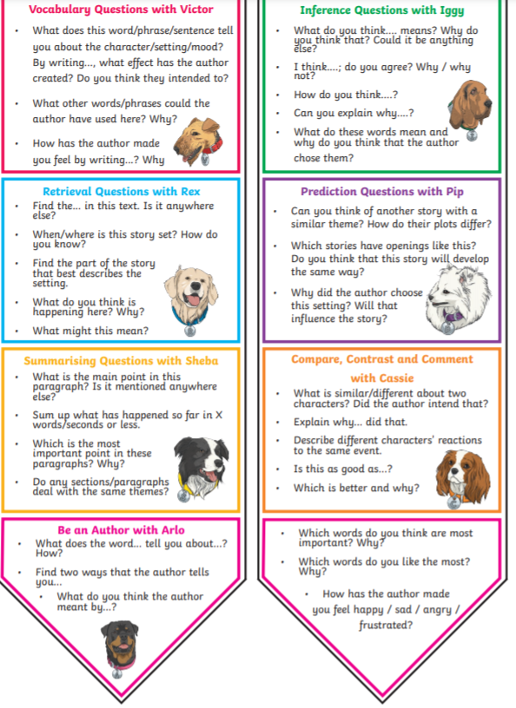
Reading

Spellings
Main spellings | Miss Dorr’s group
adventure  agriculture  capture  creature  culture  departure  feature  fixture  fracture  furniture  future | 