Maths  LO: Can I solve code-cracking maths problems?  LO: Can I add to the next 10? | Today, you are going to be Emoji detectives! Crack the code by matching up the Emojis to the numbers they represent. Complete the Emoji code breaker activities. Choose your own challenge!  Aim to try to solve the problems mentally.  Mrs Warnes’ group: Adding to the next ten. Try to do this mentally but you can use the 100 square on the sheet to help you too.  - Access Mathletics and complete an addition OR a subtraction task.  - Daily practise of the 7 times tables.
English  LO: Can I independently use adverbs in my writing?  LO: Can I rewrite my sentences so that the adverb is at the start? | - Read the Trolls information. Talk about your favourite piece of information about Trolls!  - Complete the second adverb sheet (attached). Use your favourite facts to write sentences, which contain one of the adverbs given to you. If you need a reminder, here’s a link! https://www.bbc.co.uk/bitesize/topics/zwwp8mn/articles/zgsgxfr  Miss Dorr’s group: Remind yourself what an adverb is. See if you can reorganise your sentences from yesterday so that the –ly adverb is that the front. Make sure that there is a comma after the –ly word E.g. Slowly, the troll plods.  - Daily reading.  - Complete a task in your reading record.
Handwriting  LO: Can I practise my handwriting? | Word list – gu (or Miss Dorr’s group own words)  Complete over the week; focussed practise of writing the words out every day, aiming to improve each day.  Remember to have clearly defined ascenders and descenders. Ensure joins are clear and your writing not too big or too small!
Spellings  LO: Can I include my spelling words within sentences? | Word list – gu/Miss Dorr’s list  Try to use your gu words in a sentence.  E.g., The guard stood outside the castle, so she could protect the king.  Send me what you have learnt on the class email.
Afternoon lessons:  LO: Can I identify ways of living a healthy lifestyle?  LO: Can I complete a series of PE activities? | PSCHE  What does it mean to be healthy? Make a mind map of ideas.  How can you maintain a healthy lifestyle? Make a list of ways you can remain healthy.  Create a poster/PowerPoint/leaflet with your top-tips of maintaining a healthy lifestyle.  PE  Joe Wicks  Cosmic Kids Yoga OR try to make up your own yoga sequence with your own poses.  We often do this in PE, our favourites are:  Roald Dahl yoga poses  Animal Crossing poses  Pokémon poses  Animal poses  Dinosaur poses.  I’d love to see what you come up with. Send me some pictures of your poses on the class email!

Please ensure that you email completed work to rowan@lyng.norfolk.sch.uk so I can provide feedback on certain pieces to ensure progression.
I will provide feedback via the class email.

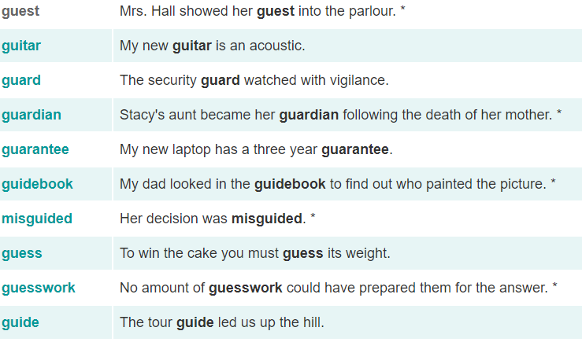
Word list:

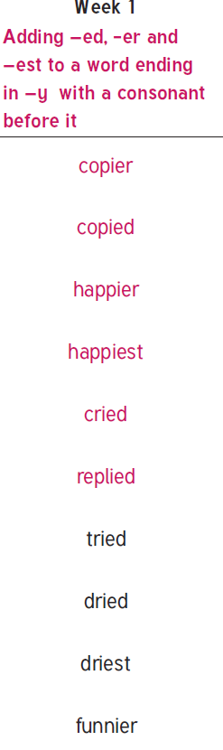
Miss Dorr’s group

Maths – option 1
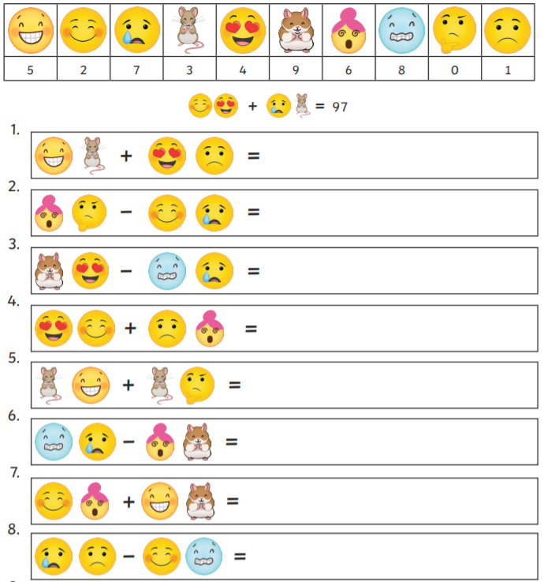

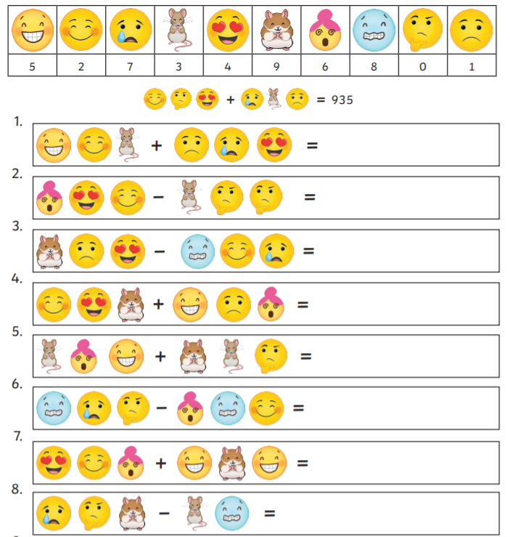
Maths option 2

Maths option 3

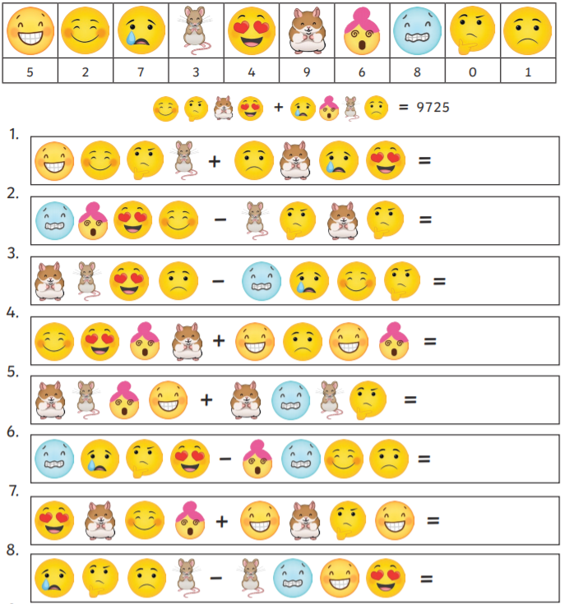

Mrs Warnes’ maths
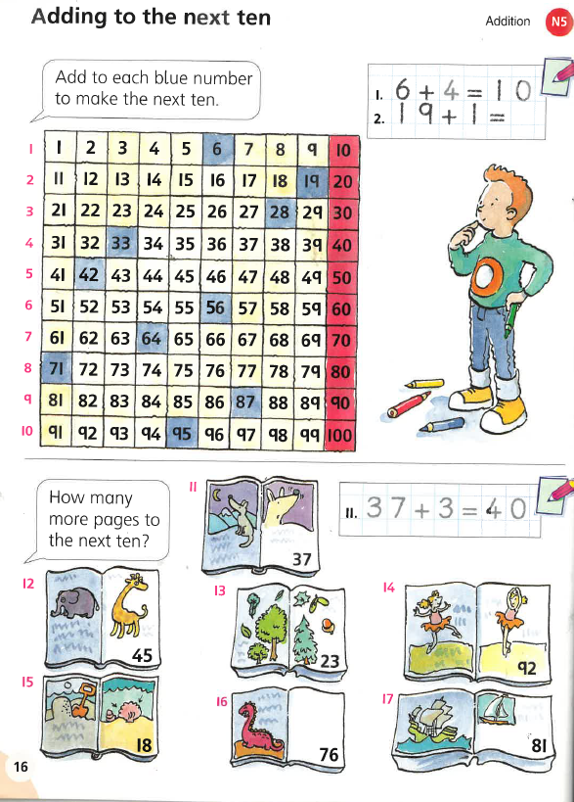

English
